**2018- MEGA FREE HEALTH CAMP PROGRAMME CHIEF GUESTS AT RAYAPURAM VILLAGE**

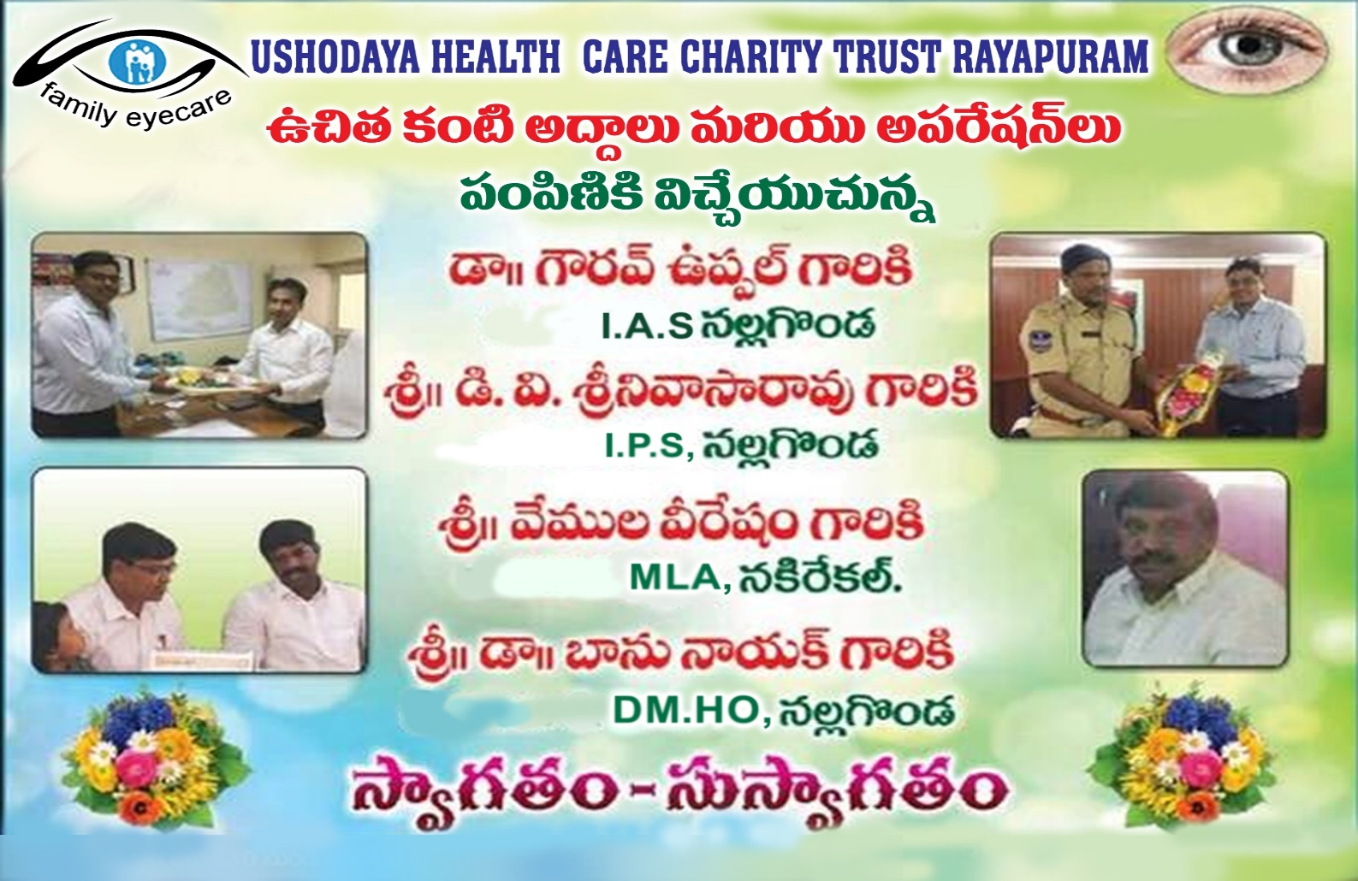

**FREE EYE CAMP IN MEDCHAL VILLAGE 2017. SCREENED 1267 PATIENTS, FREE MEDICINES AND FREE GLASSES PROVIDED. 345 FREE CATARCT SURGERIES PERFORMED BY USHODAYA HEALTH CARE**

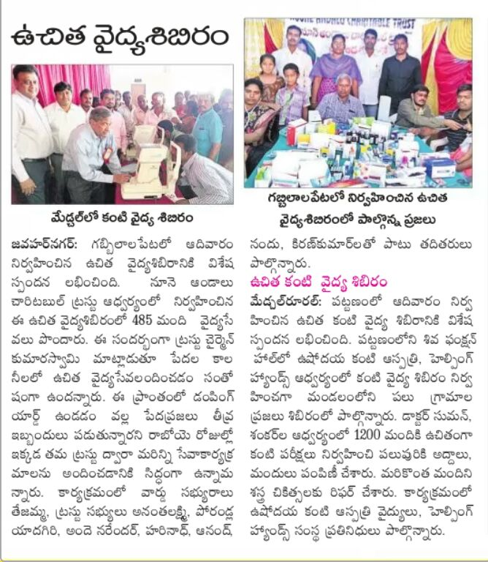

**FREE EYE CAMP FOR SCHOOL CHILDREN. SCREENED 2028 STUDENTS, PROVIDED 656 FREE GLASSES**

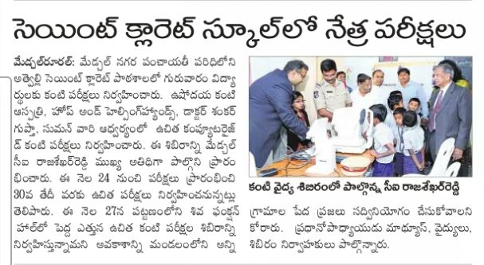

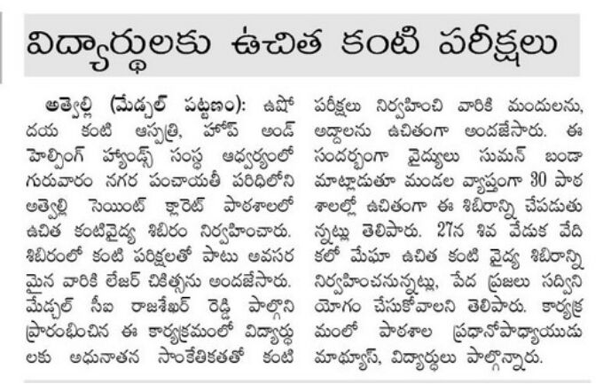

**FREE EYE CAMP FOR VILLAGERS . SCREENED 870 PATIENTS, PROVIDED 231 FREE GLASSES, PERFORMED 28FREE CATARACTS SURGERIES**

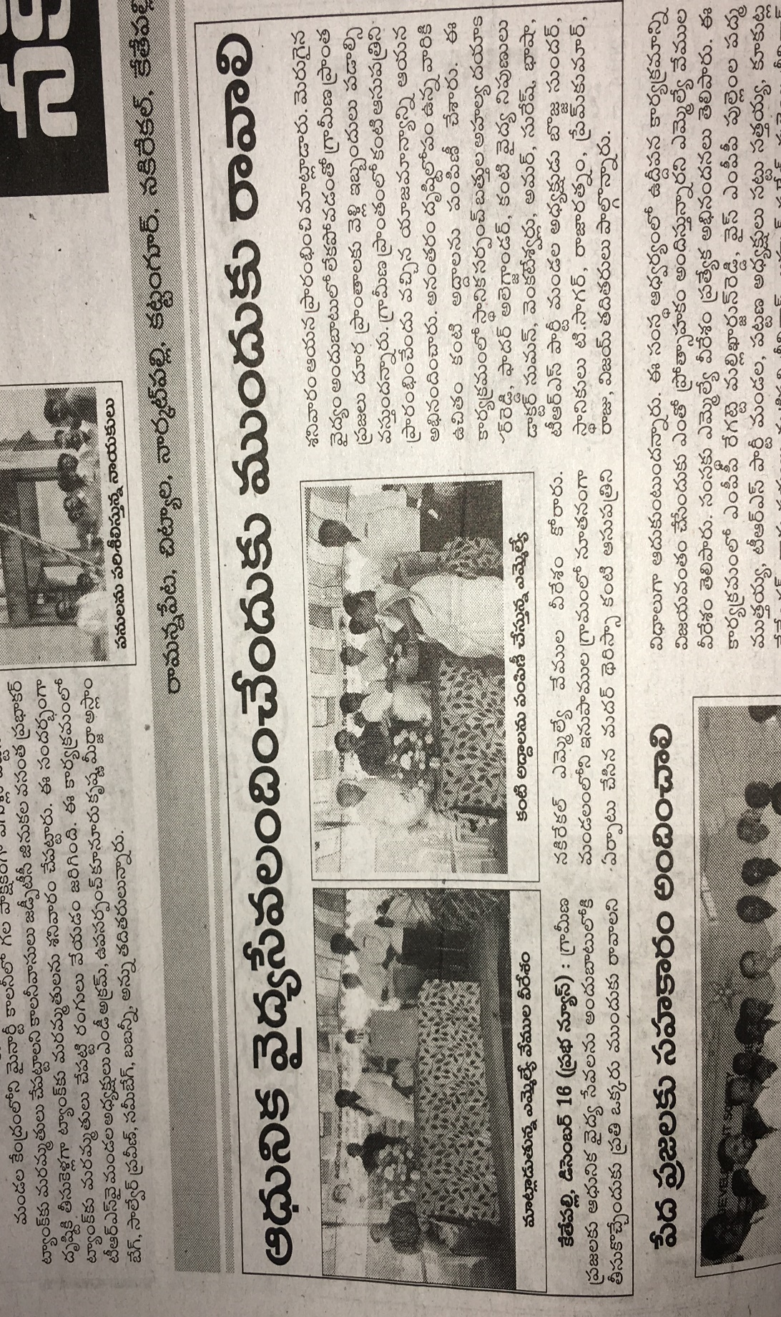

**Free Eye Camp for School Children & provided free glasses**

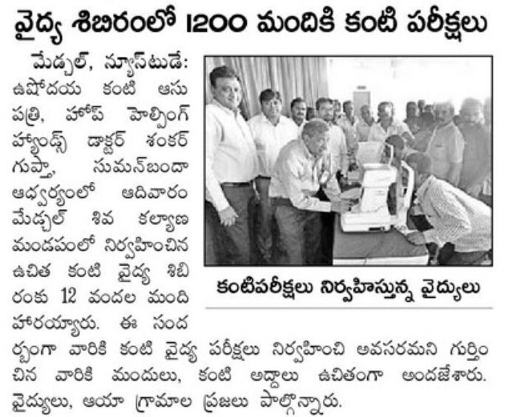 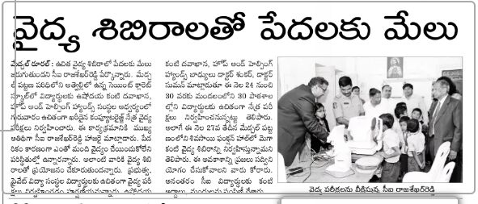 **free Eye Camp for Villagers with the support of MS.Agarwal Company. Screened 450 villagers & company staff, provided 270 free glasses & 82 free cataract surgeries.**

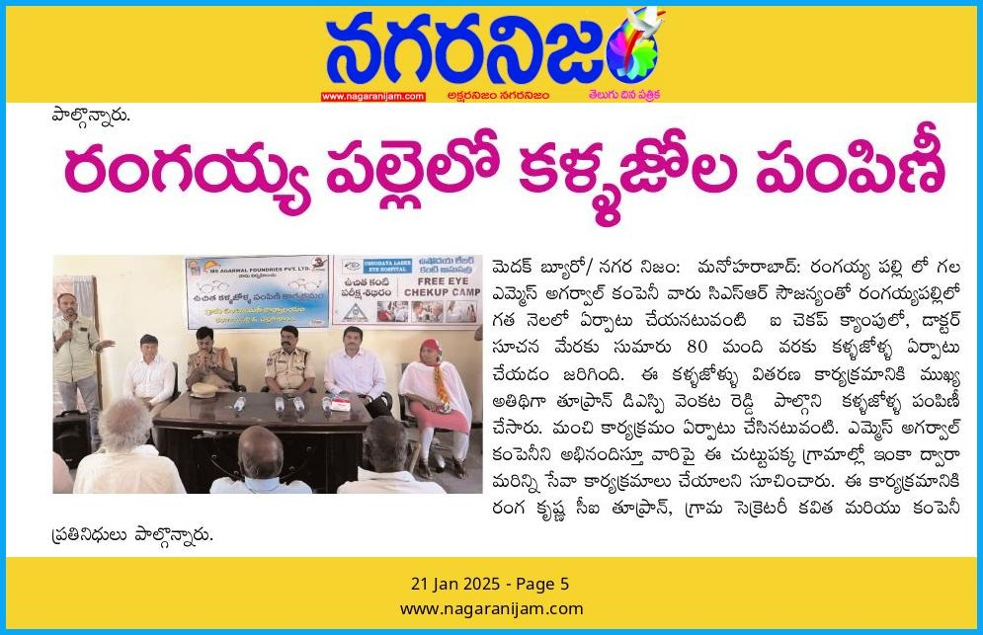

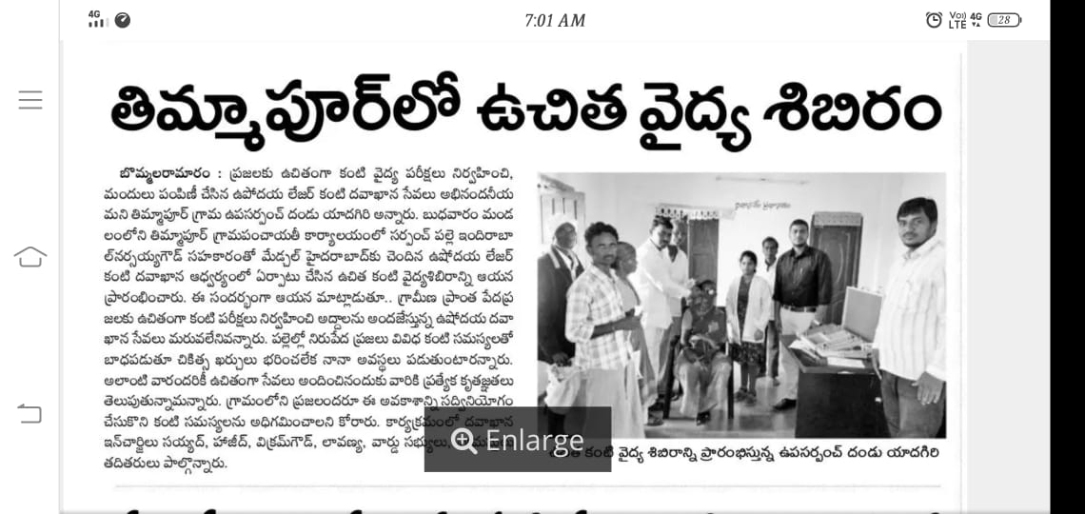

**free Eye Camp for Villagers with the support of Sarpanch Screened 450 villagers, provided 207 free glasses & 21 free cataract surgeries.**

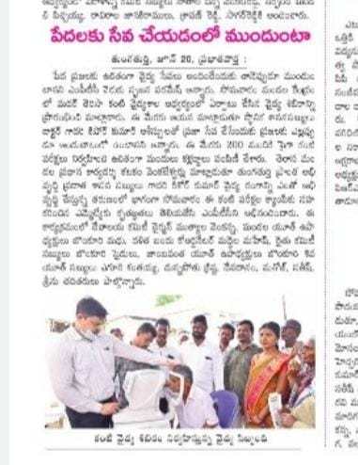

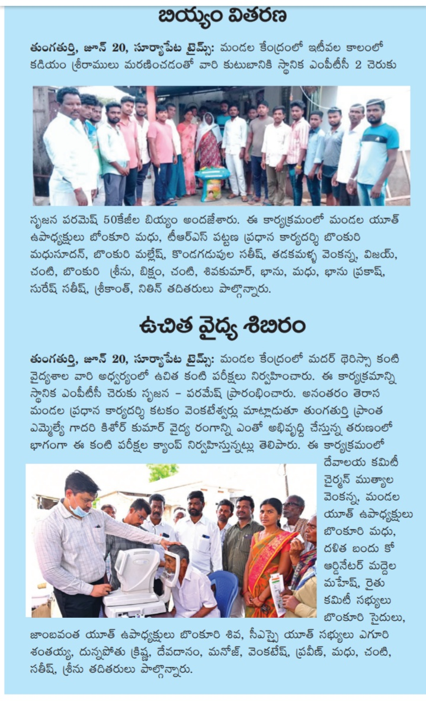

**free Eye Camp for Villagers with the support of Hope & helping hands Screened 1200 villagers**

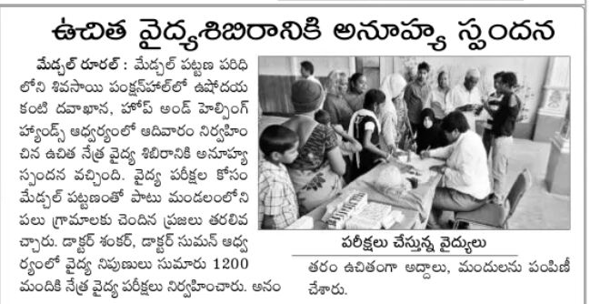

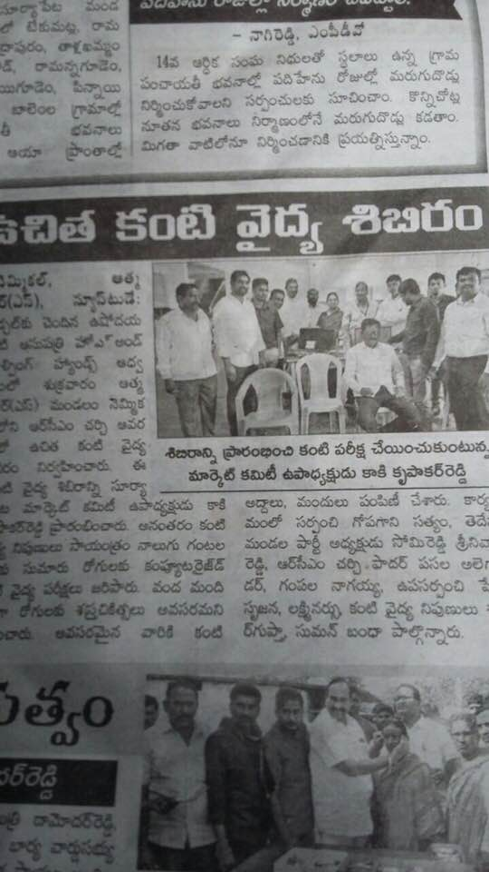

**free Eye Camp for Villagers with the support of Hope & helping hands Screened 522 villagers & School children free glasses 109 & free medicines. 200 school bags given.**

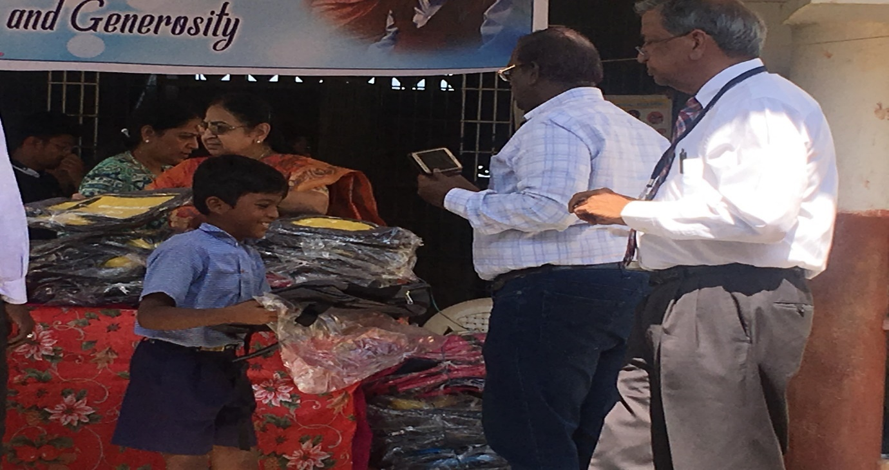 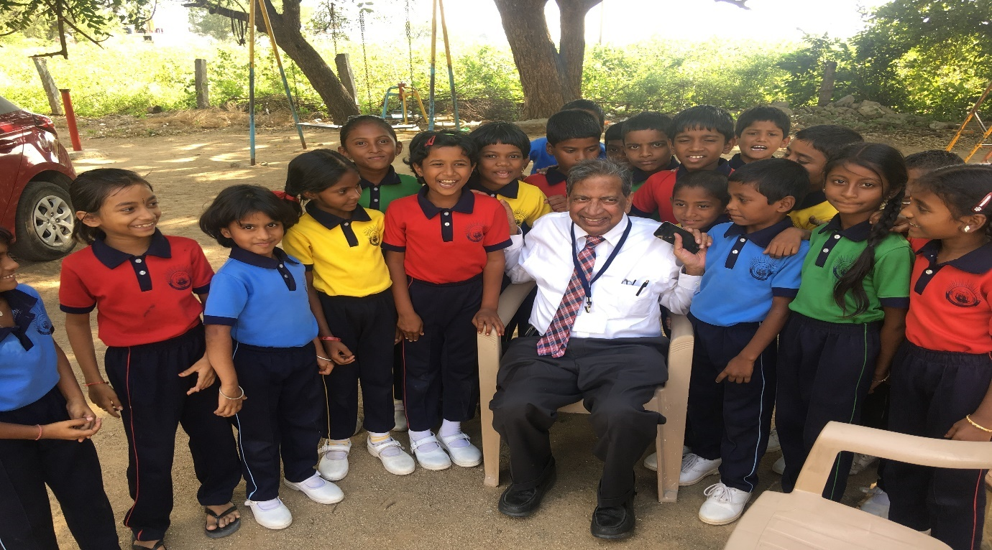

**Inviting Minister Mallareddy Sir for the Mega Health Camp & Distribution of glasses**

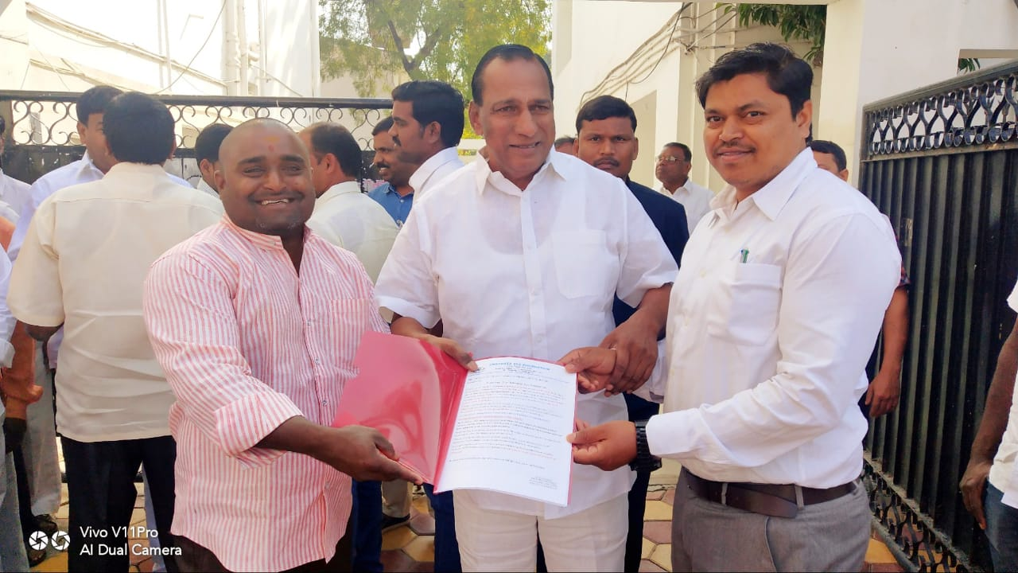

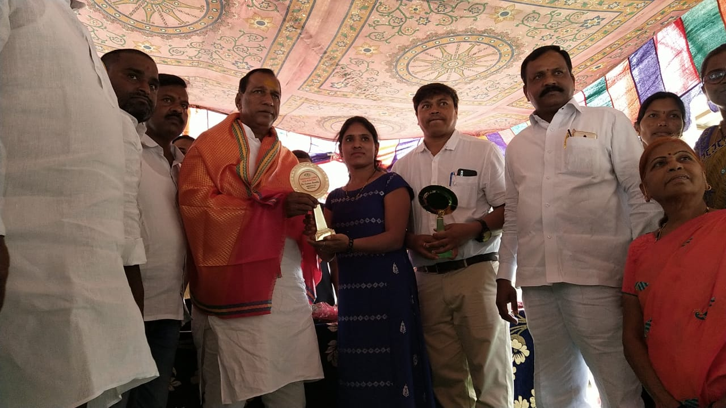

**Receiving appreciation from Medchal CI Raja Shekar Reddy & ST.Claret School Management**

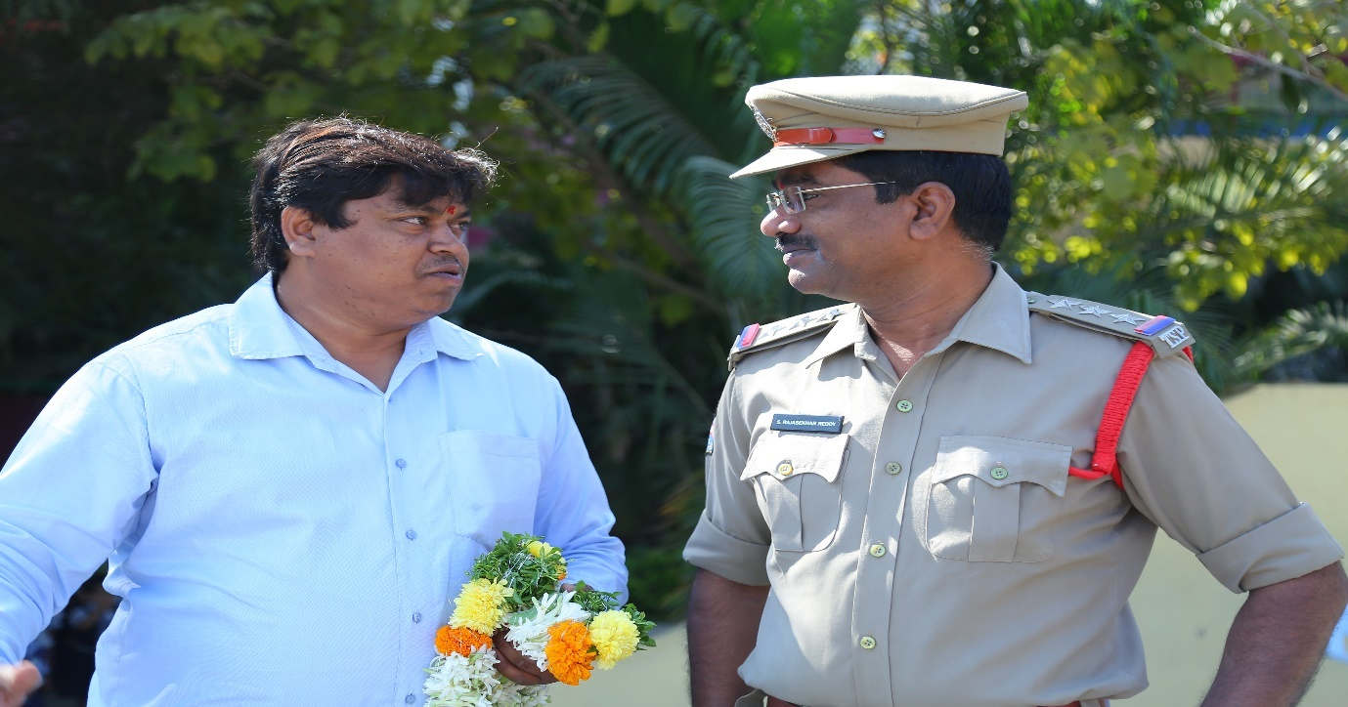

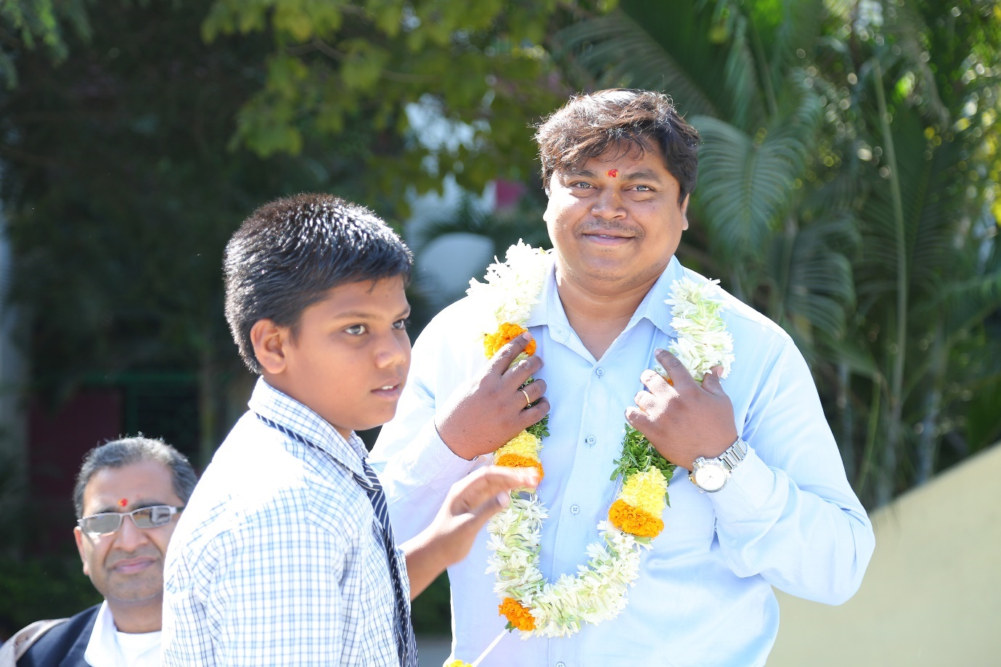

**FREE EYE CAMP & FREE GLASSES PROGRAMME2019, CHIEF GUESTS MLA.MALLAREDDY SIR, DCP. PADMAJA REDDY MADAM.PROVIDED 350 FREE GLASSES** 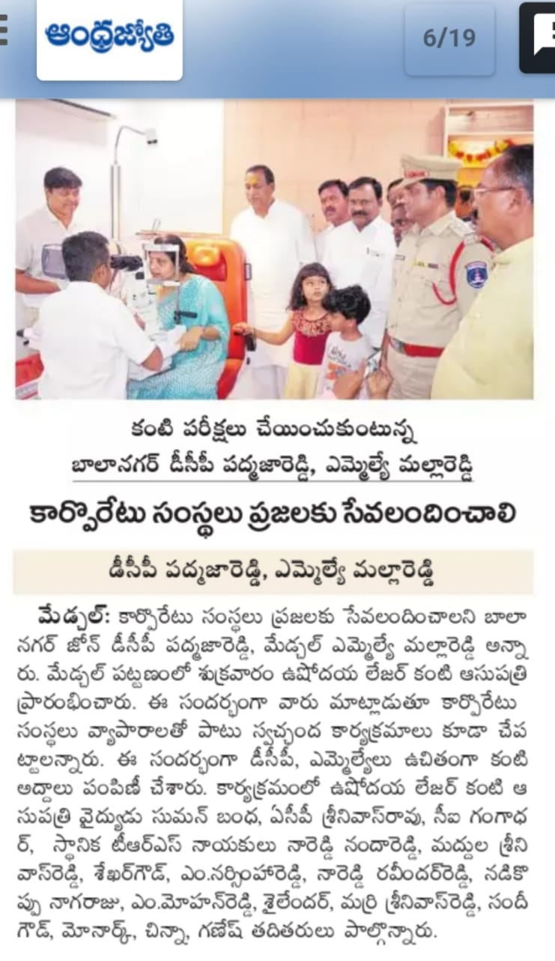

**Awareness on Eye care and digital screens for Cyber Age School Medchal**

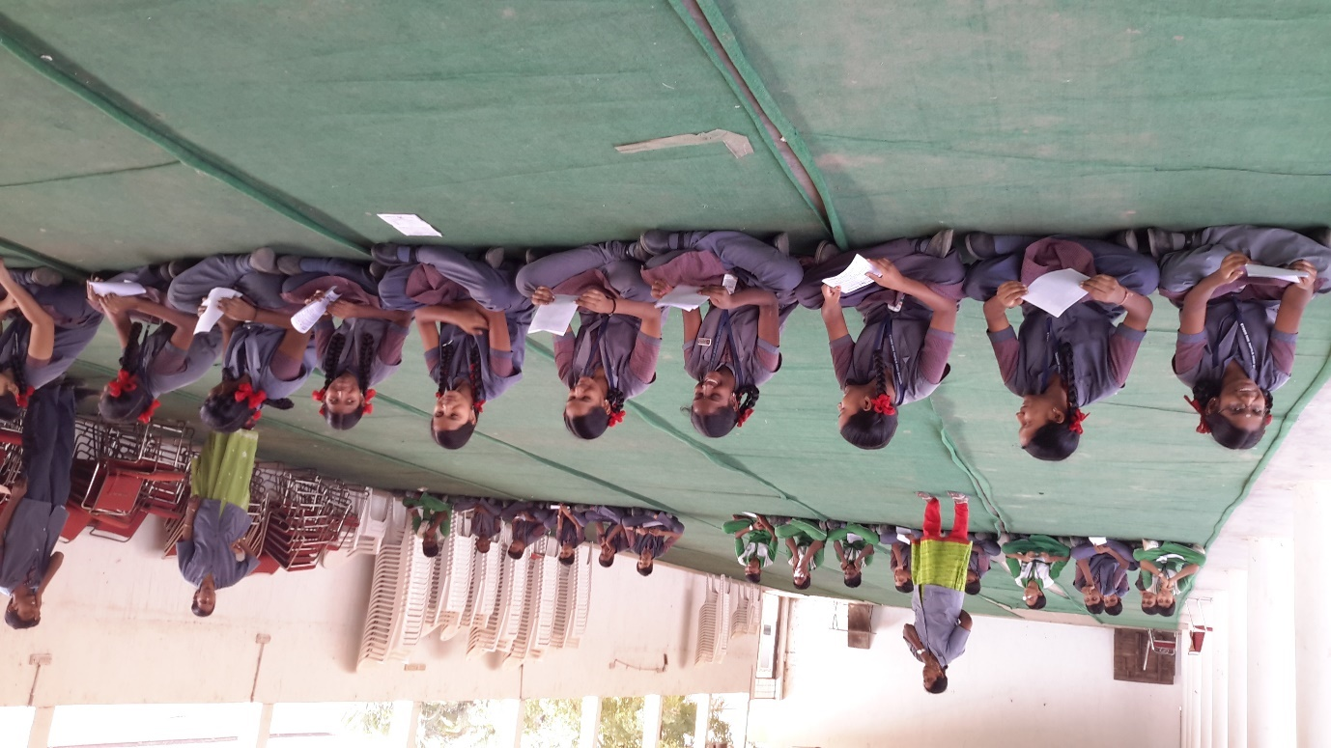

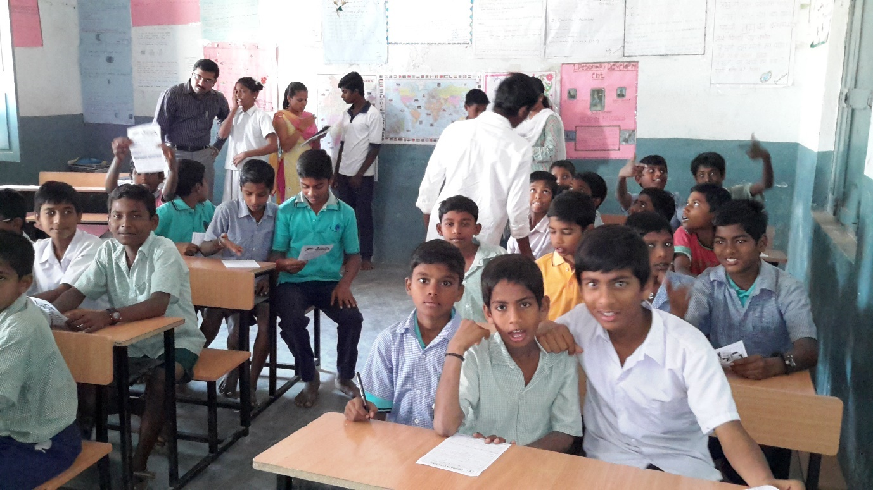

**Awareness on Eye care and digital screens for Govt Primar School**

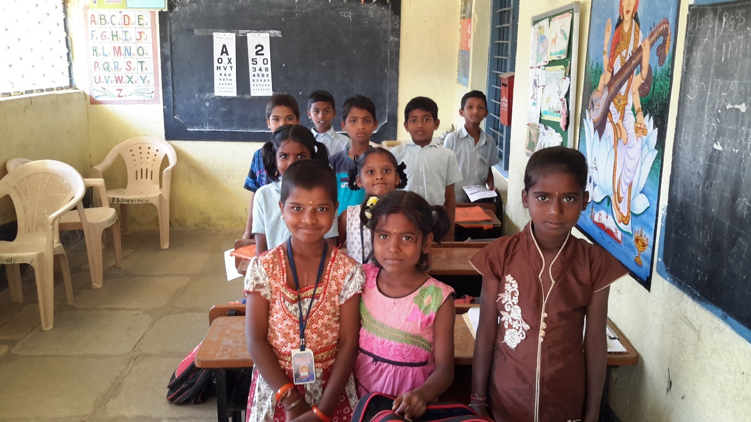

**Awareness on conjunctivitis for Govt School Medchal**

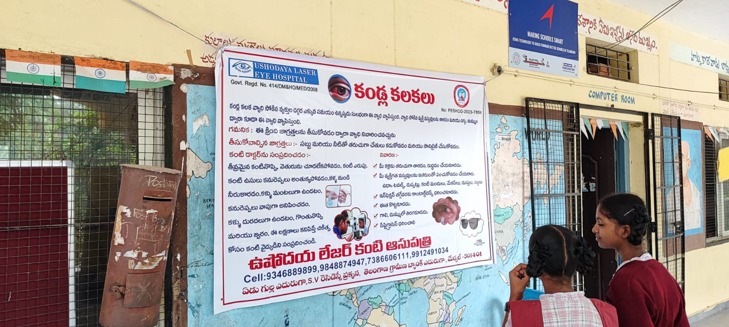

**Awareness on Eye care and digital screens for ST.Claret High School Medchal**

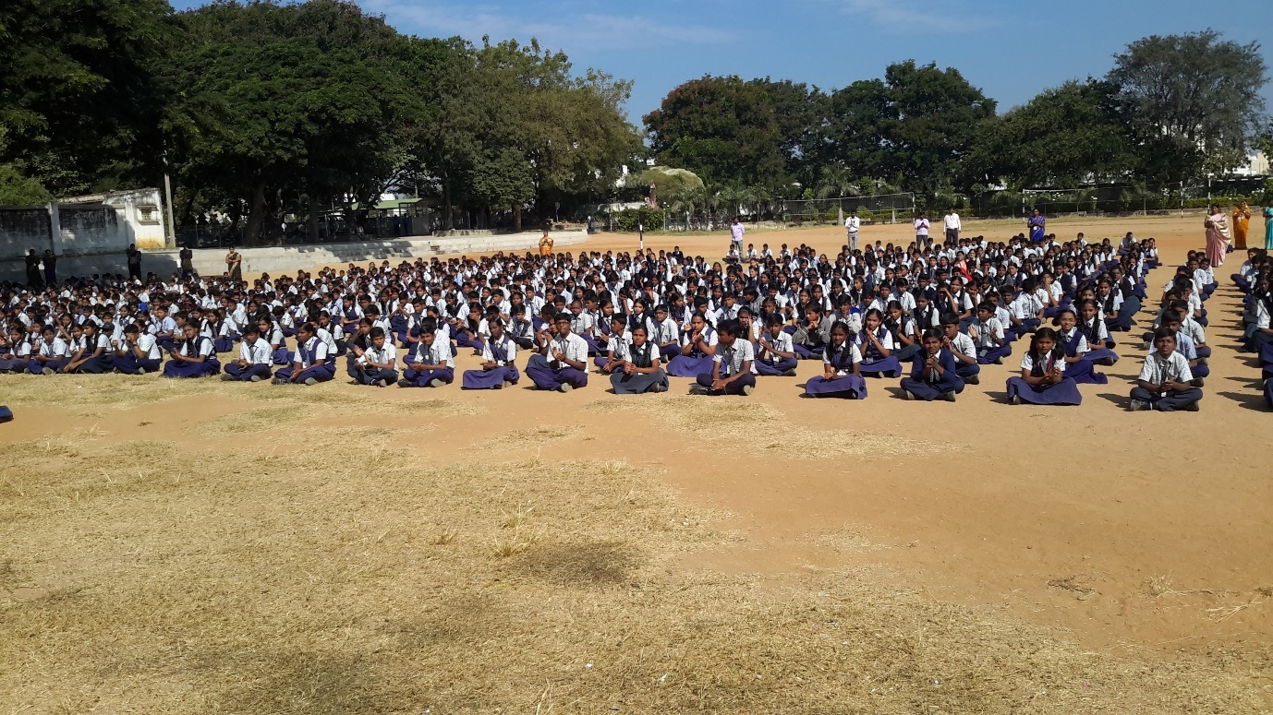

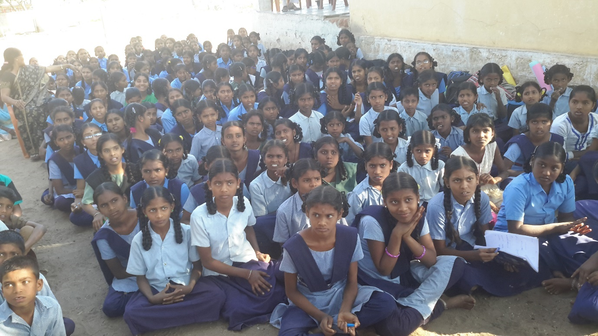

**Awareness on Eye care and digital screens for Govt High School**

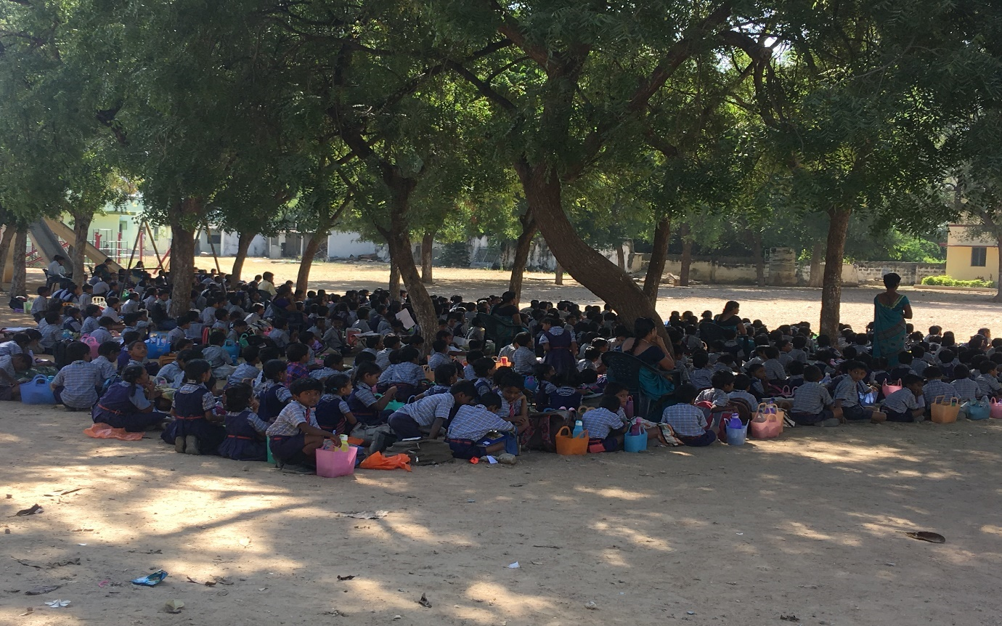

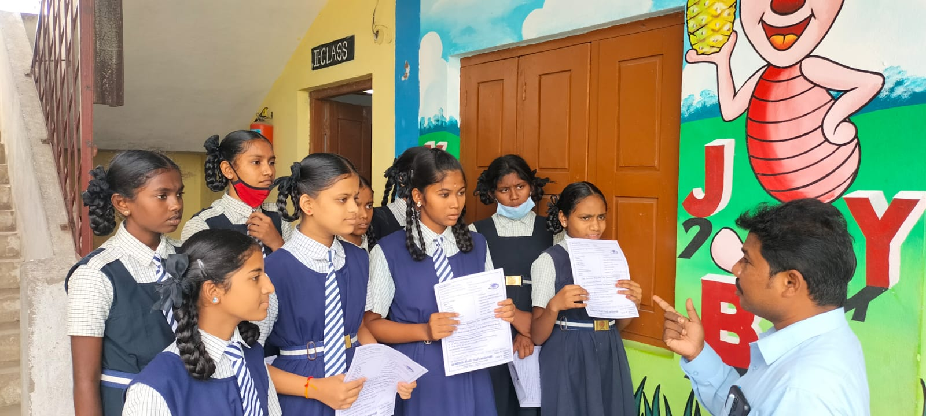

**Awareness on Eye care and digital screens for Govt High School Medchal District**

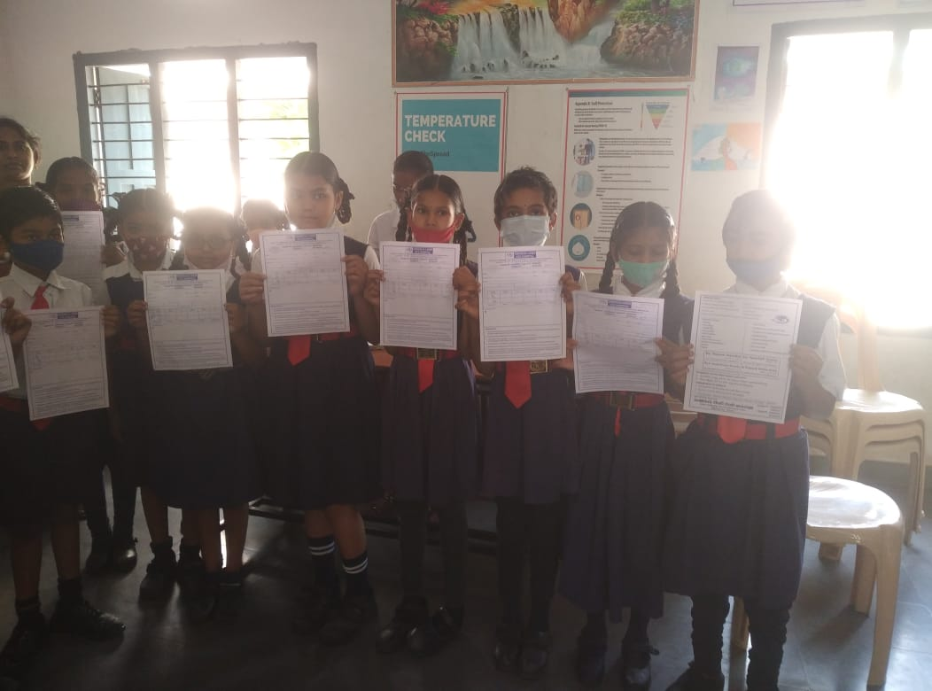

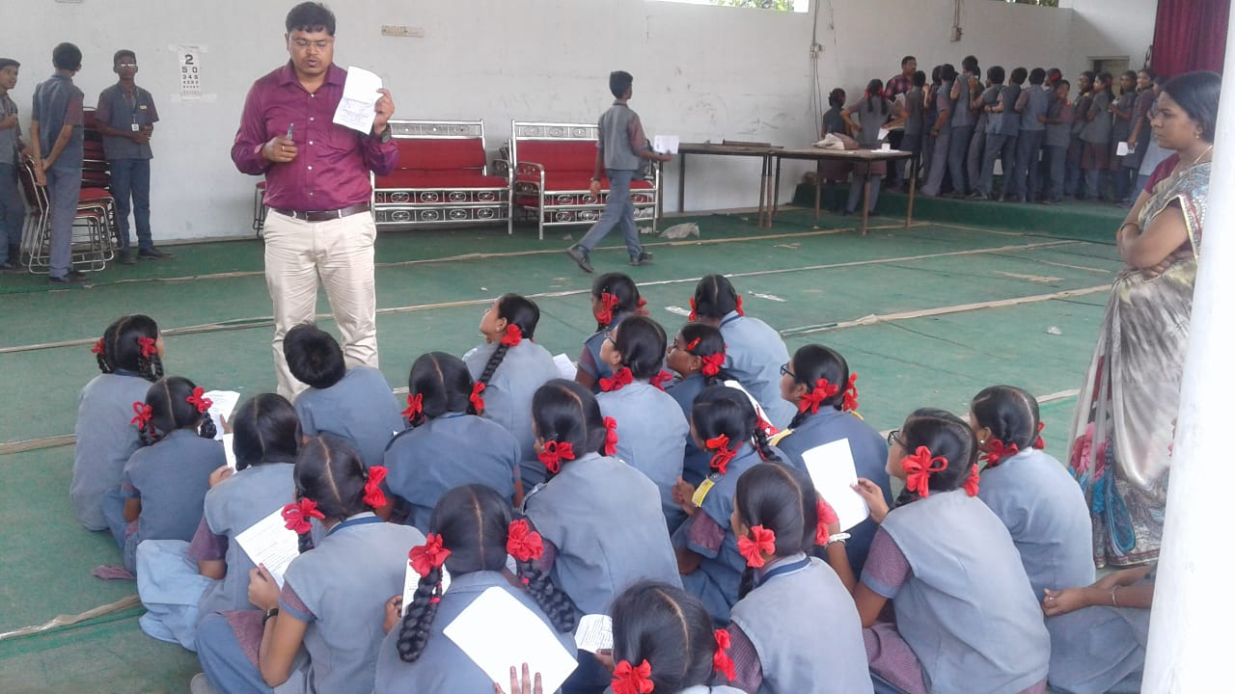

**Free Eye Camp**

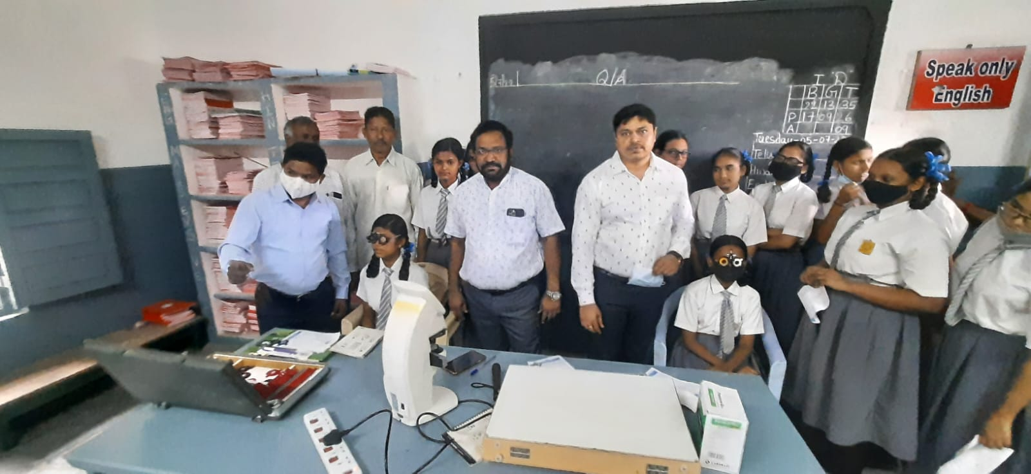

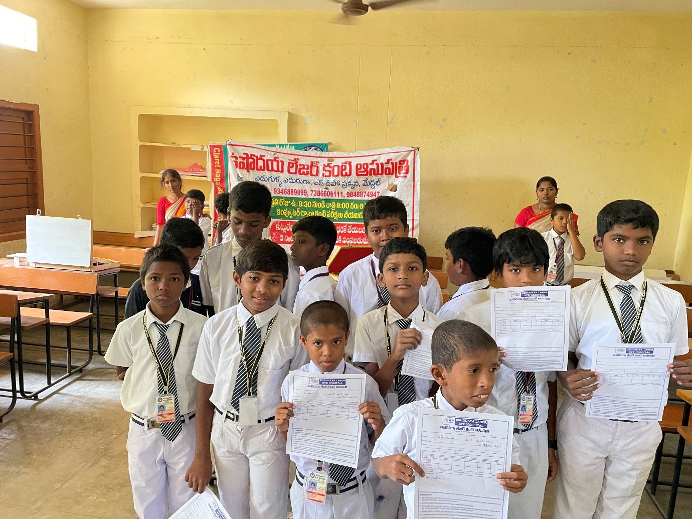

**Awareness on Eye care and digital screens for Govt High School Medchal District**

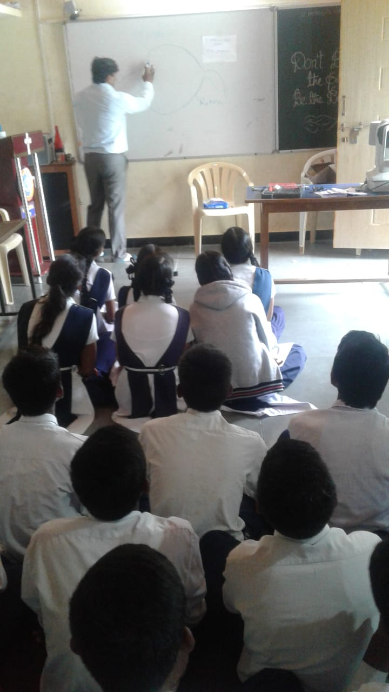 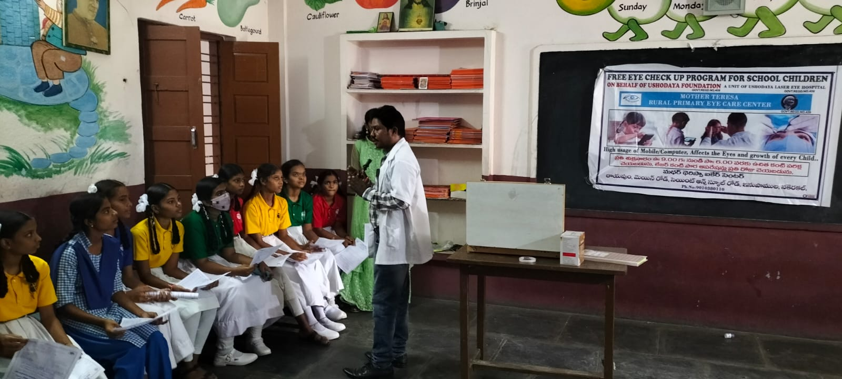

**Awareness on Eye care and digital screens for Govt High School Medchal District**

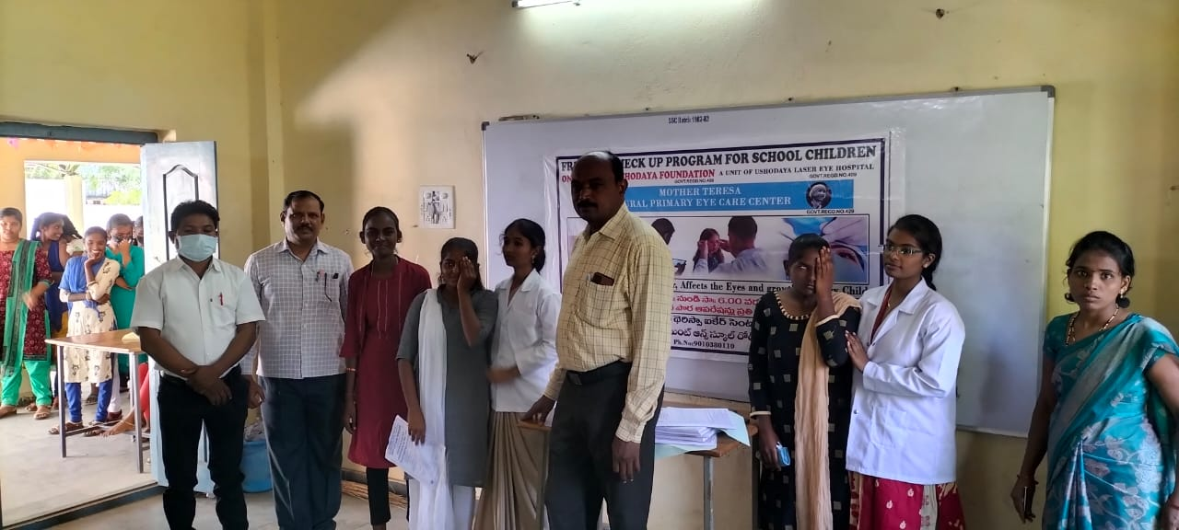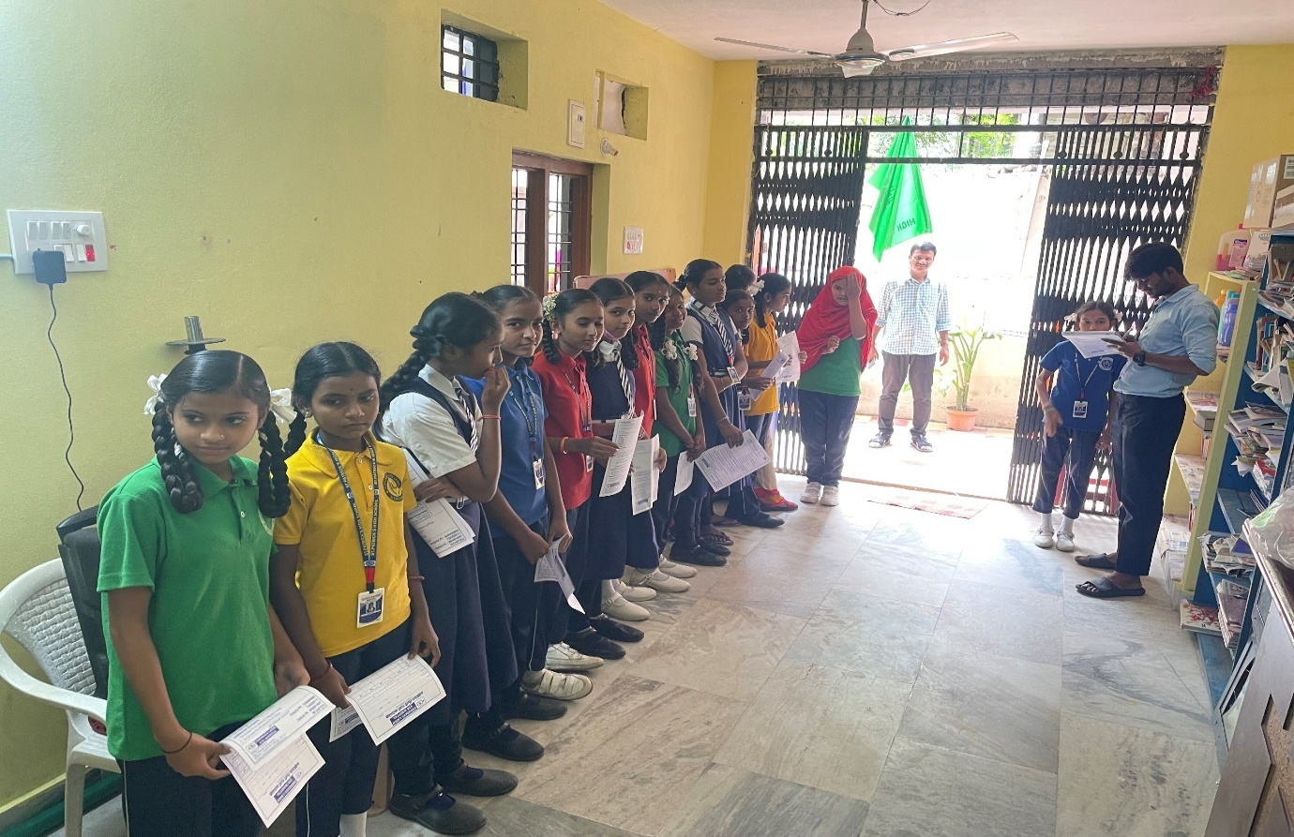

**Awareness on Eye Care Tips to School Teachers**

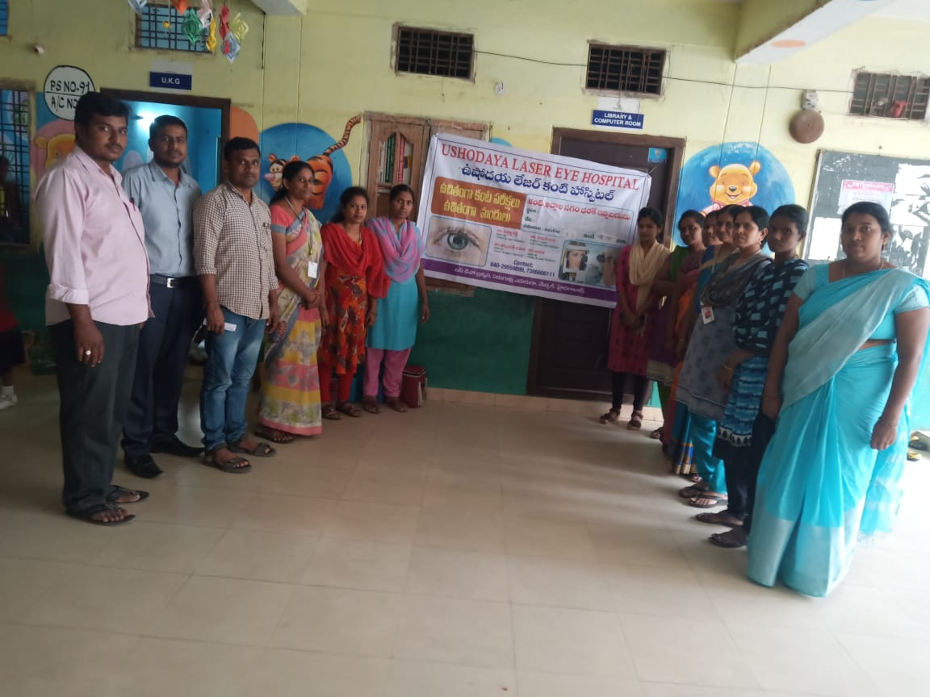 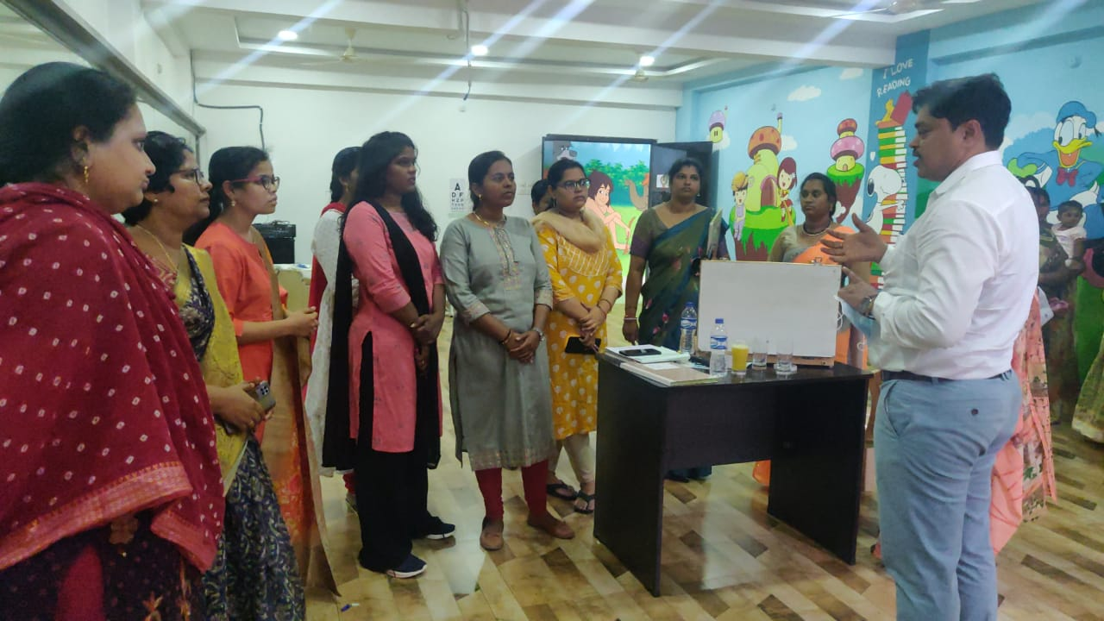

**Awareness on Eye care and digital screens for School children Medchal District**

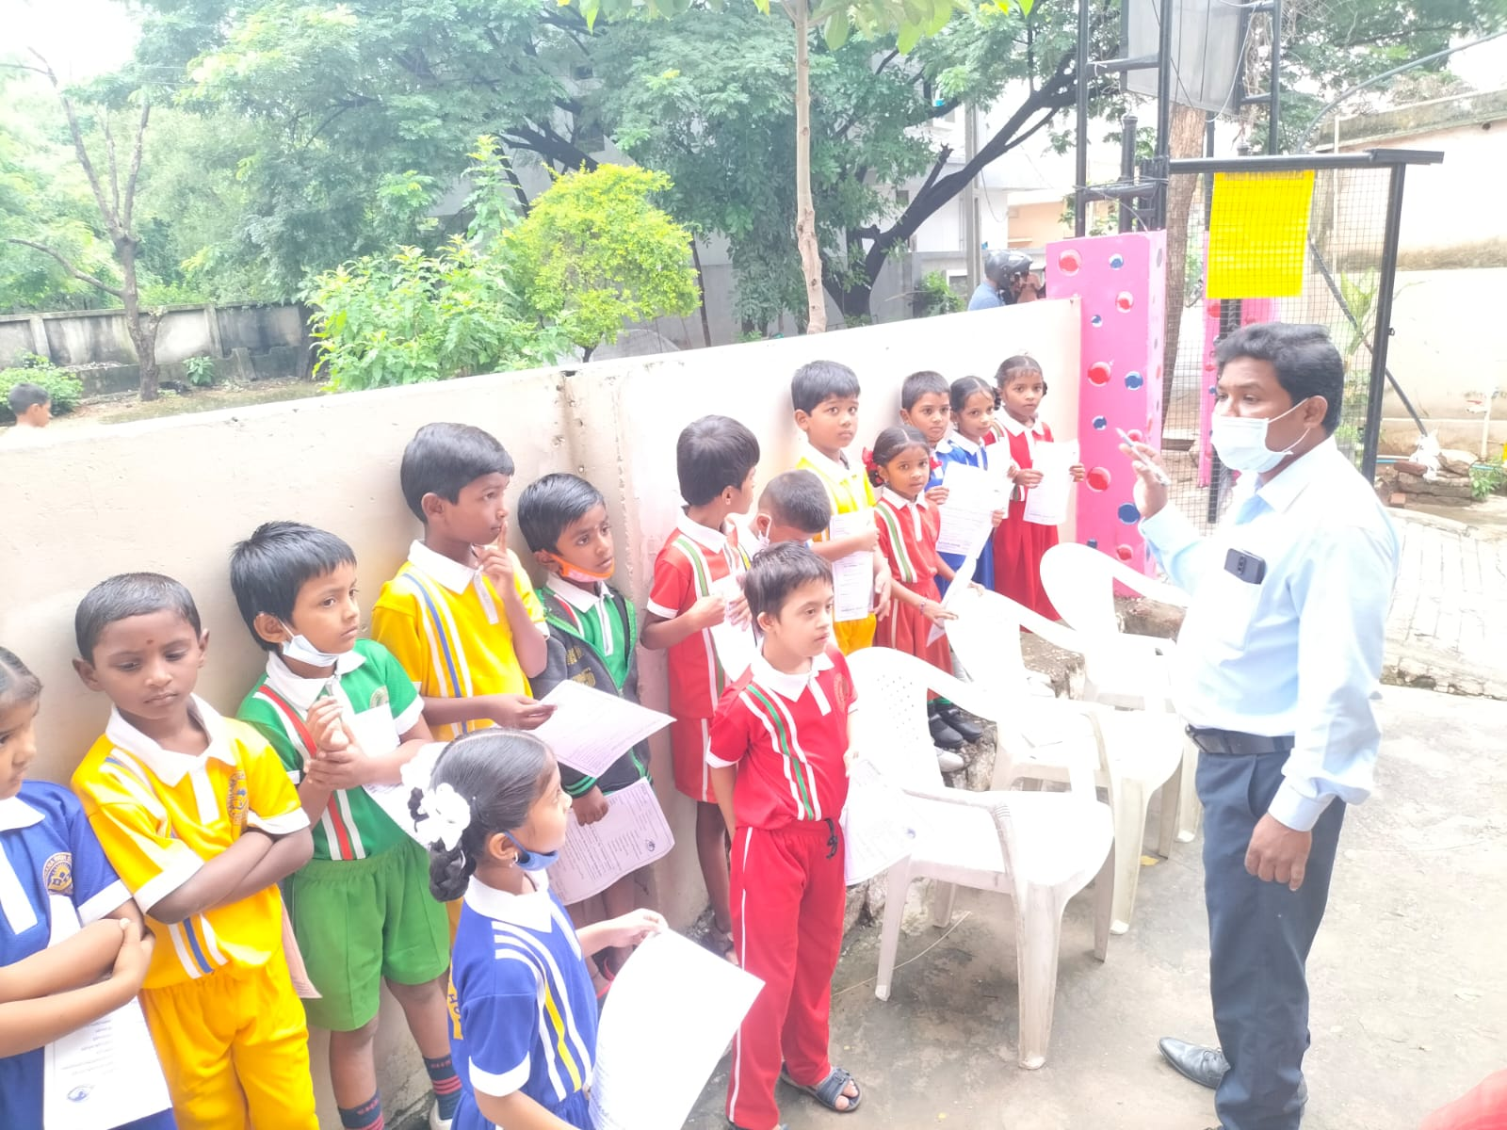

**Awareness on Eye Care Tips to School Teachers** 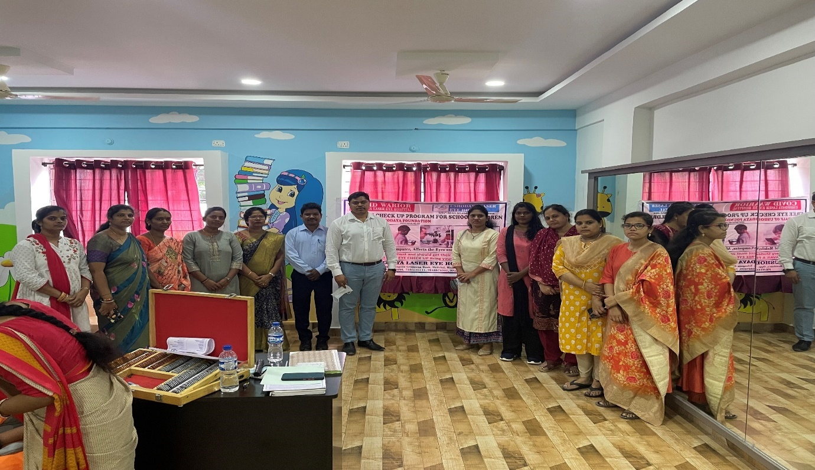

**Free Eye Camp & Free Medicines to Villagers in Medchal District**

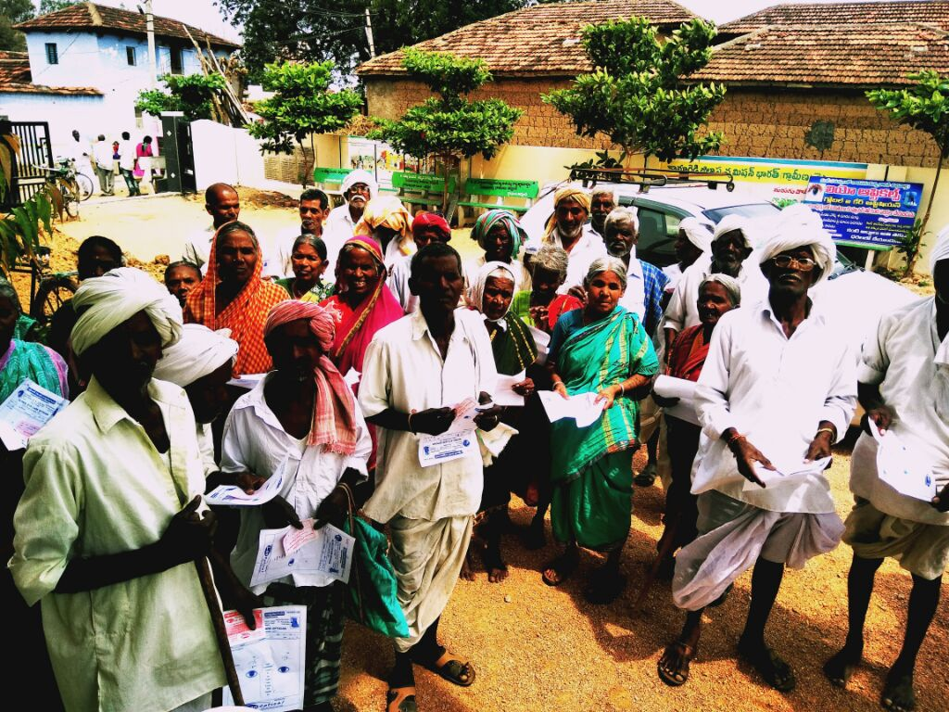 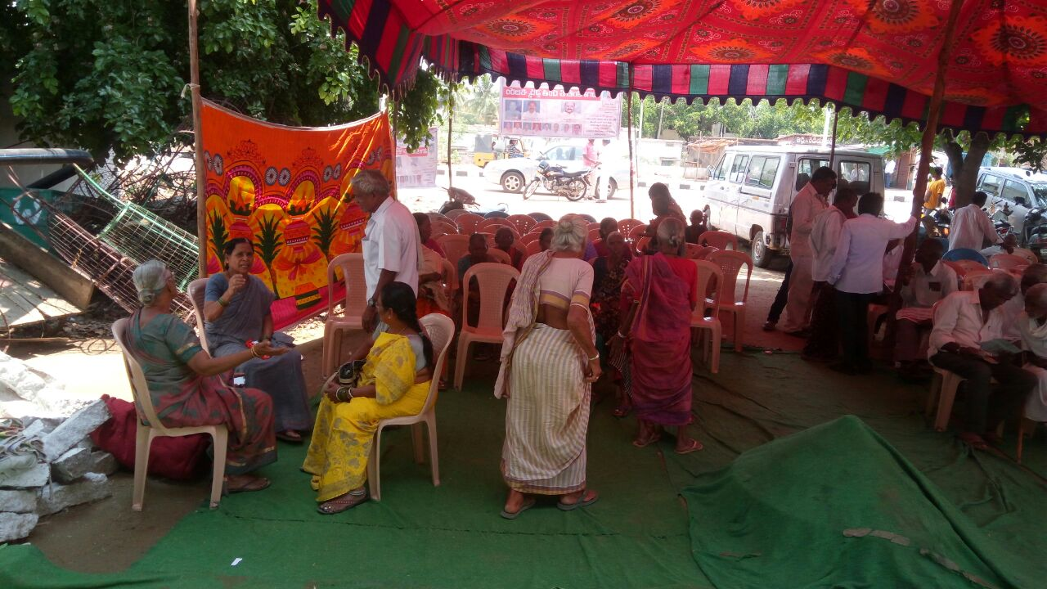

**Awareness on Eye care and digital screens for Govt High School Medchal District** 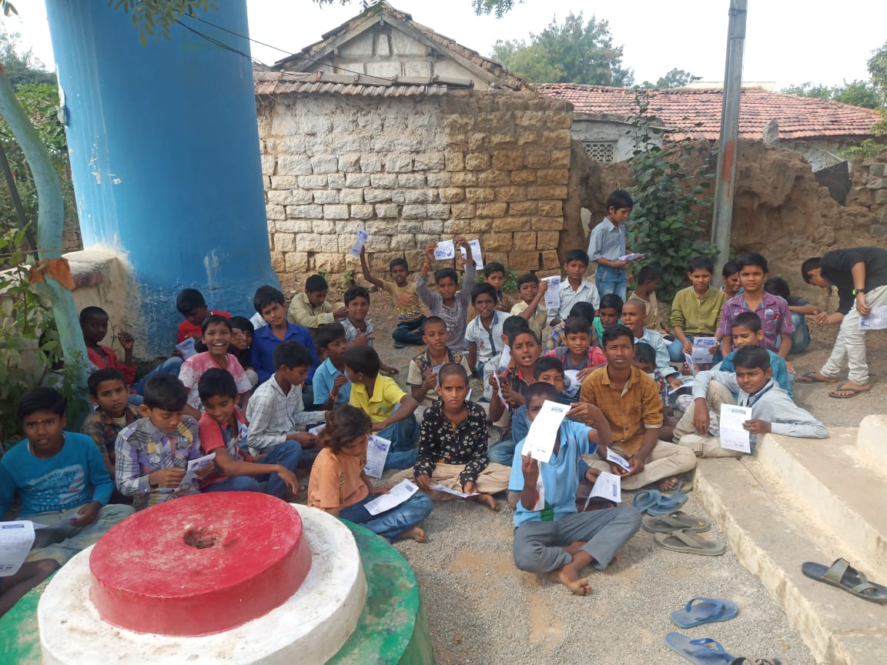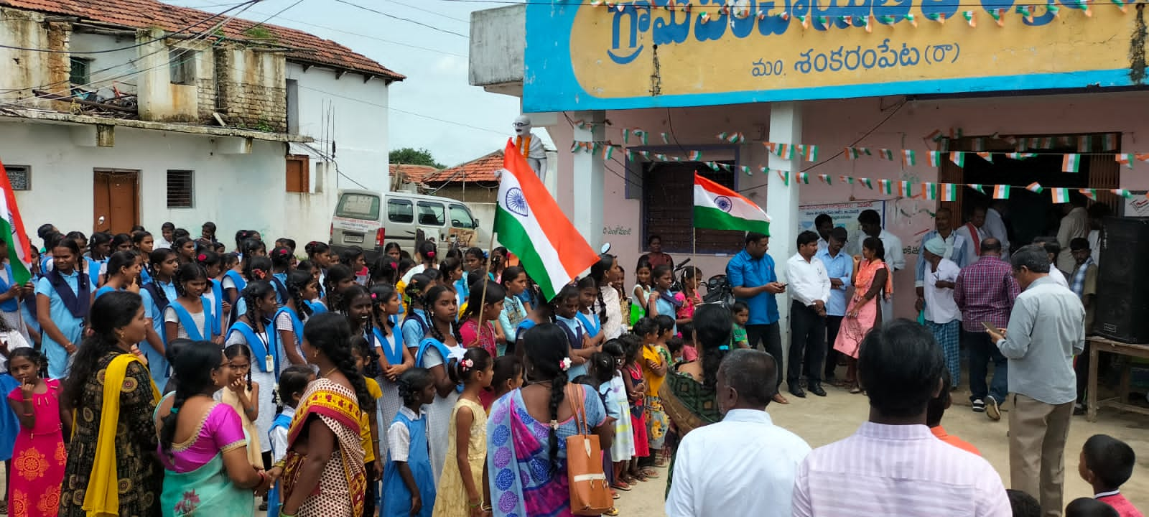

**APRECIATION FOR PROVIDING FREE EYE CARE SERVICES FROM ST. JOSEPH SCOOL MANAGEMENT**

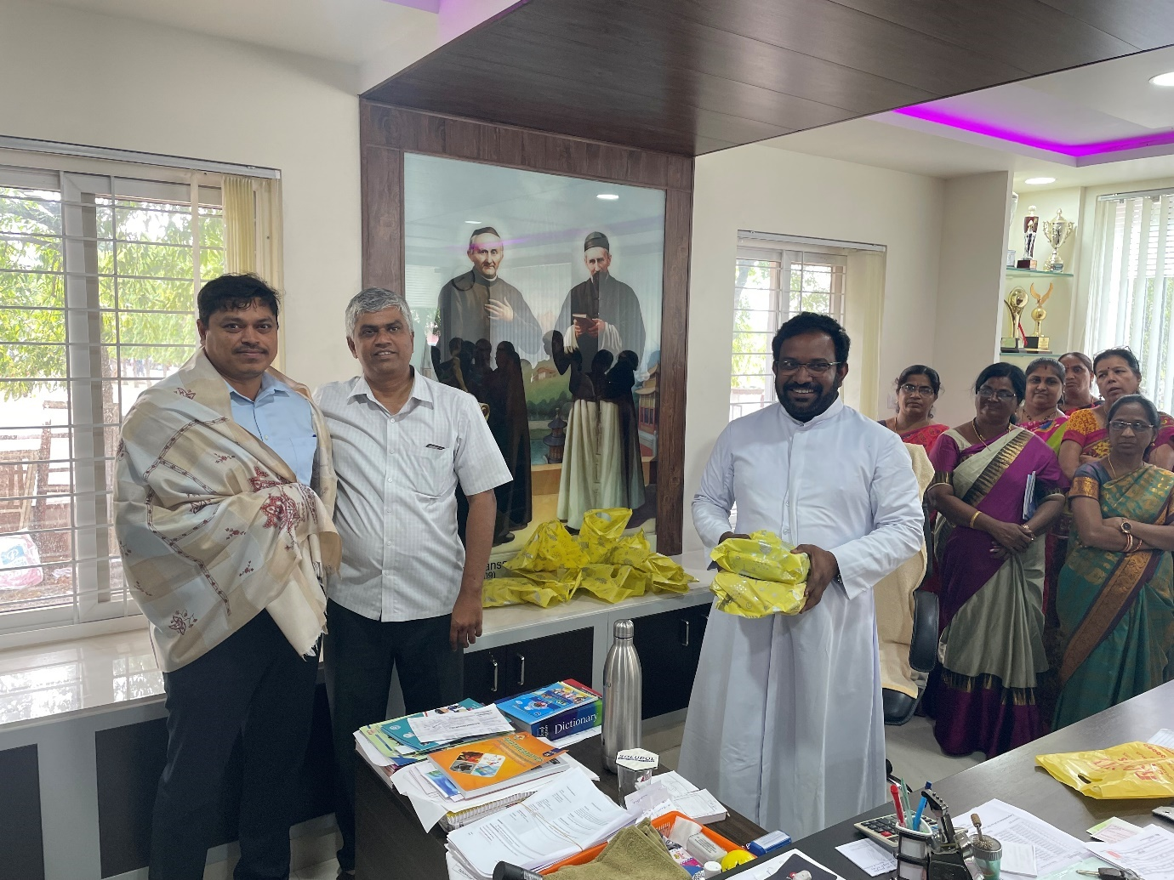

**COVID PANDAMIC SUPPORT. PROVIDED FREE GLASSES & MEDICINES** 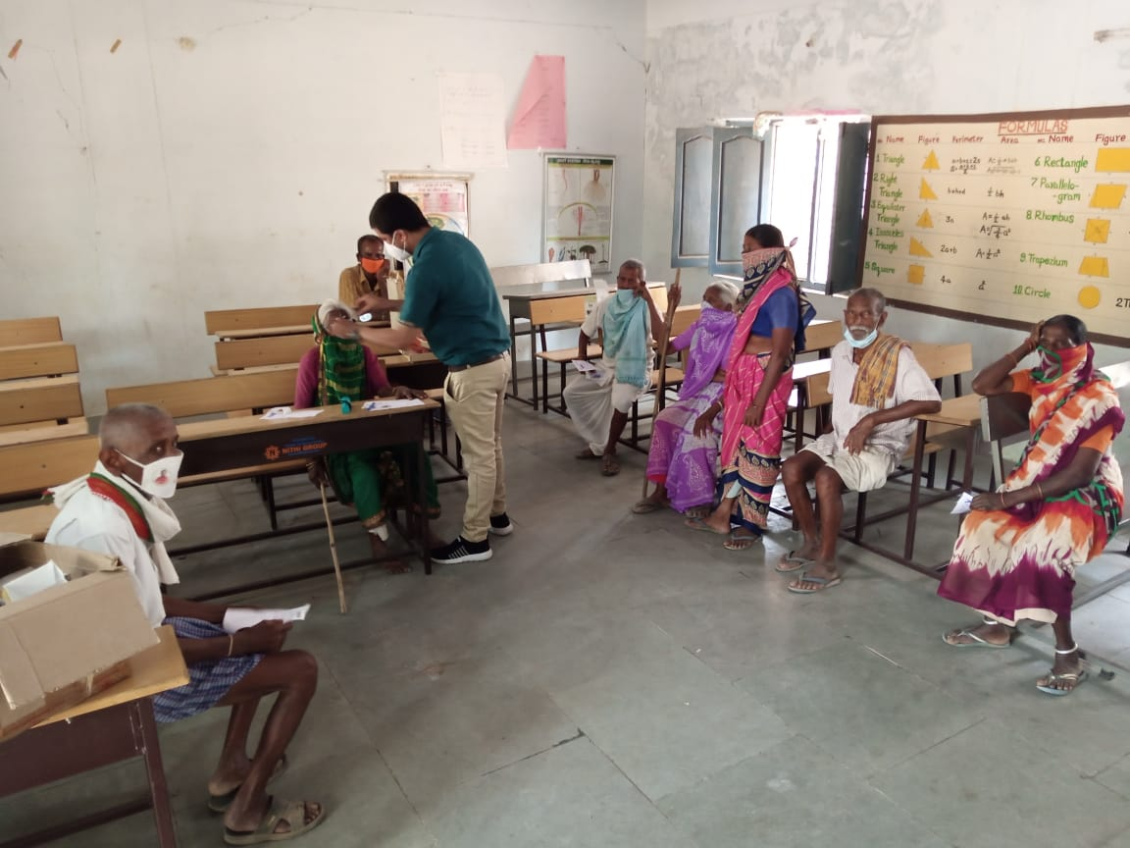

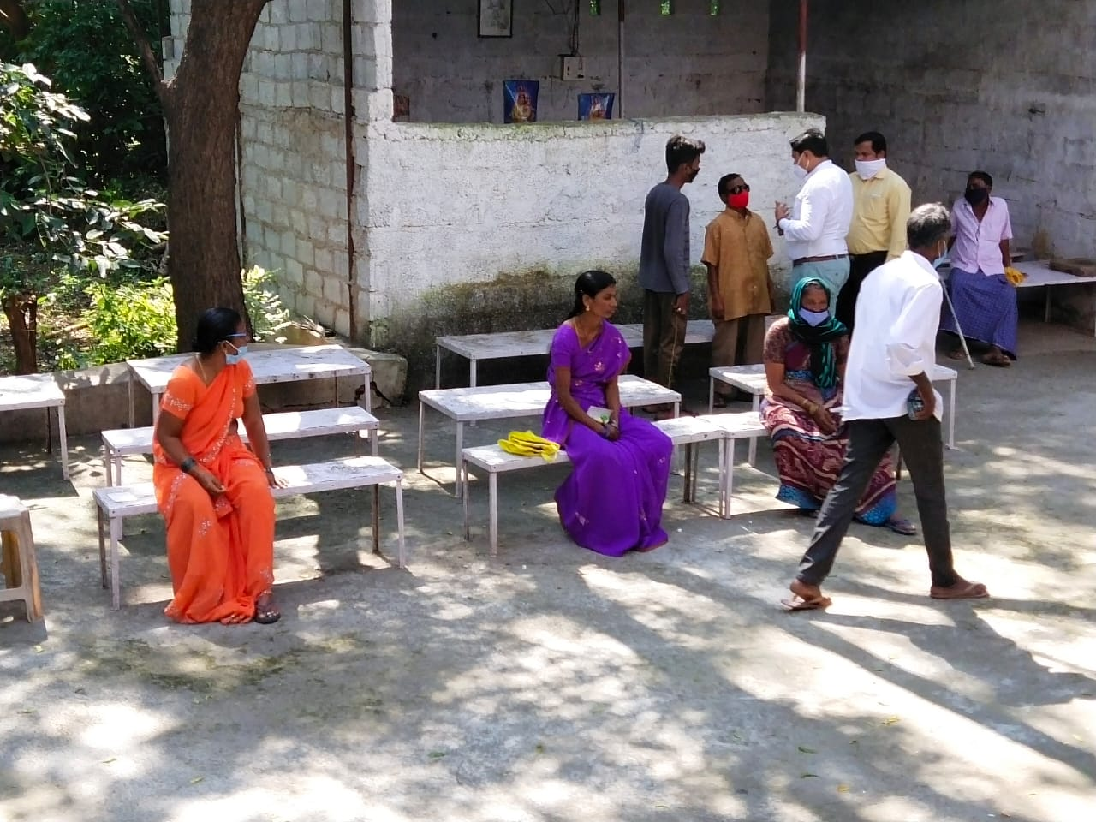

**FREE GLASSES DISTRIBUTION**

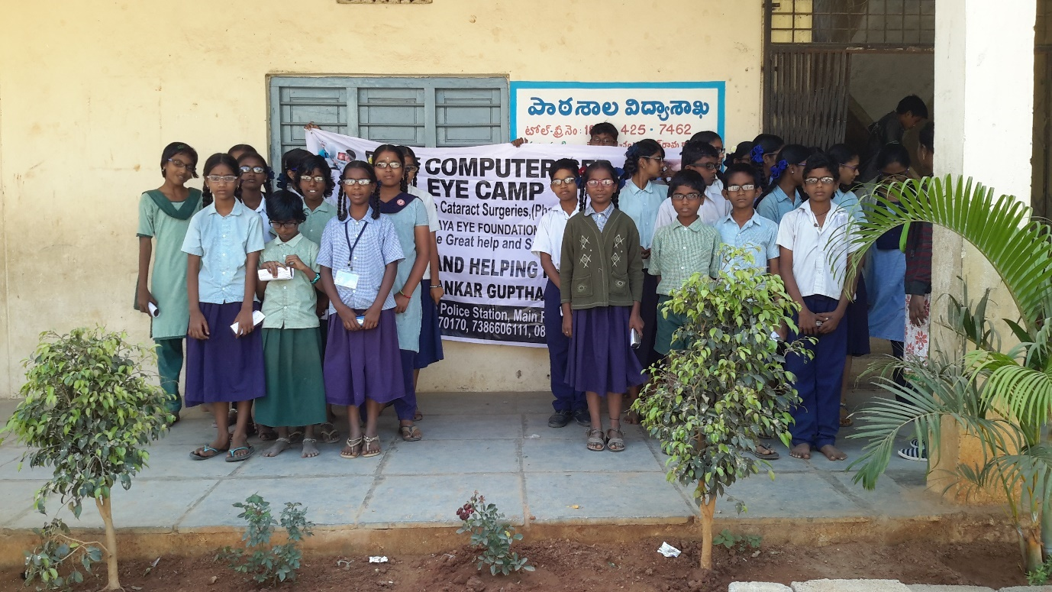 **FREE GLASSES DISTRIBUTION**

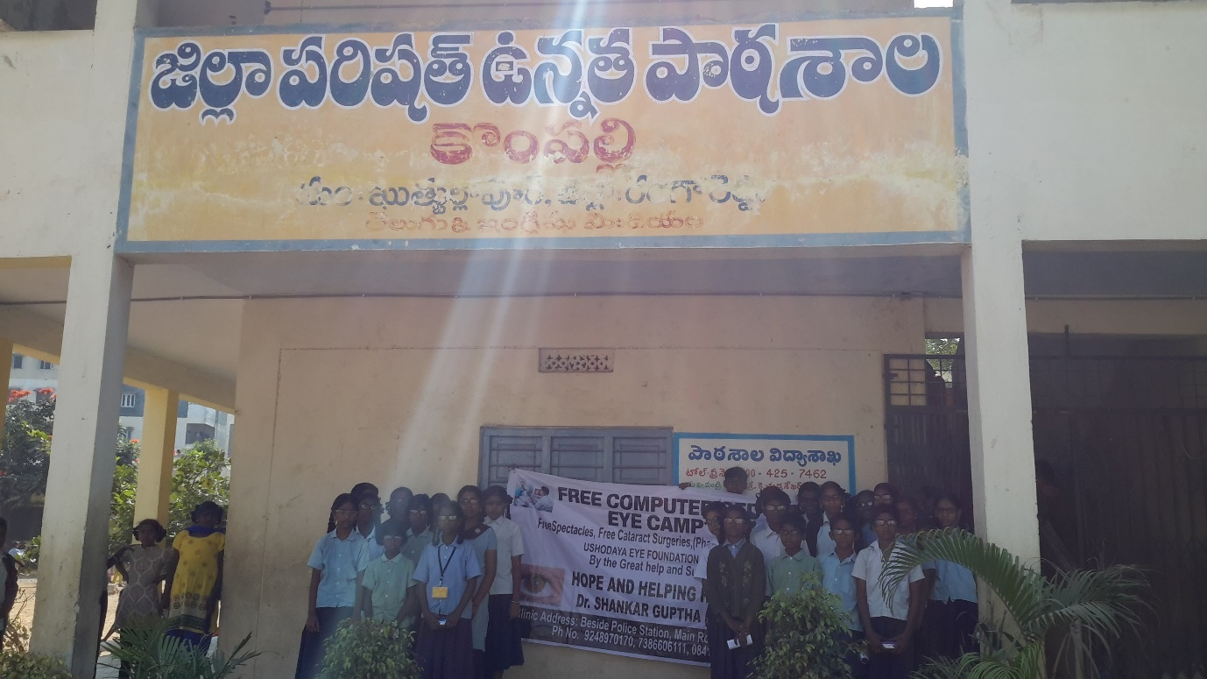

**FREE GLASSES DISTRIBUTION**

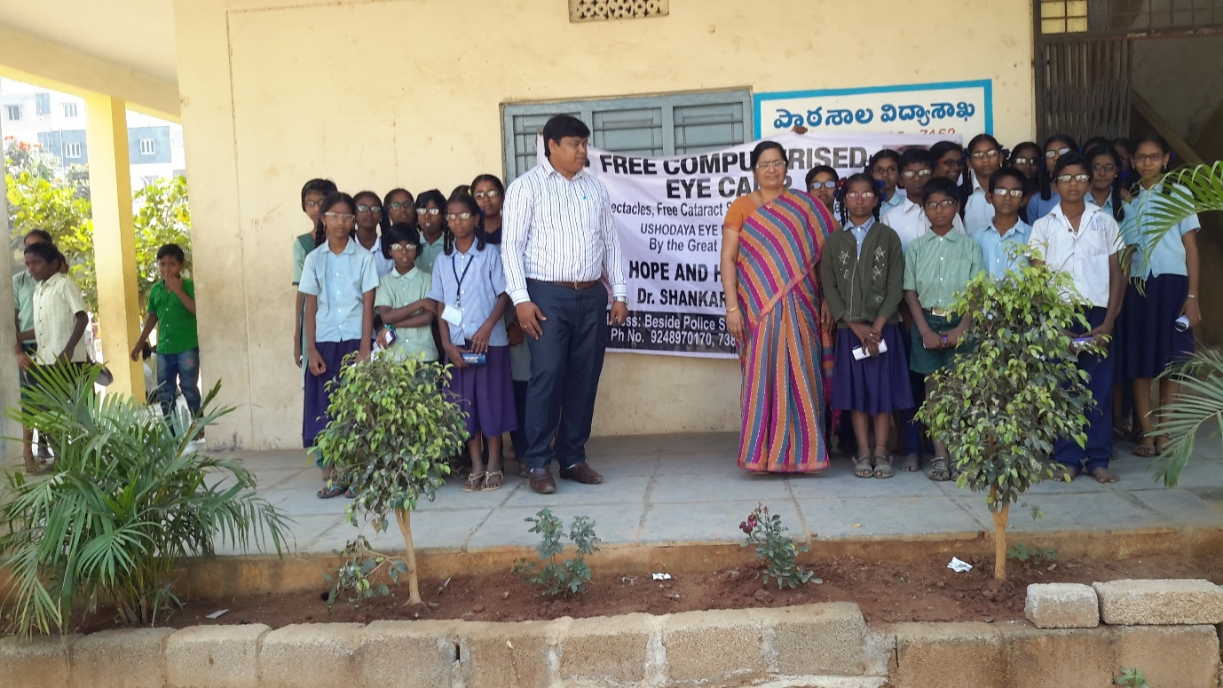 **FREE GLASSES DISTRIBUTION**

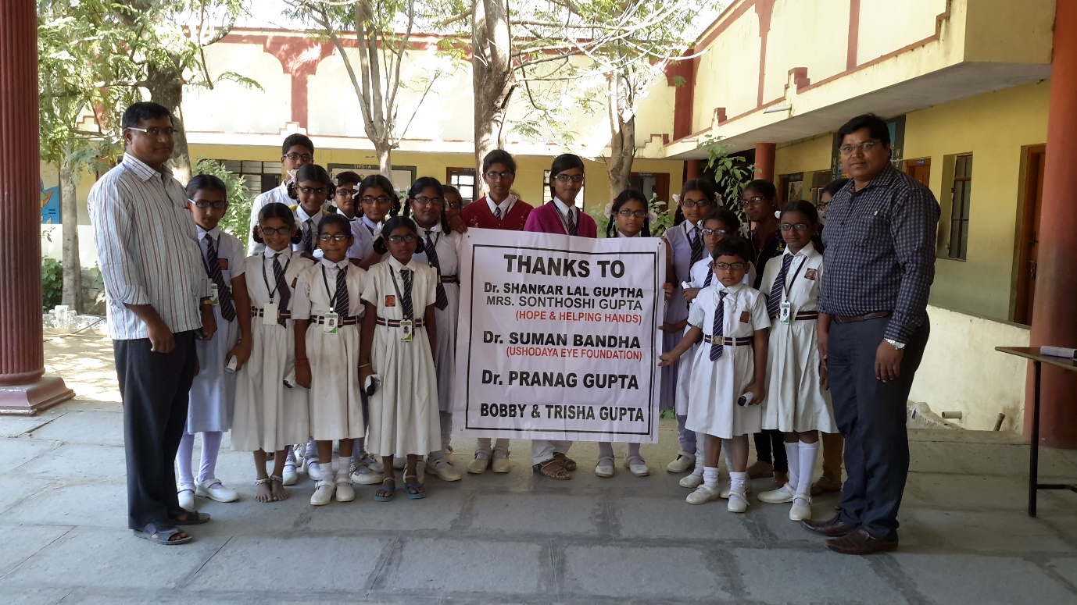

**Free Glasses Distribution for Govt School. Medchal District by Ushodaya Foundation & Hope & Helping Hands**

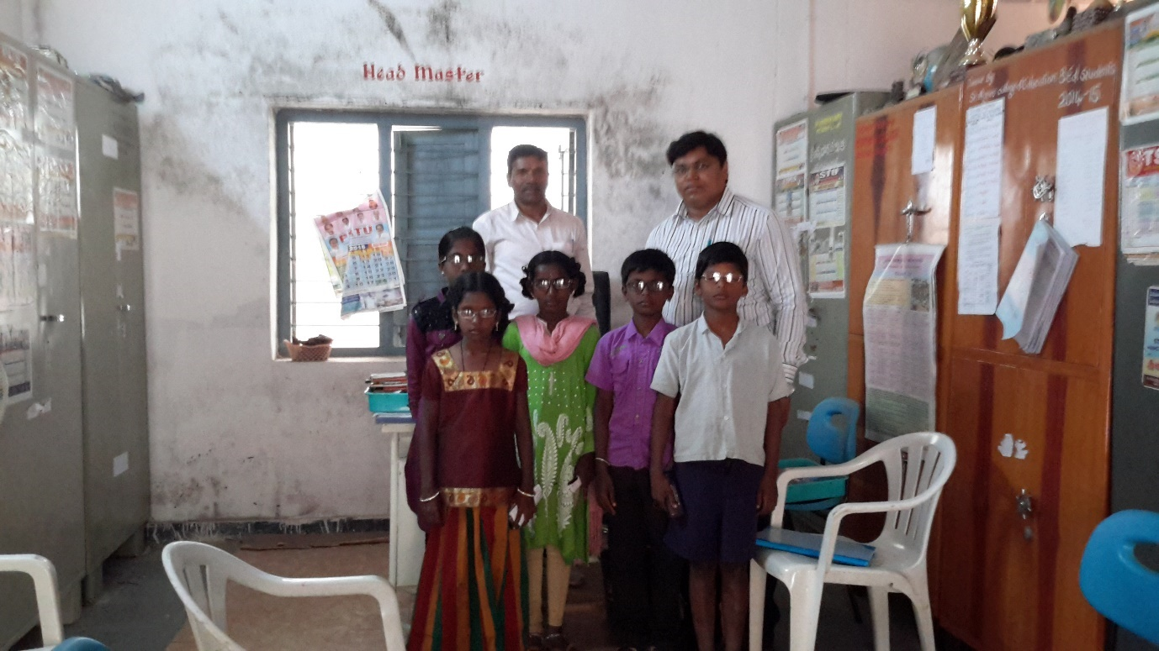 **Free Glasses Distribution for Govt School. Medchal District by Ushodaya Foundation & Hope & Helping Hands** 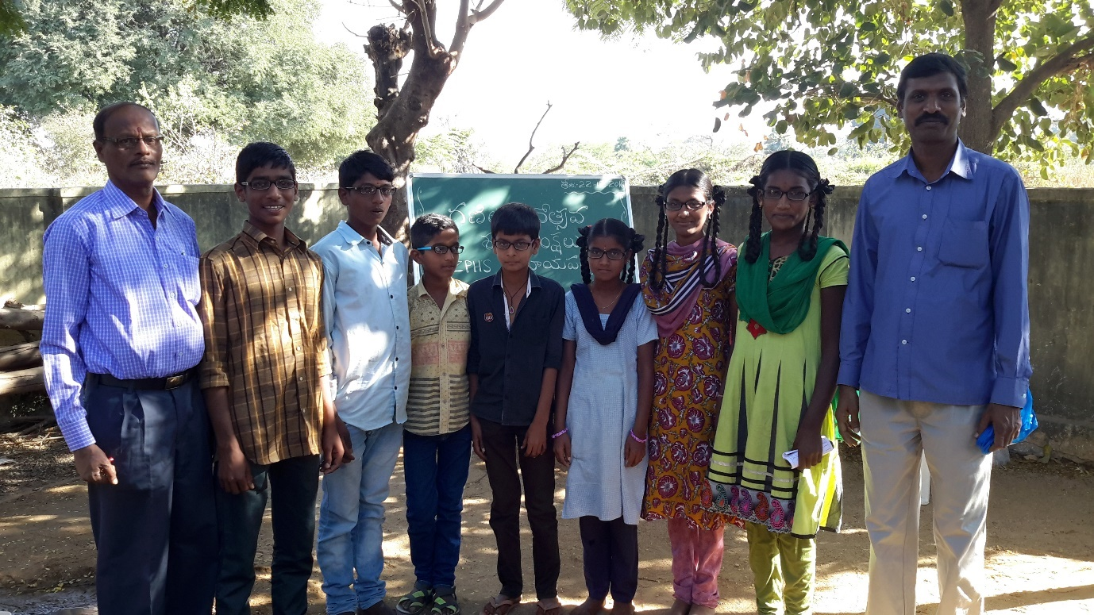

**Free Glasses Distribution for Govt School. Medchal District by Ushodaya Foundation & Hope & Helping Hands**

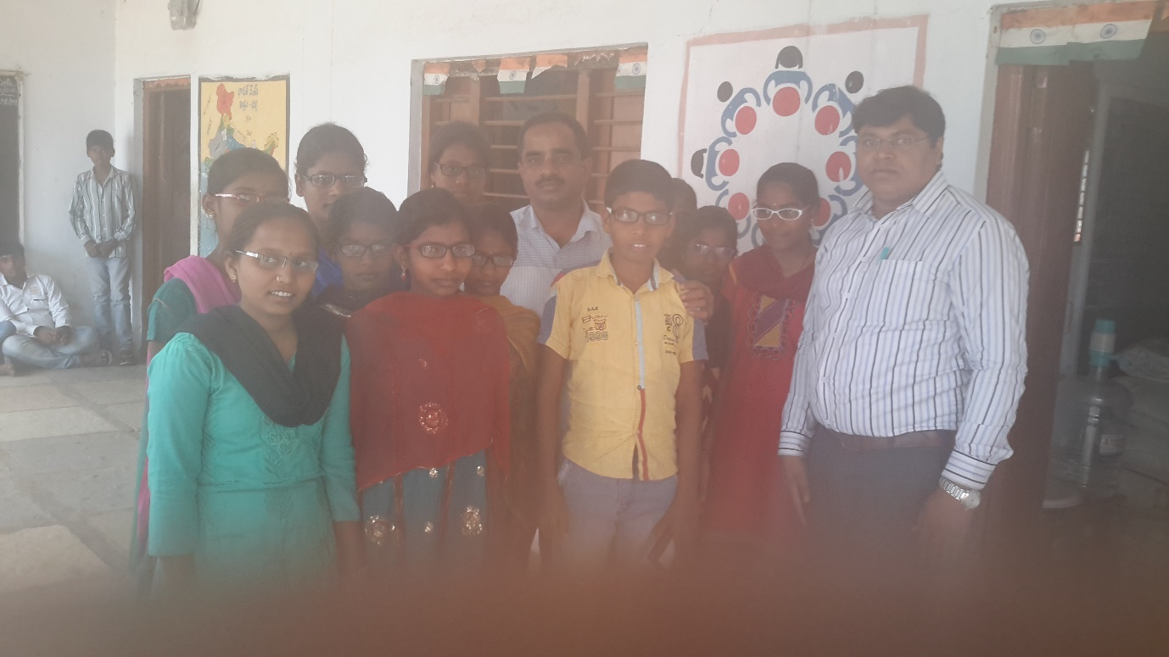 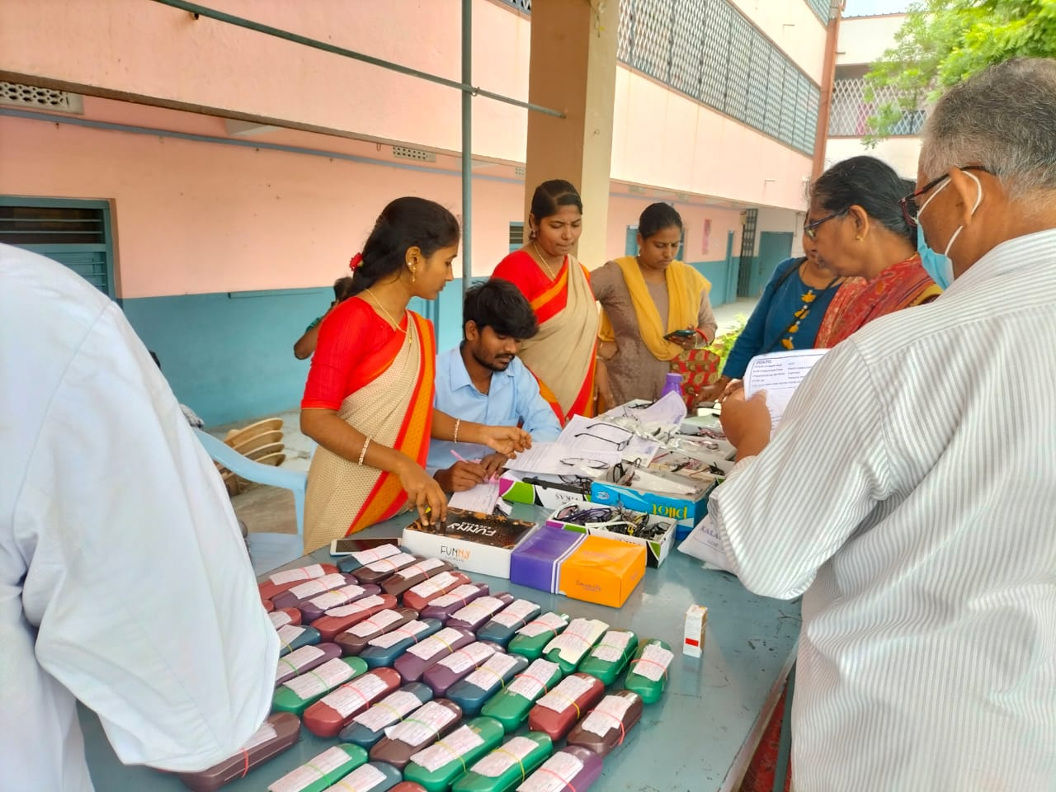

**Free Glasses Distribution for Govt School. Medchal District by Ushodaya Foundation & Hope & Helping Hands 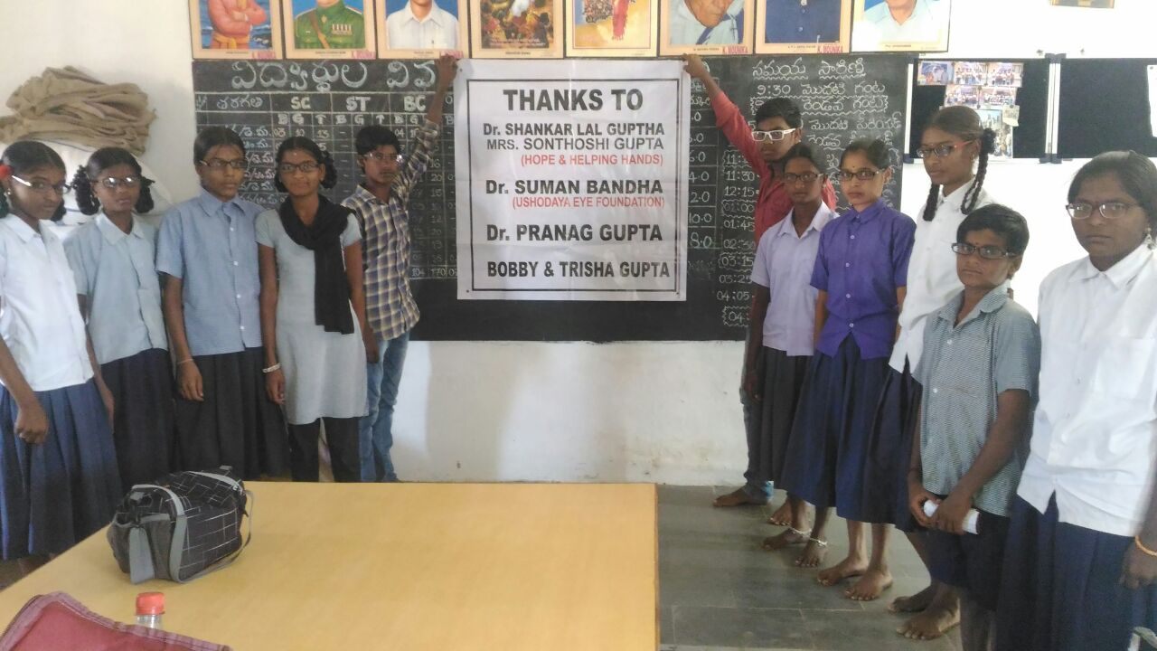 Free Glasses Distribution for Govt School. Medchal District by Ushodaya Foundation & Hope & Helping Hands** 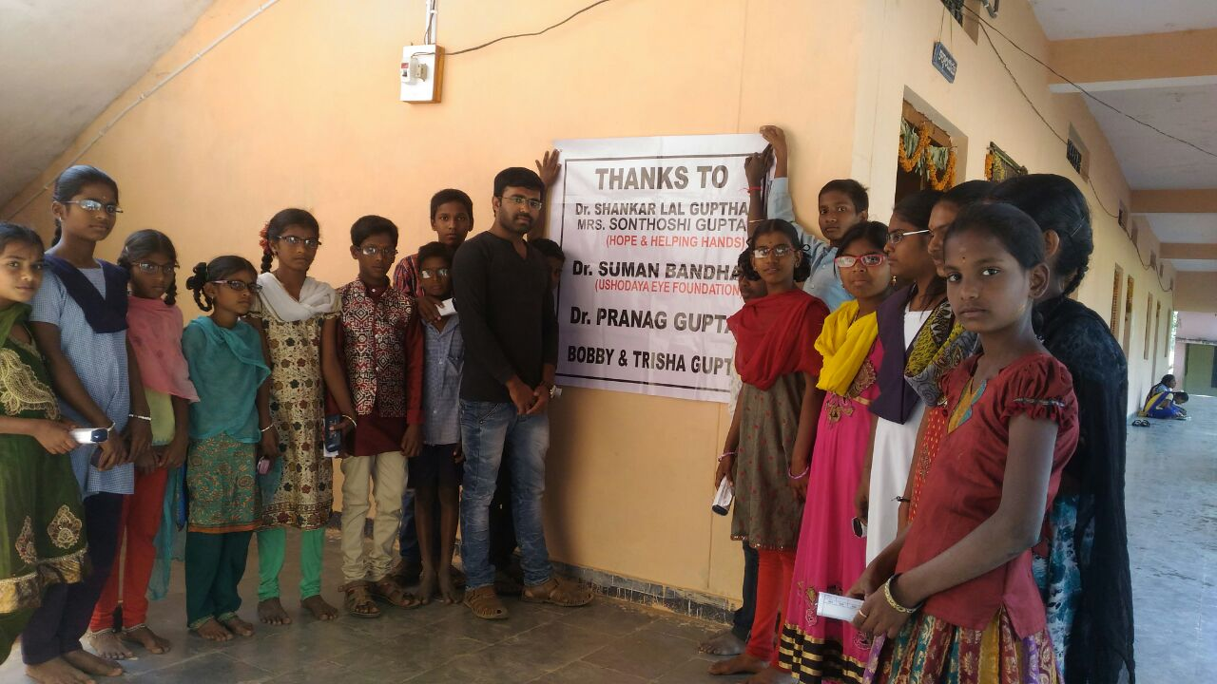

**Free Glasses Distribution for Govt School. Medchal District by Ushodaya Foundation & Hope & Helping Hands 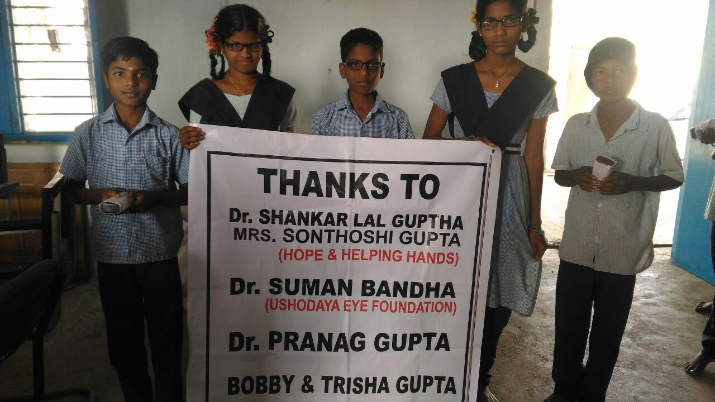 Free Glasses Distribution for Govt School. Medchal District by Ushodaya Foundation & Hope & Helping Hands** 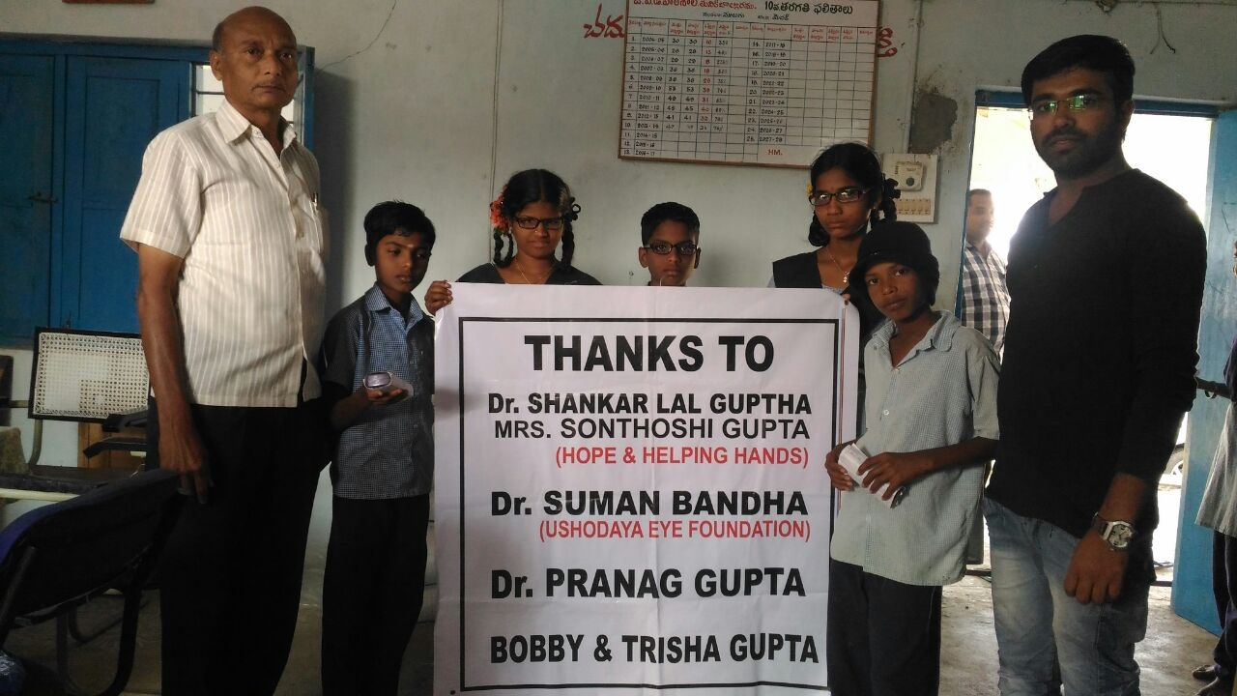

**Free Glasses Distribution for Govt School. Medchal District by Ushodaya Foundation & Hope & Helping Hands**

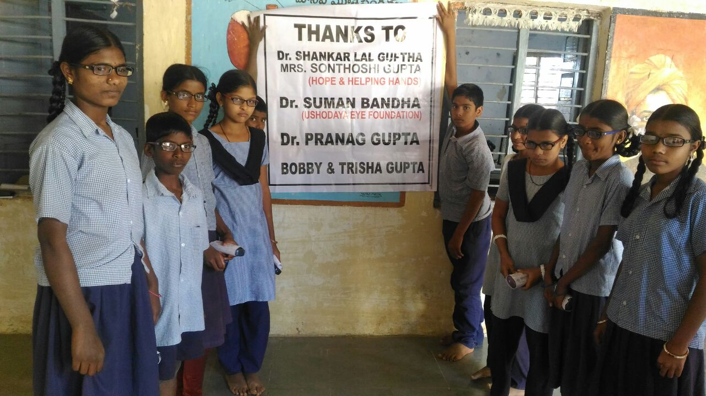 **Free Glasses Distribution for Govt School. Medchal District by Ushodaya Foundation & Hope & Helping Hands** 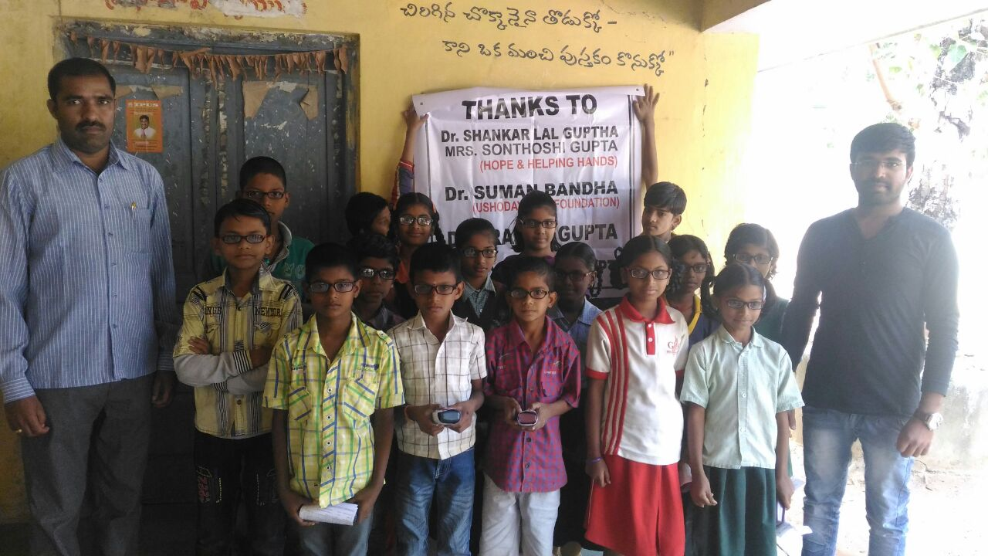

**Free Glasses Distribution for ST.Joseph School. Patancheru by Ushodaya Foundation & Hope & Helping Hands 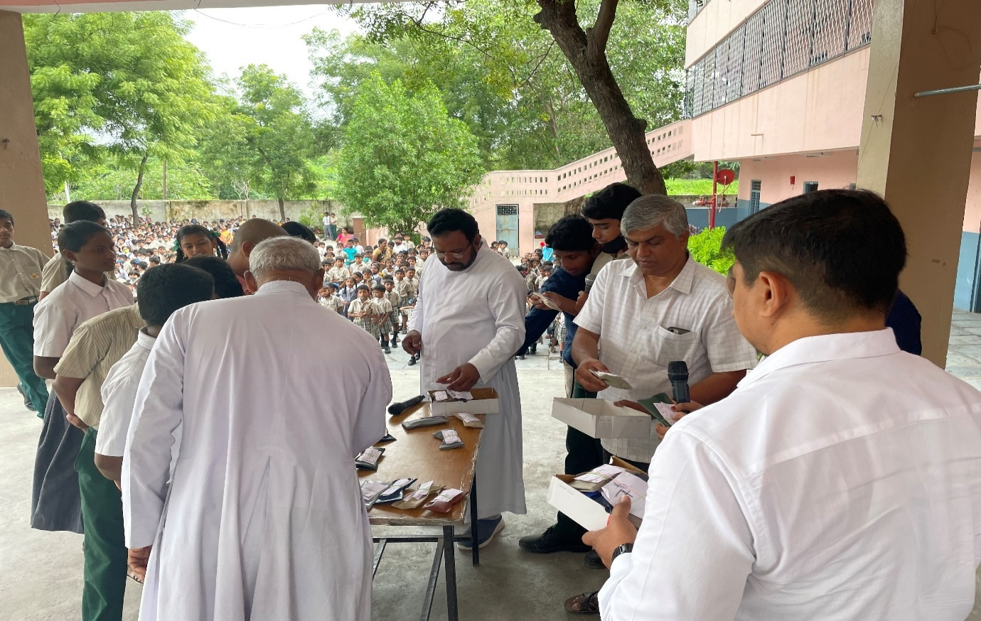 Free Glasses Distribution for Govt School. Medchal District by Ushodaya Foundation & Hope & Helping Hands** 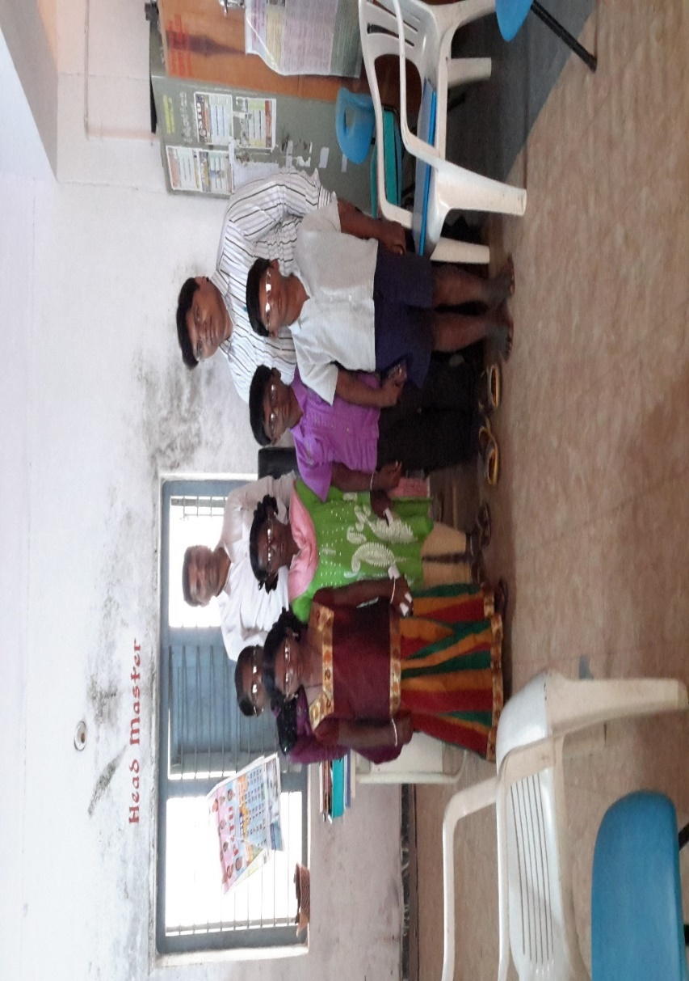

**FREE EYE CAMP & FREE GLASSES PROGRAMME2019, CHIEF GUESTS MLA.MALLAREDDY SIR.PROVIDED 270 FREE GLASSES**

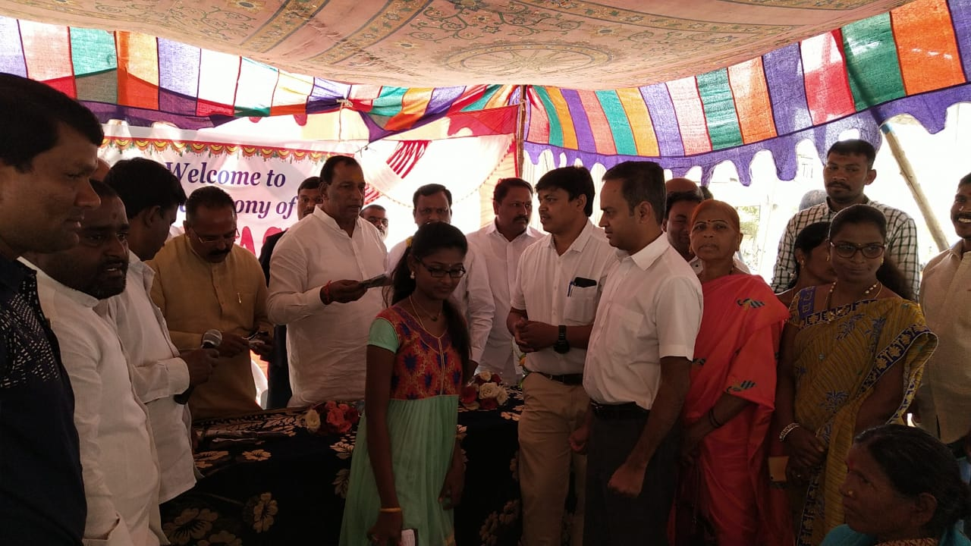 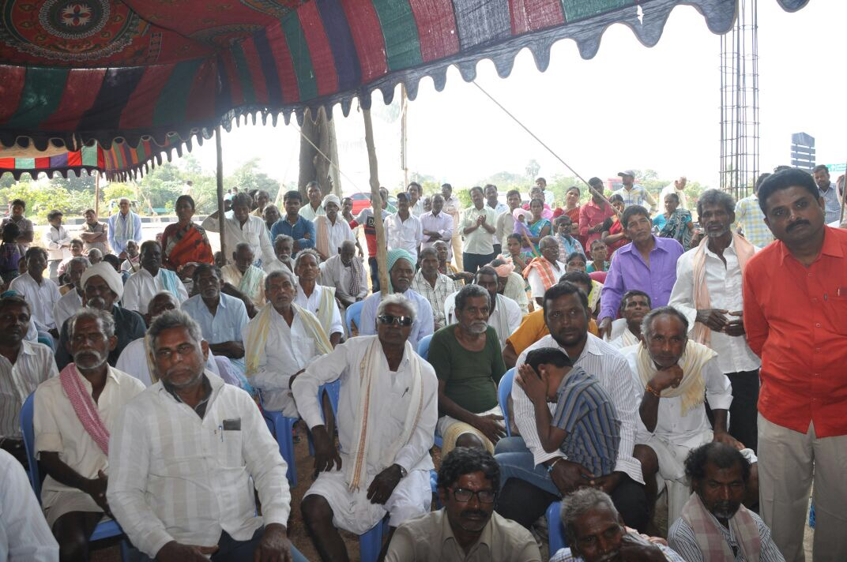

**FREE EYE CAMP & FREE GLASSES PROGRAMME2018, CHIEF GUESTS SP.SRINIVAS SIR.PROVIDED 600 FREE GLASSES**

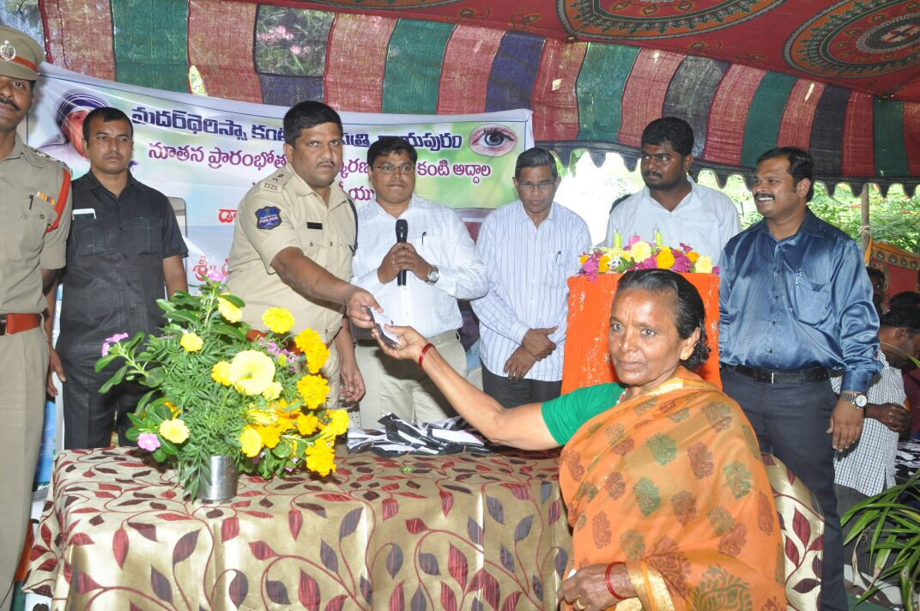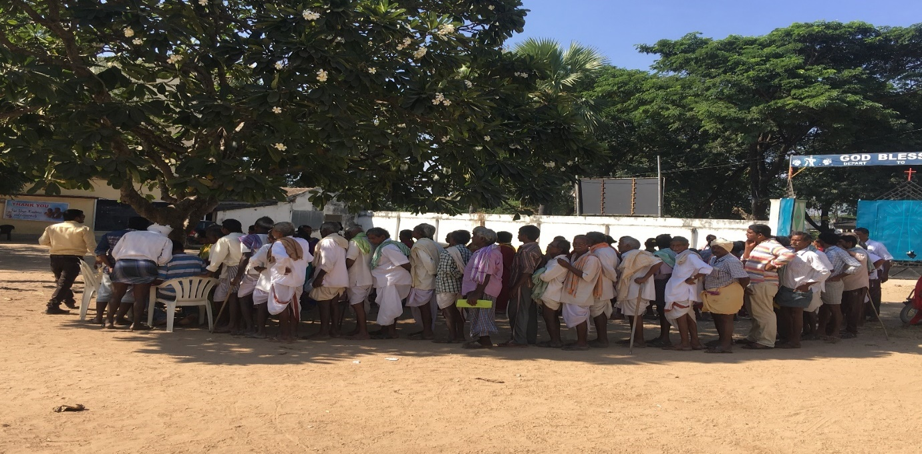

**FREE EYE CAMP & FREE GLASSES PROGRAMME2019, CHIEF GUESTS MLA.VEMULA VEERESHAM SIR.PROVIDED 600 FREE GLASSES**

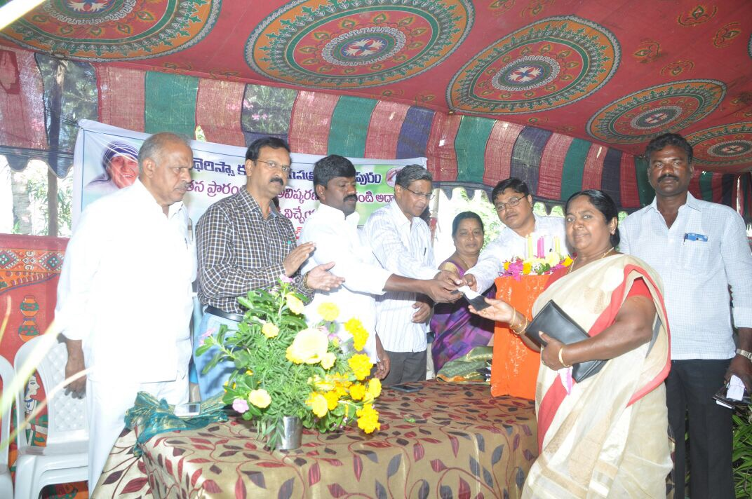 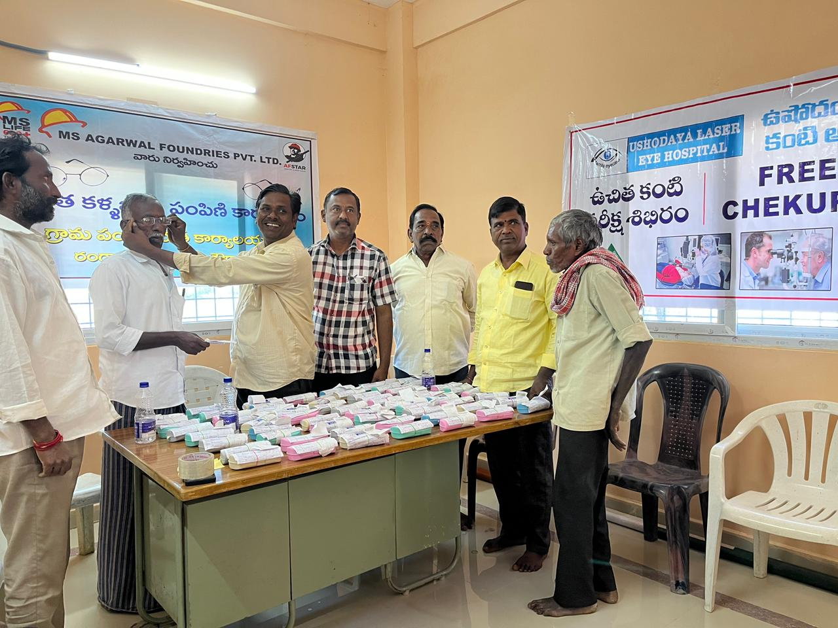

**FREE EYE CAMP & FREE GLASSES PROGRAMME2020, PROVIDED 300 FREE GLASSES**

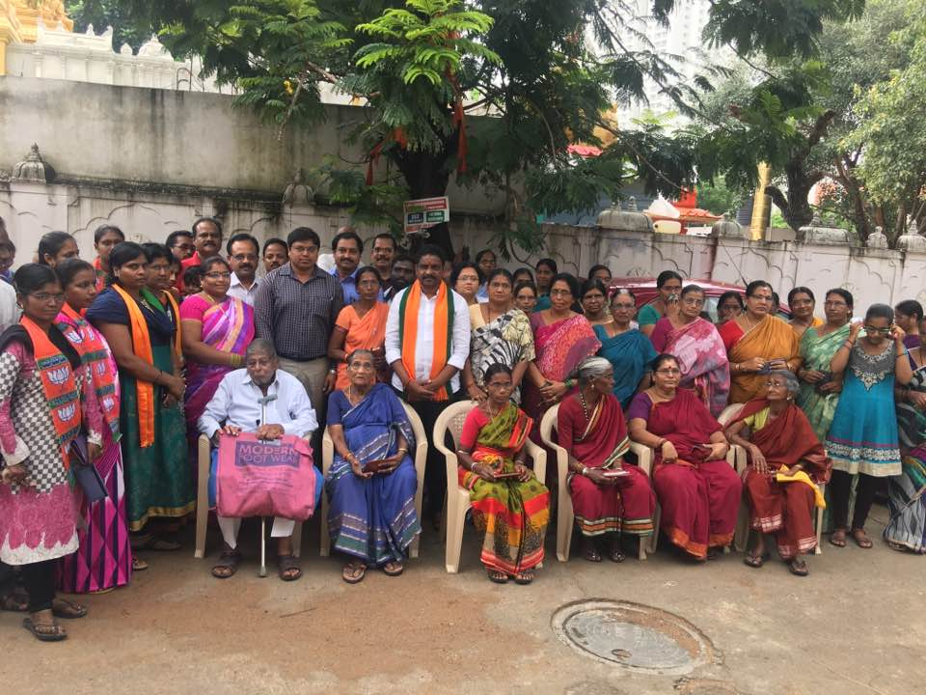

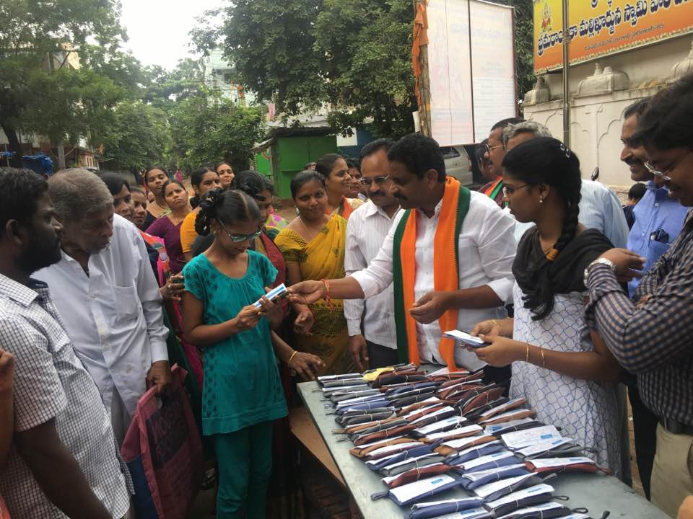

**FREE EYE CAMP & FREE GLASSES PROGRAMME2025, PROVIDED 200 FREE GLASSES**

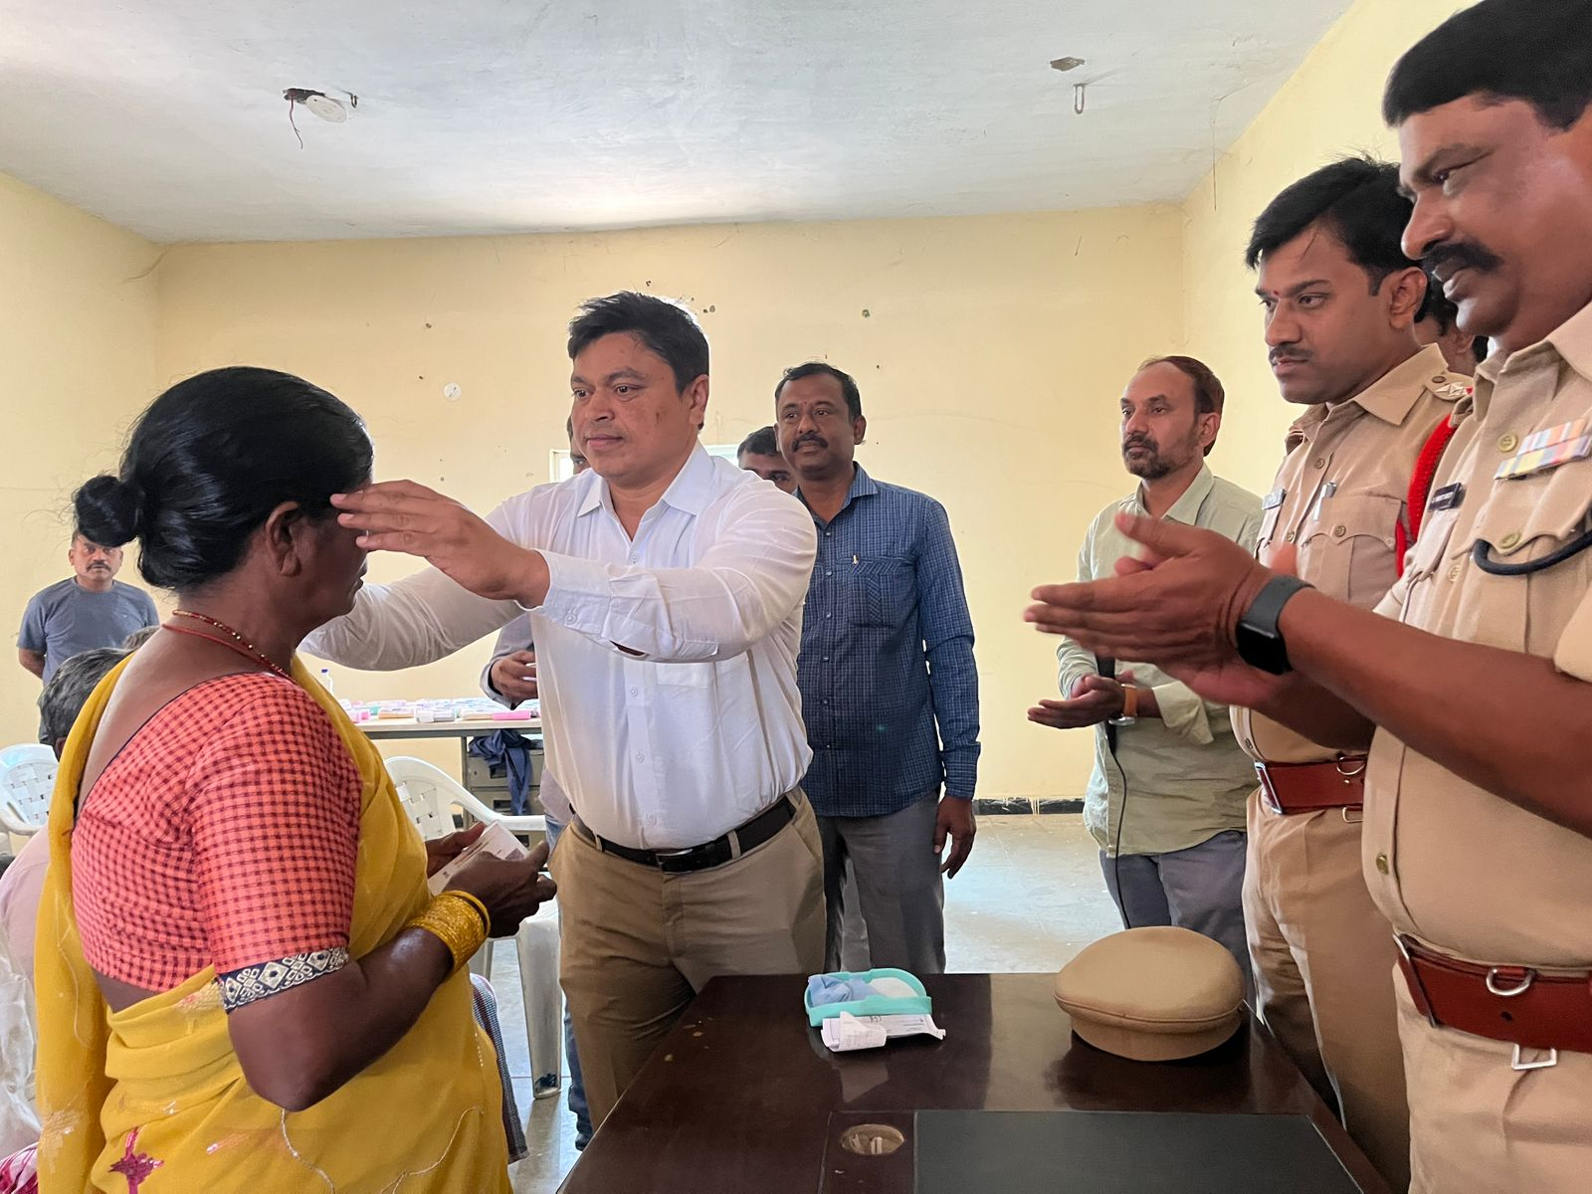

**FREE EYE CAMP & PROVIDING FREE MEDICINES**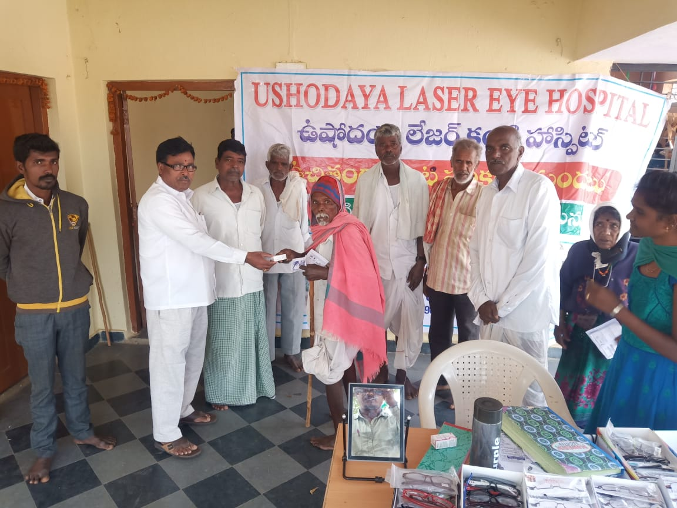

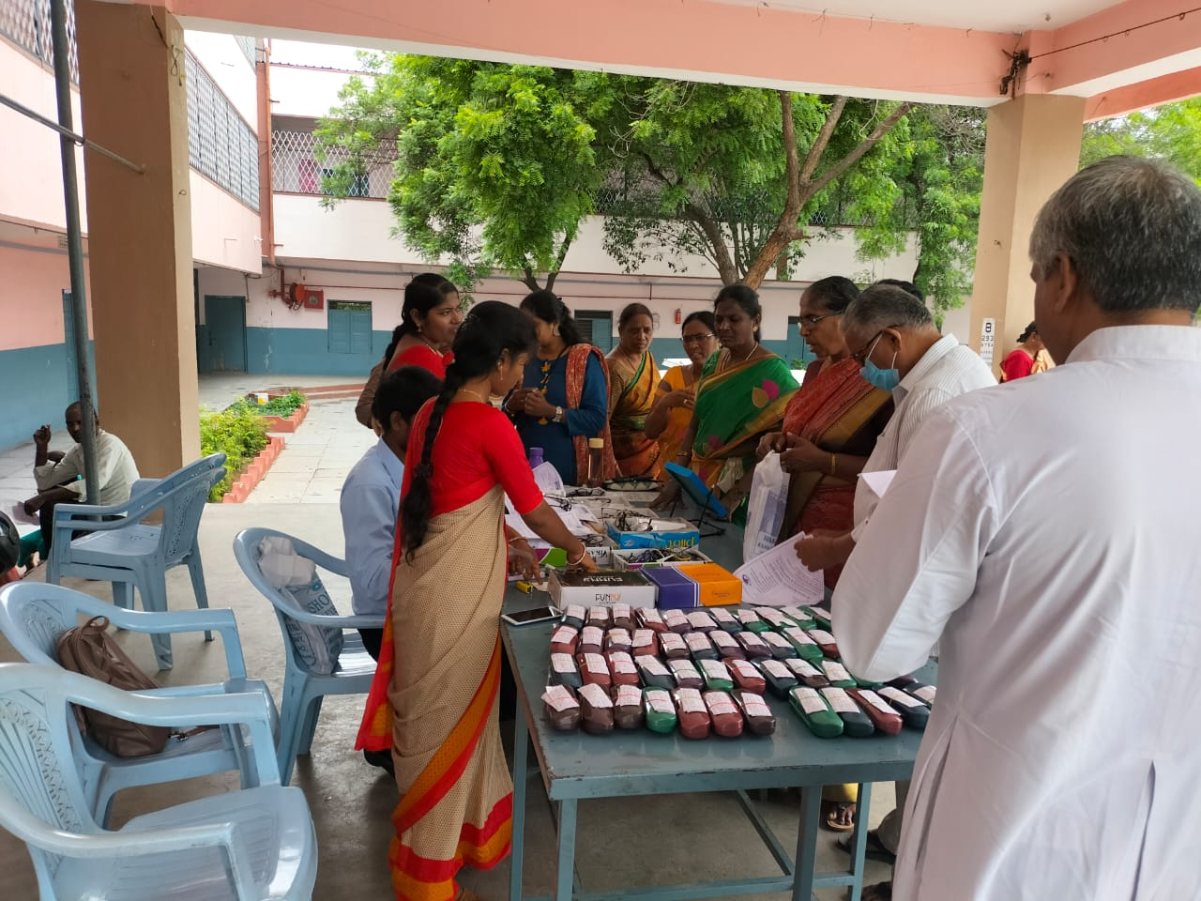 **FREE EYE CAMP & PROVIDING FREE MEDICINES** 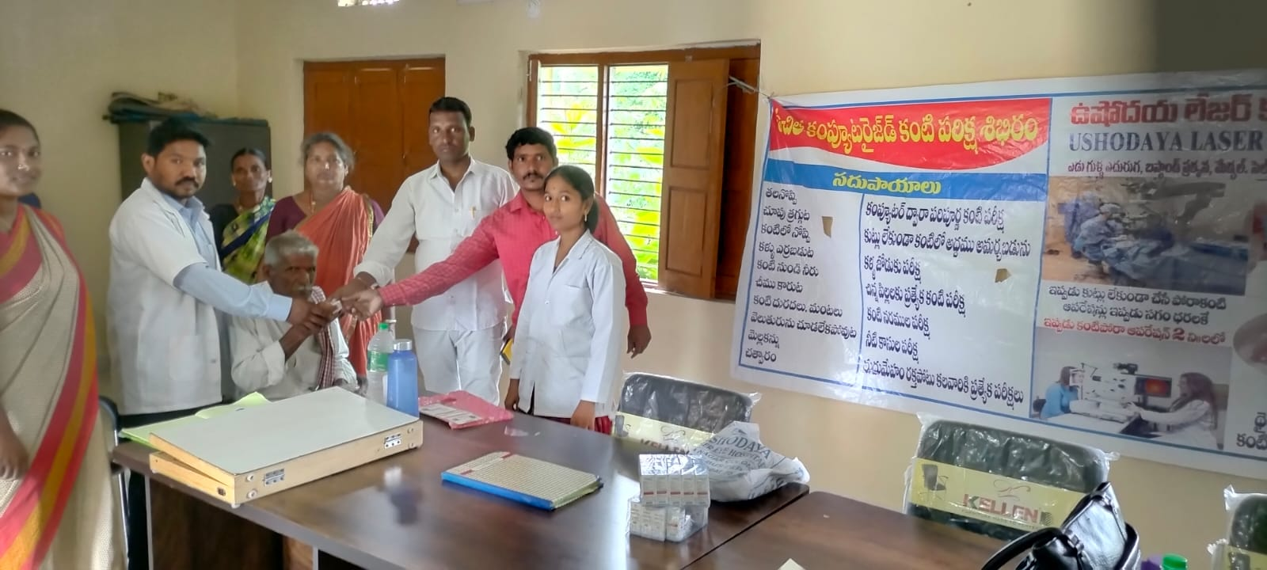

**FREE EYE CAMP & PROVIDING FREE MEDICINES 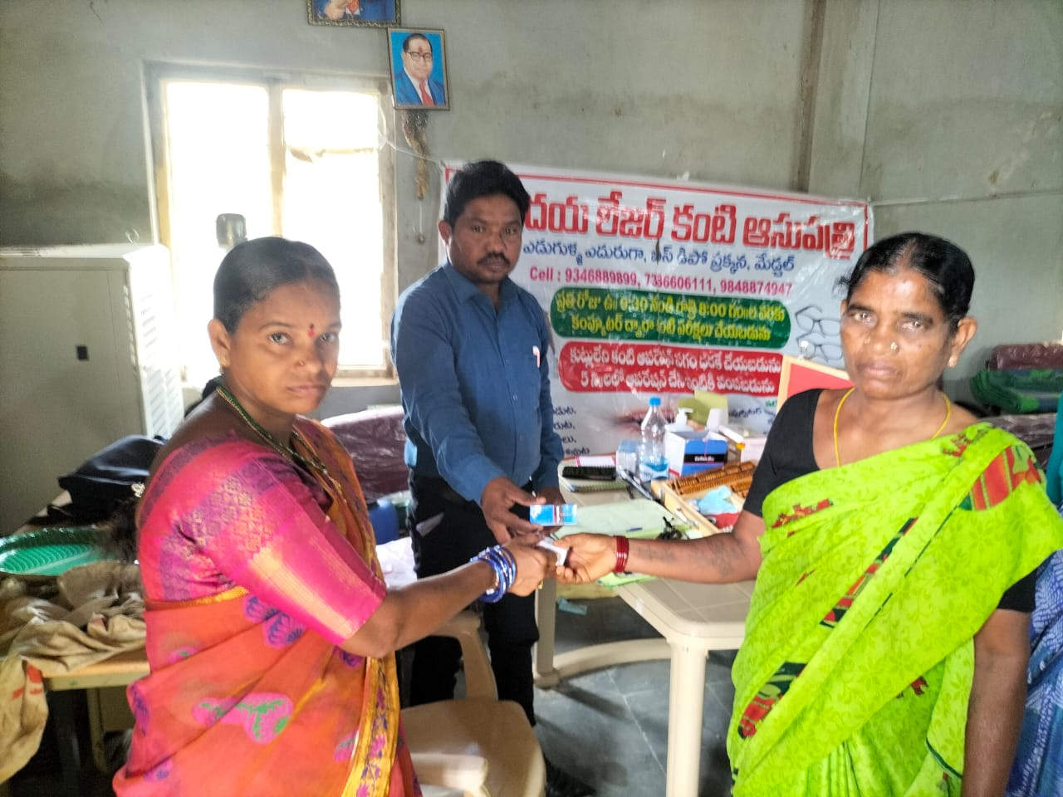 FREE EYE CAMP & PROVIDING FREE MEDICINES** 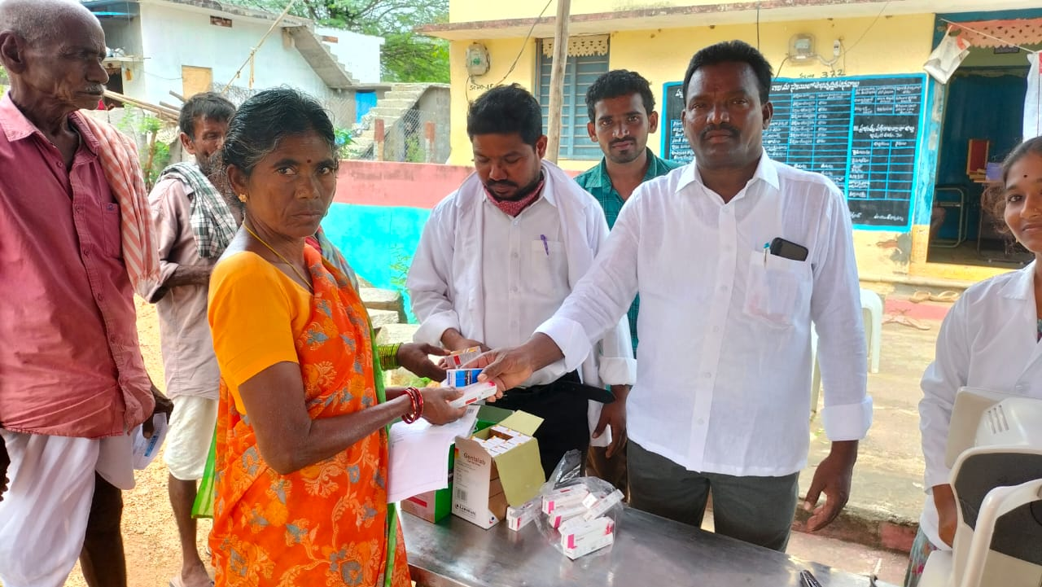

**FREE EYE CAMP & PROVIDING FREE MEDICINES**

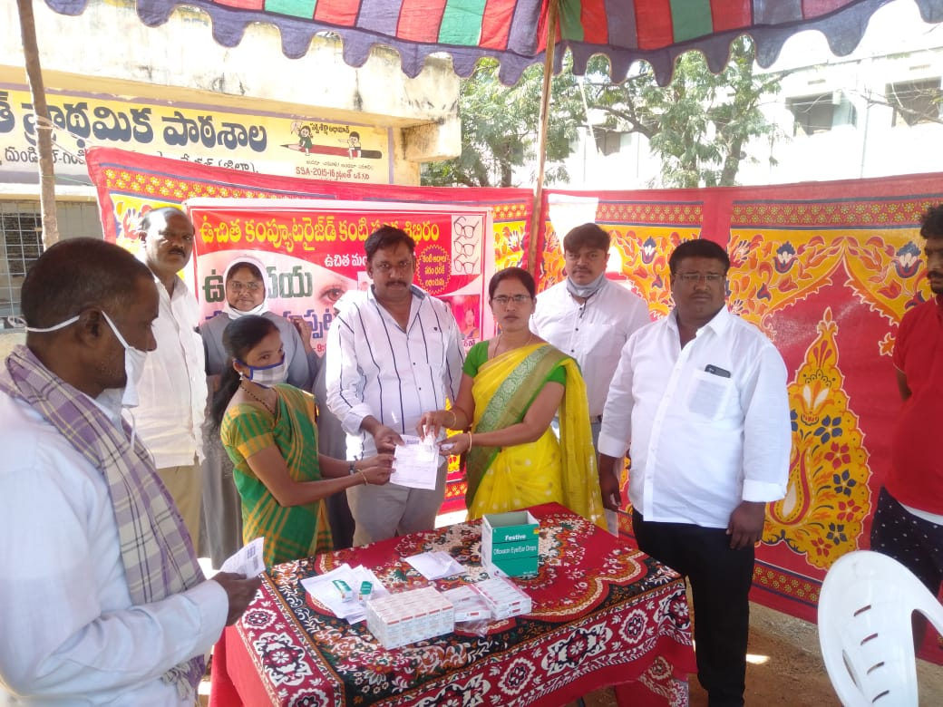

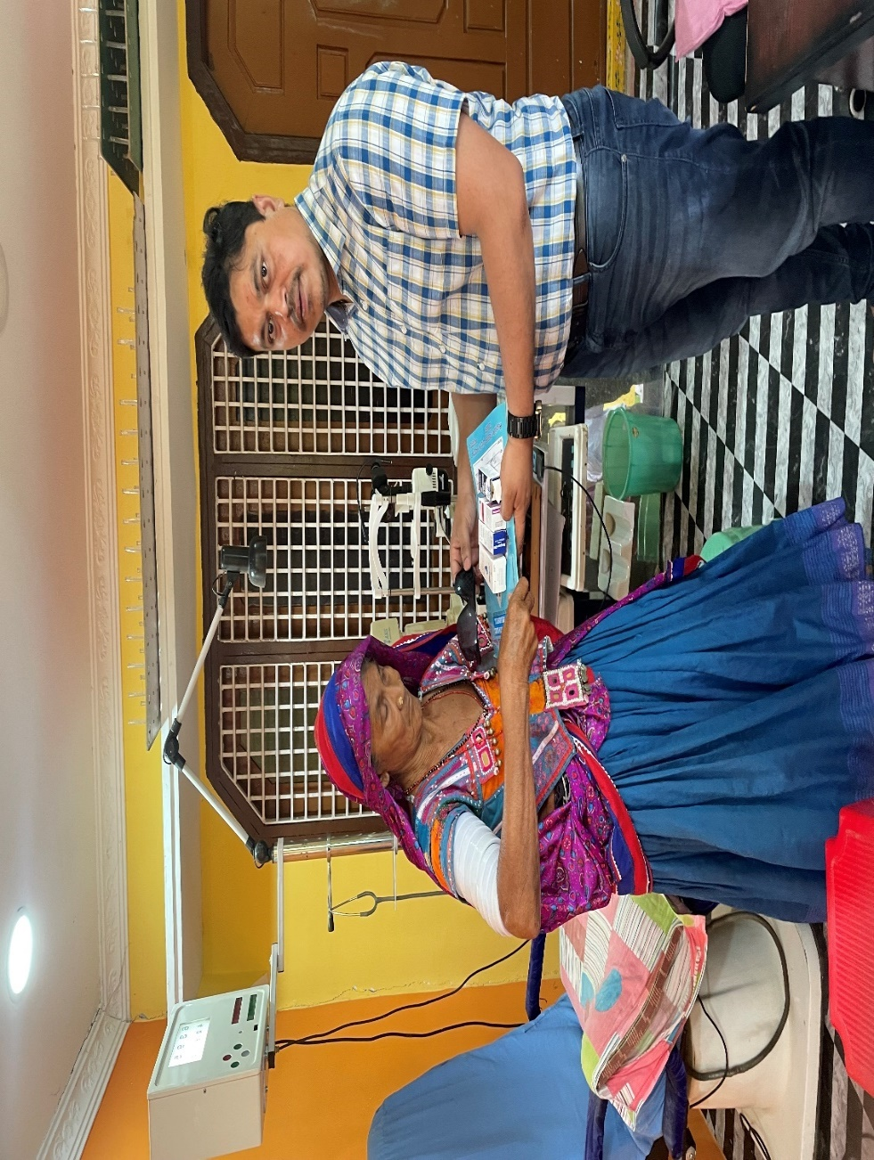

**FREE EYE SURGERIES**

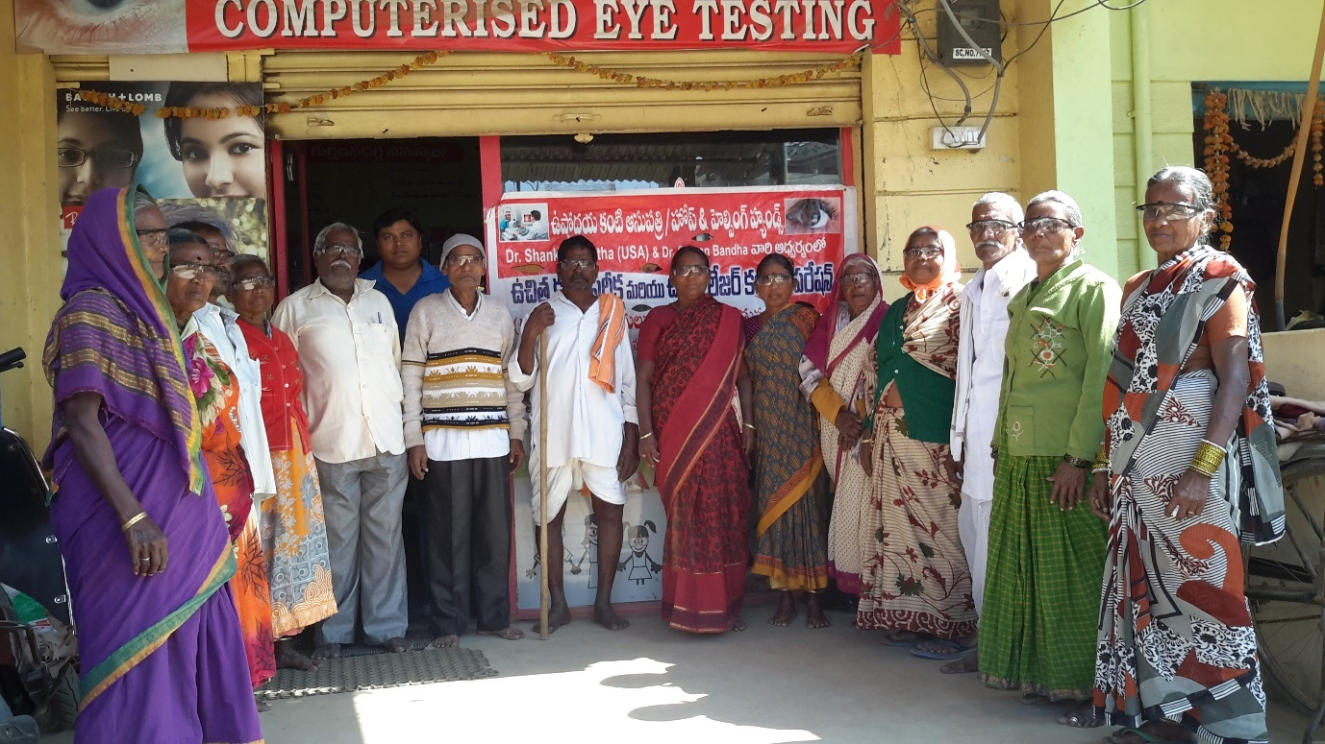 **FREE EYE SURGERIES** 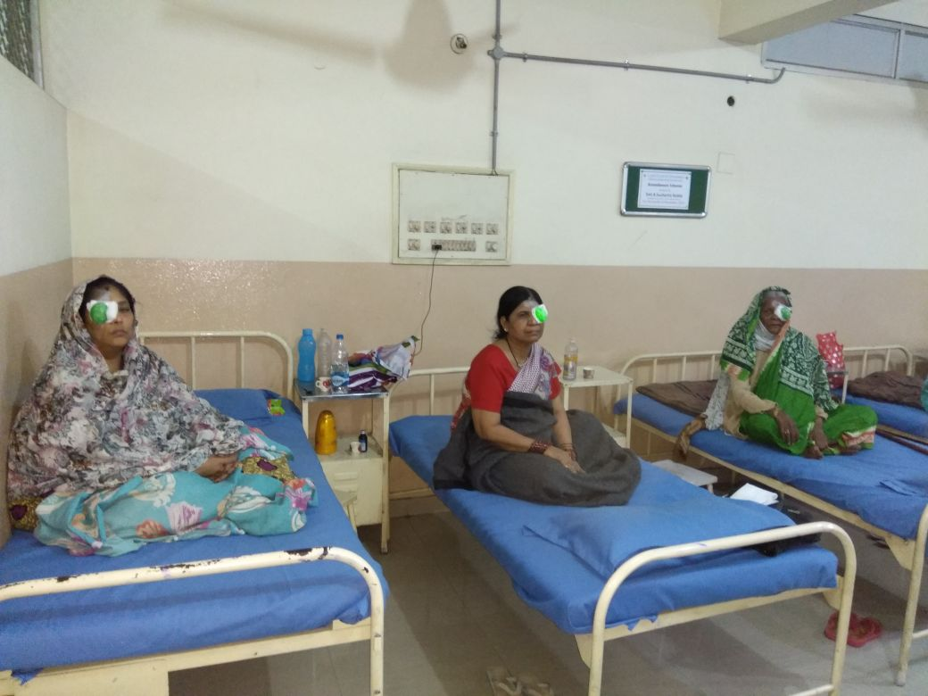

**FREE EYE SURGERIES**

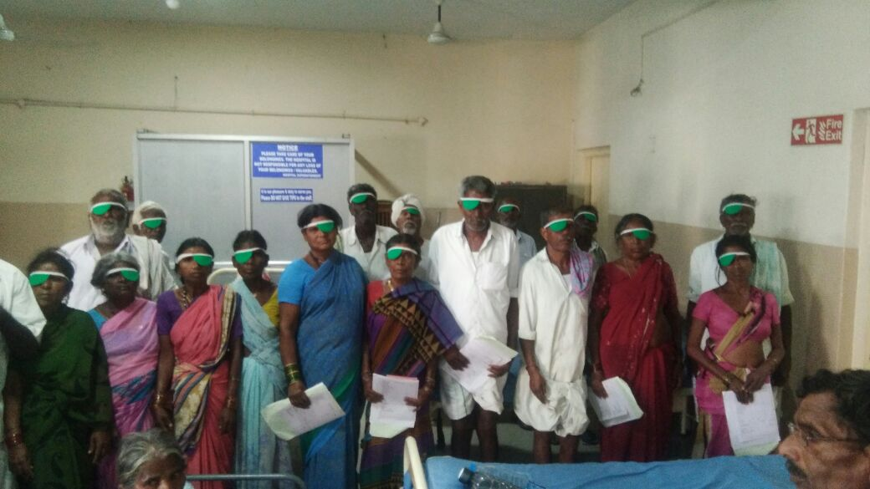 **FREE EYE SURGERIES**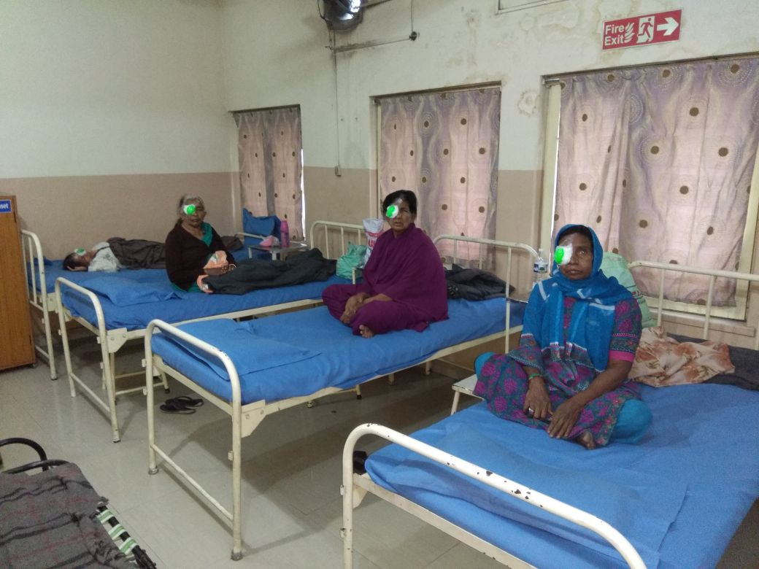

**FREE EYE SURGERIES**

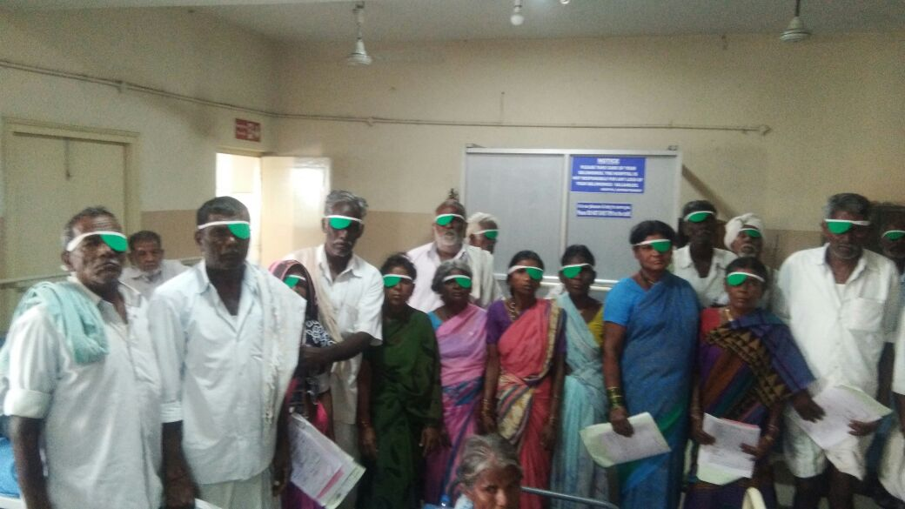 **FREE EYE SURGERIES** 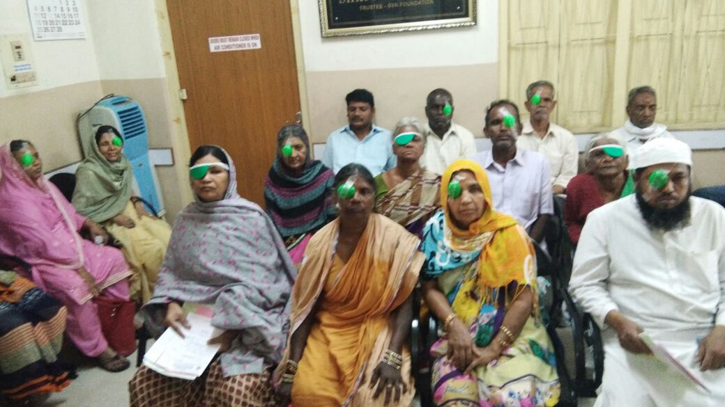

**FREE EYE SURGERIES**

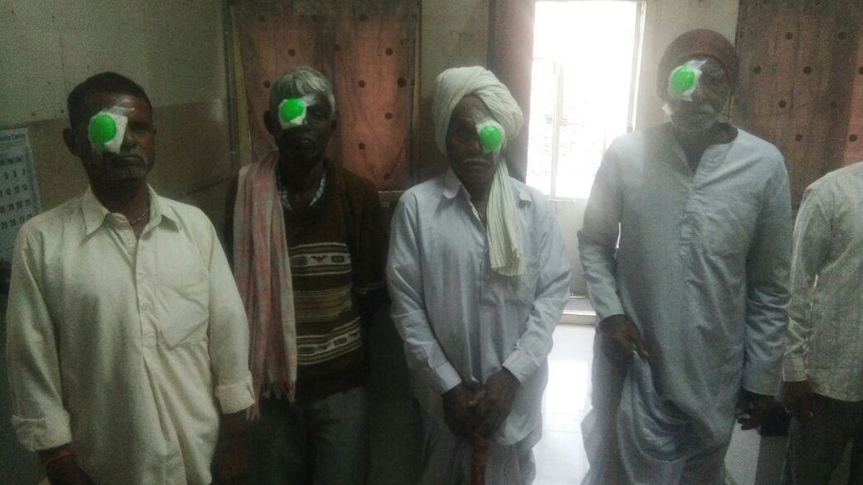 **FREE EYE SURGERIES** 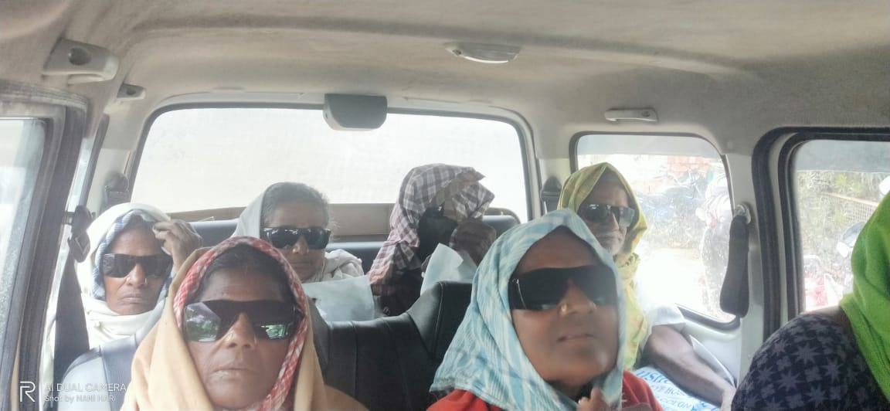

**FREE EYE SURGERIES**

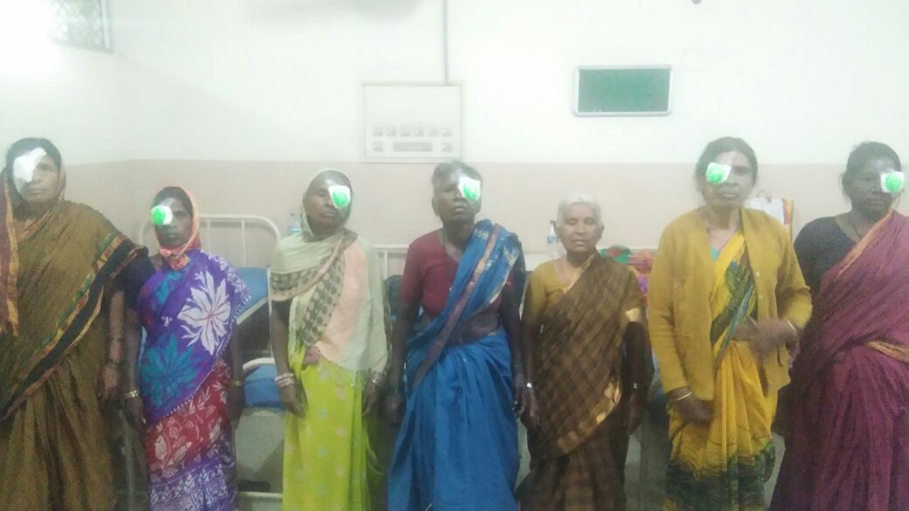 **EE EYE SURGERIES**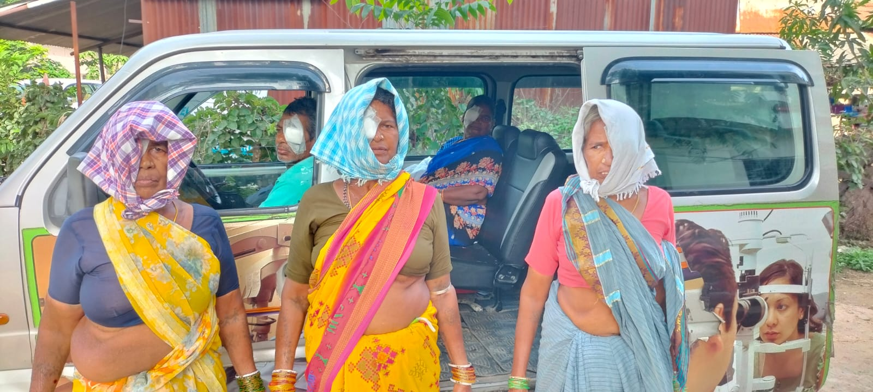

**FREE EYE SURGERIES**

 **EE EYE SURGERIES** 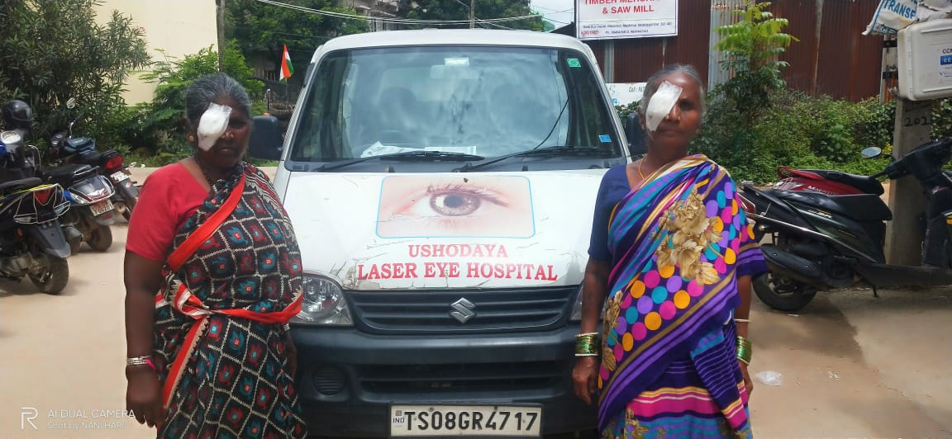

**FREE EYE SURGERIES**

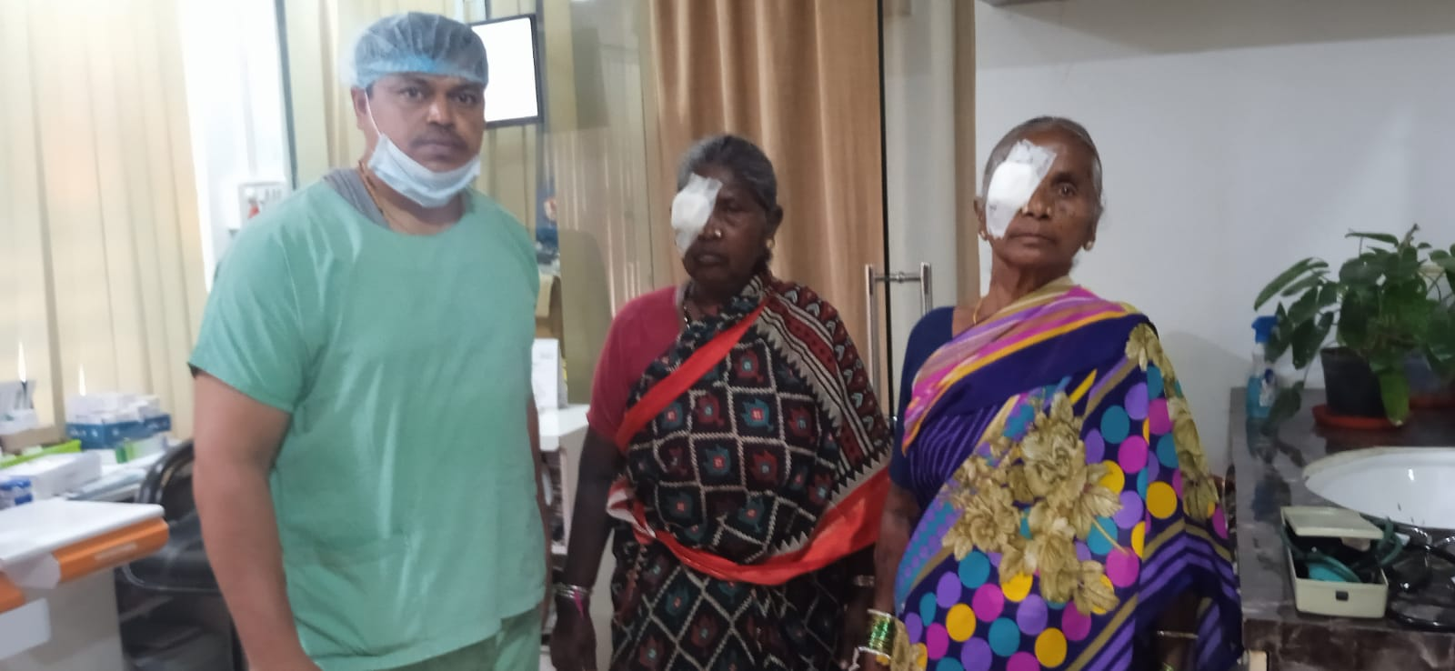 **FREE EYE SURGERIES** 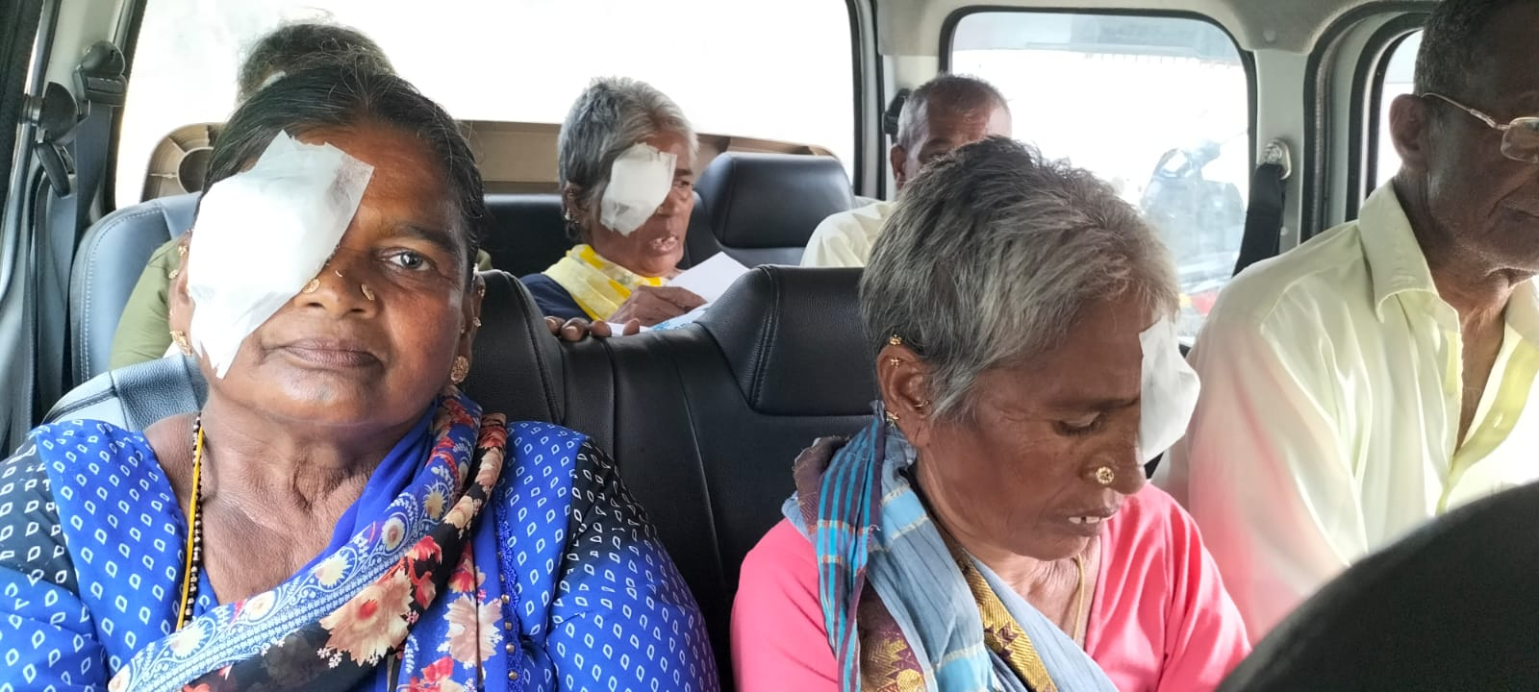

**FREE EYE SURGERIES**

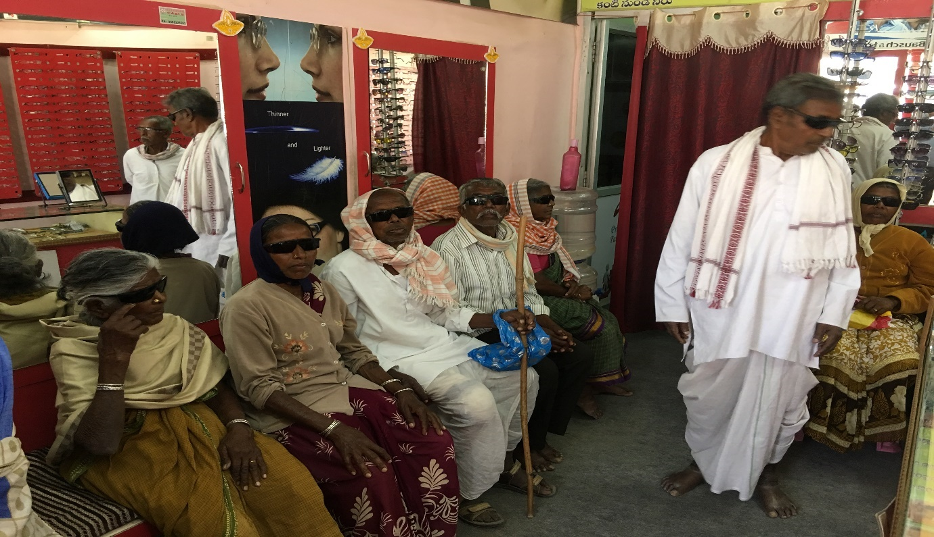 **FREE EYE SURGERIES** 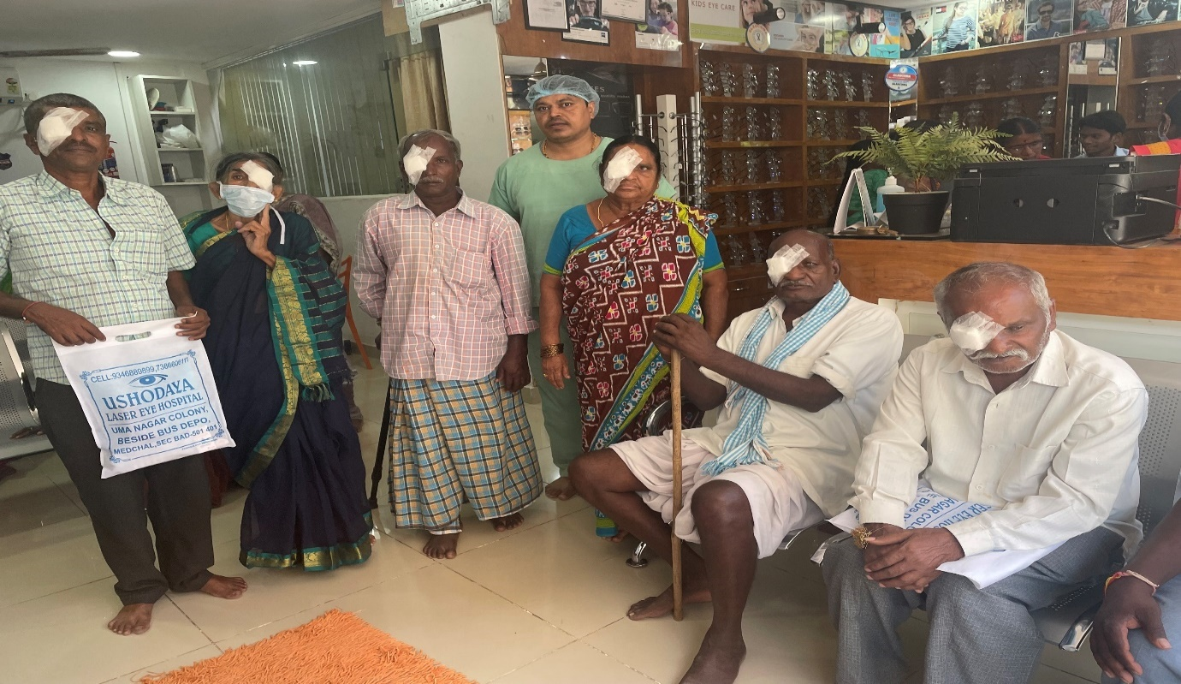

**FREE EYE SURGERIES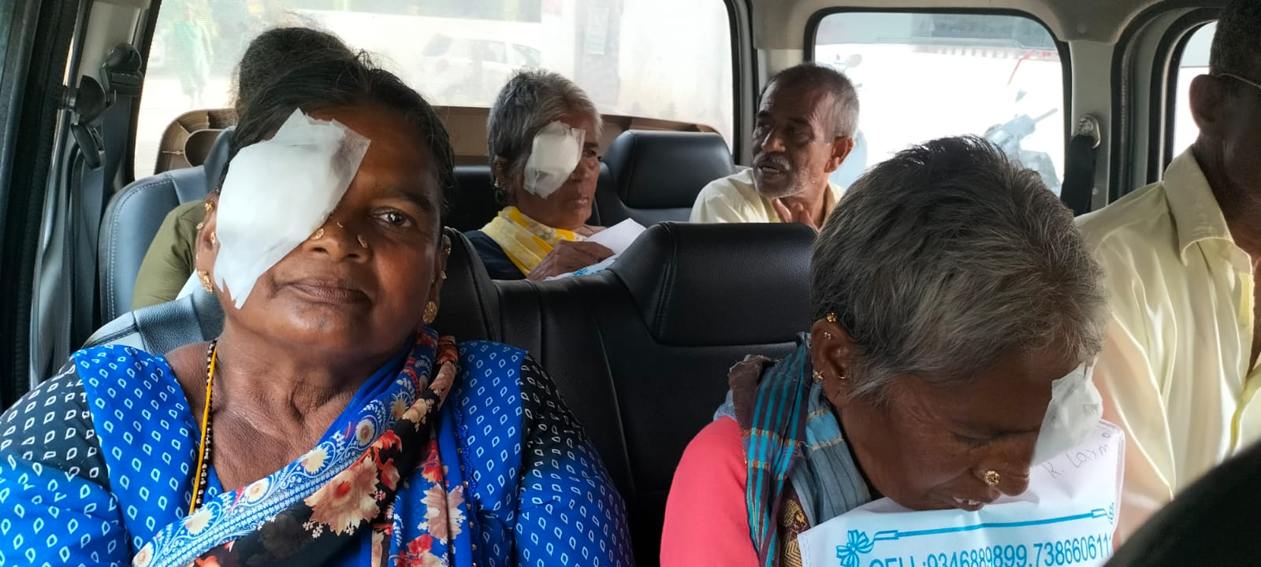 FREE EYE SURGERIES** 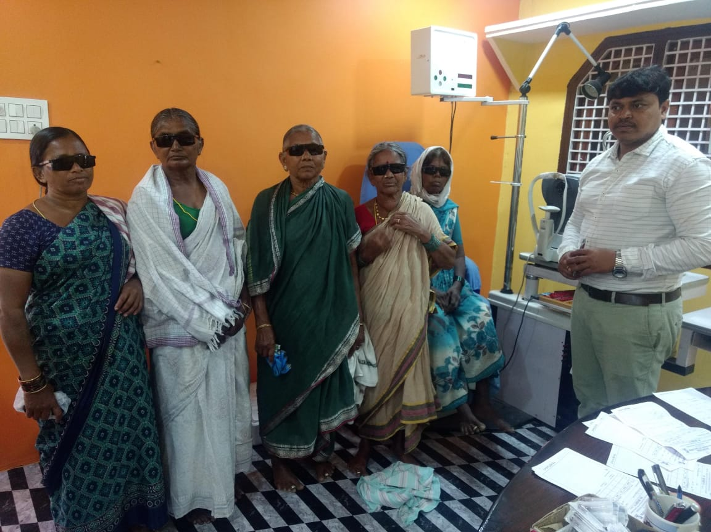

**FREE EYE SURGERIES**

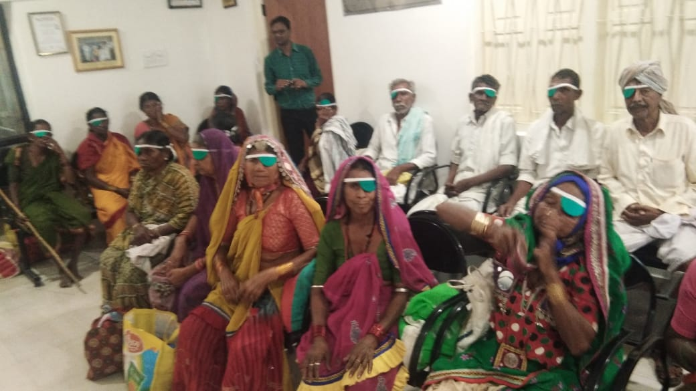

**Free School Camps & Free Glasses & Medicine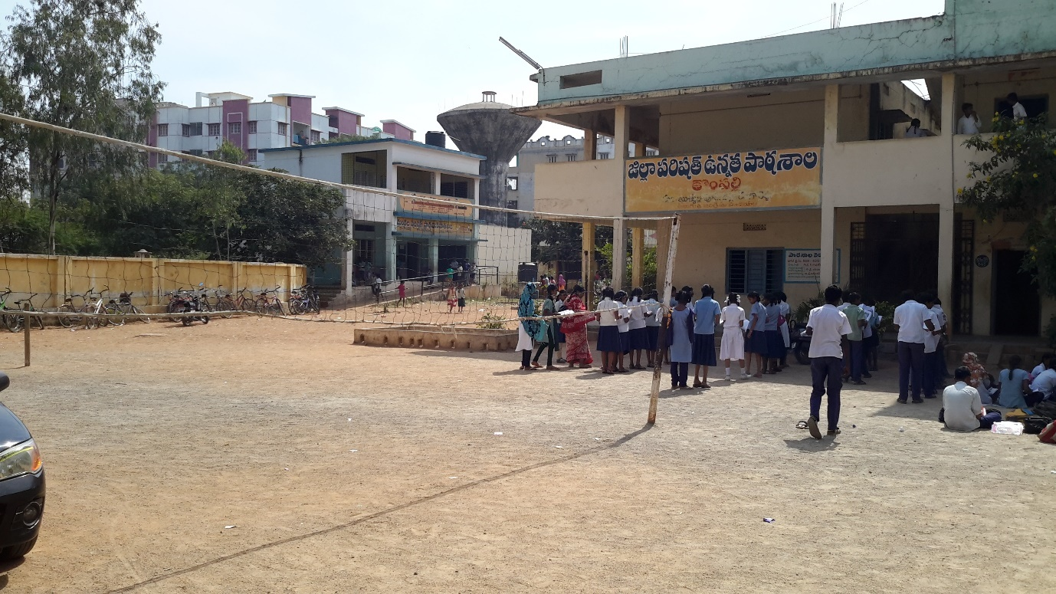 Free School Camps & Free Glasses & Medicine** 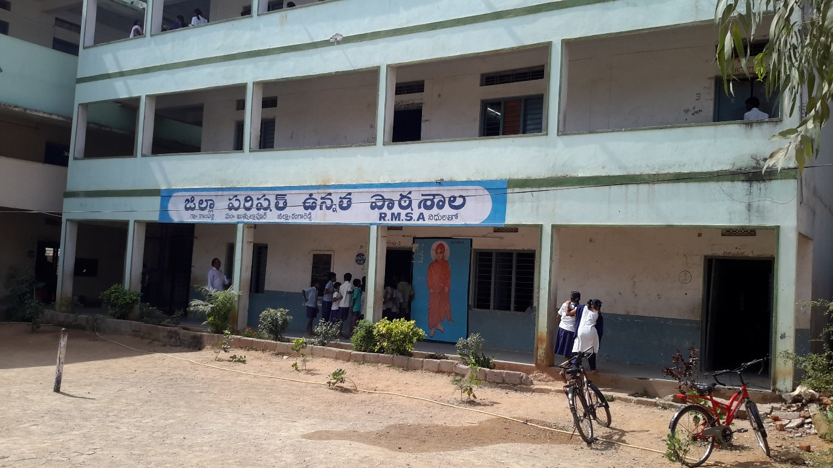

**Free School Camps & Free Glasses & Medicine 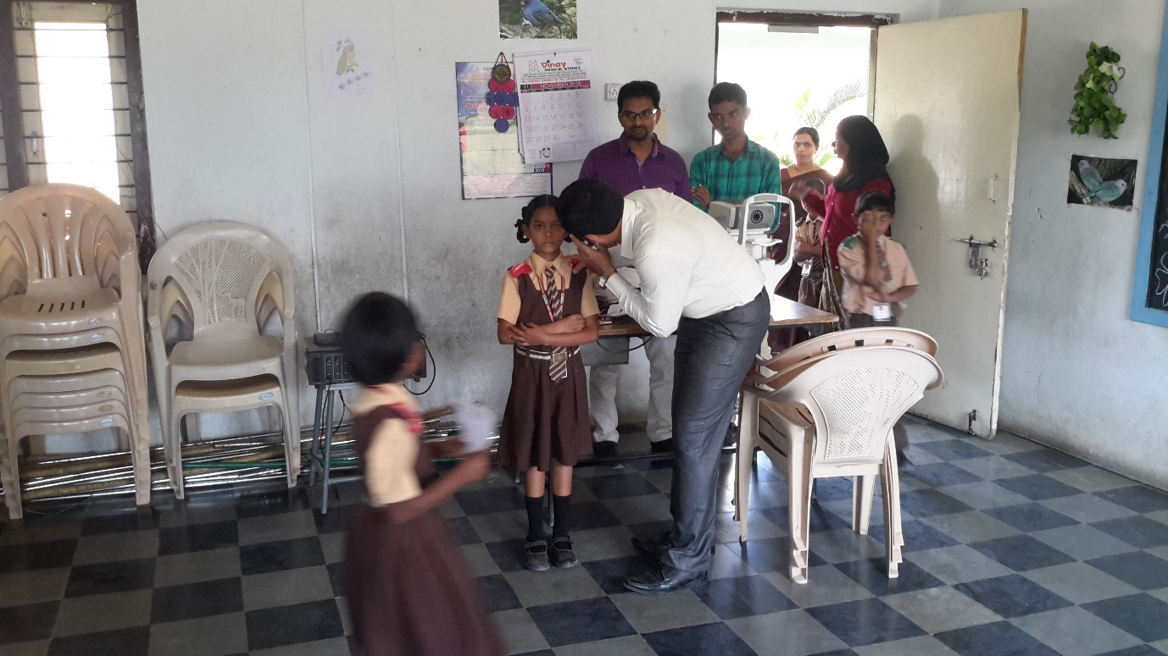 Free School Camps & Free Glasses & Medicine** 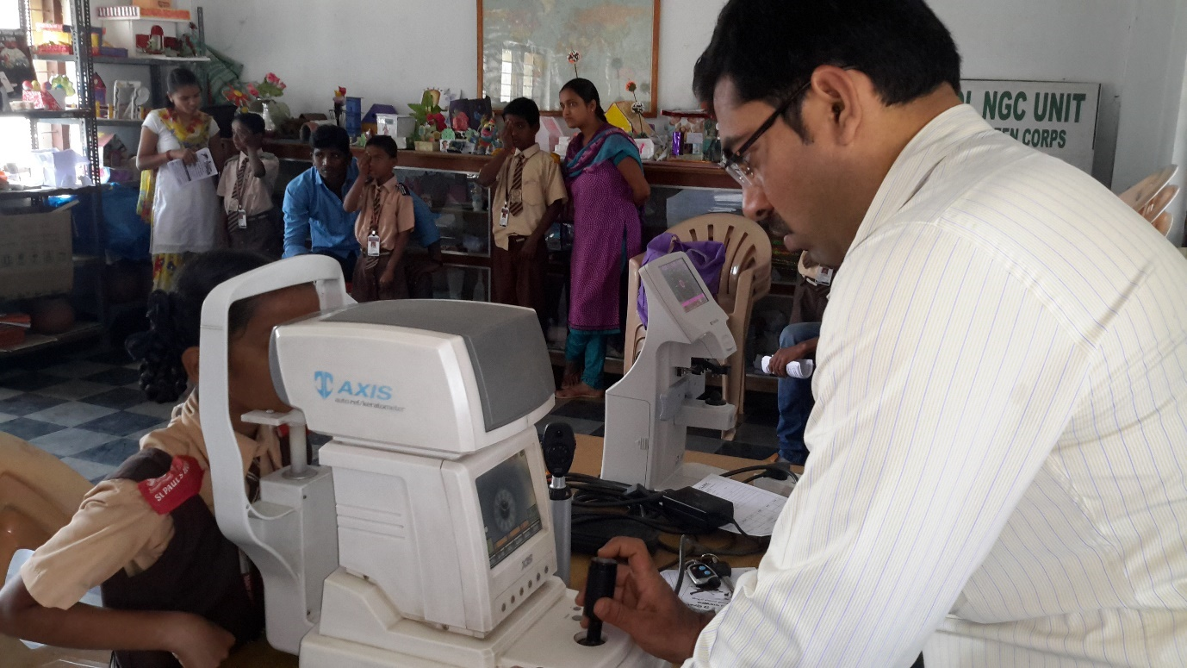

**Free School Camps & Free Glasses & Medicine 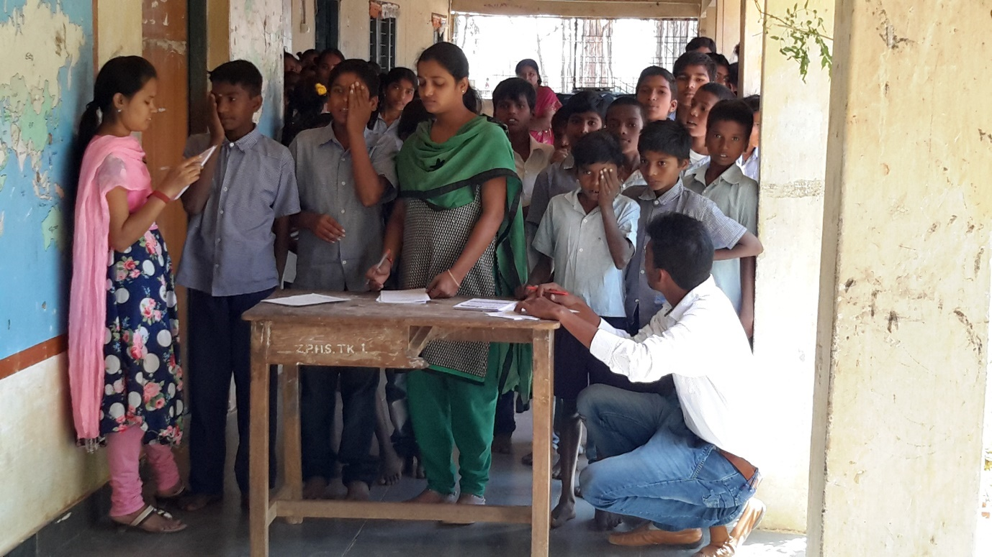 Free School Camps & Free Glasses & Medicine** 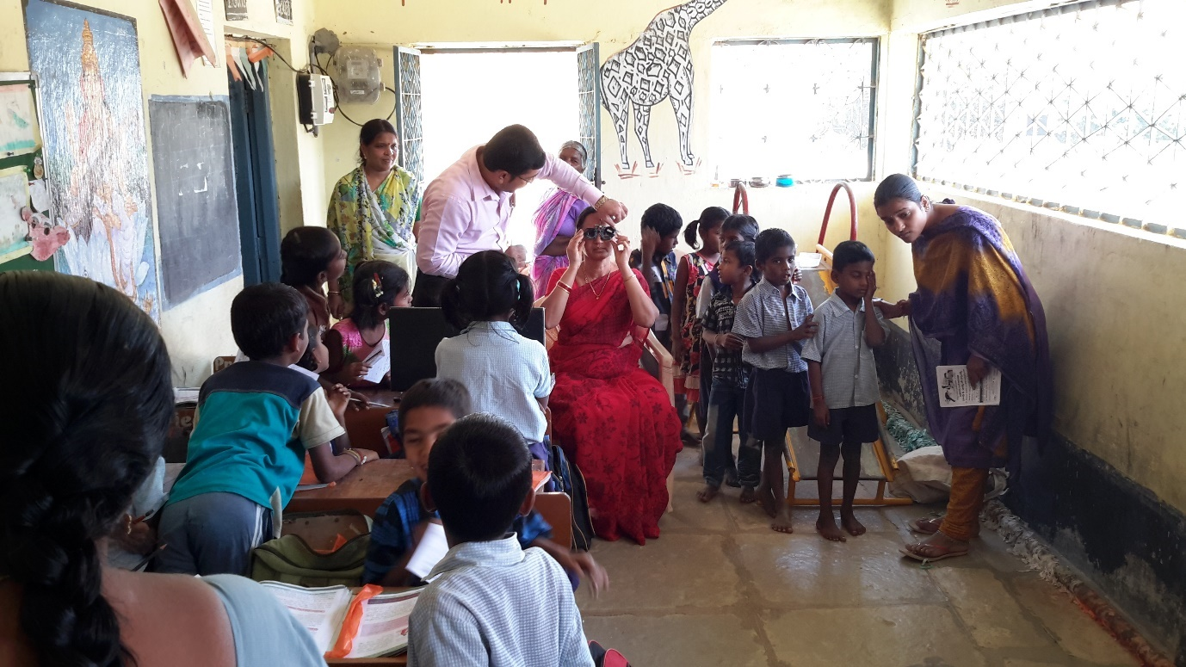

**Free School Camps & Free Glasses & Medicine 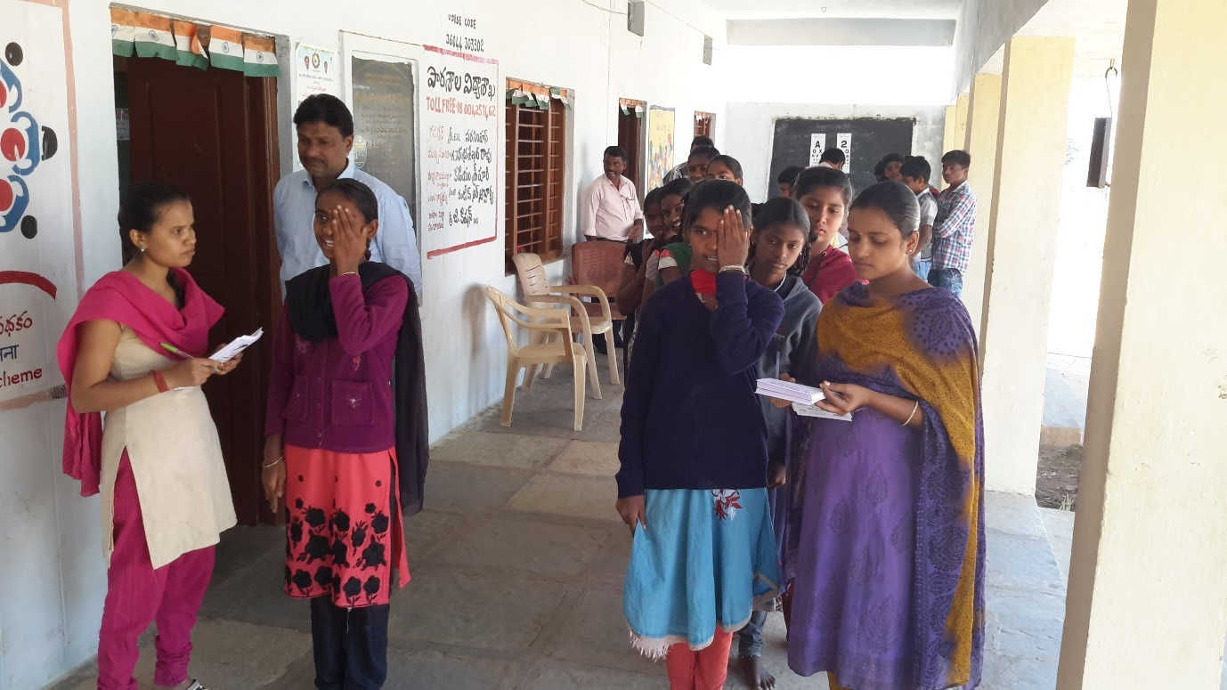 Free School Camps & Free Glasses & Medicine** 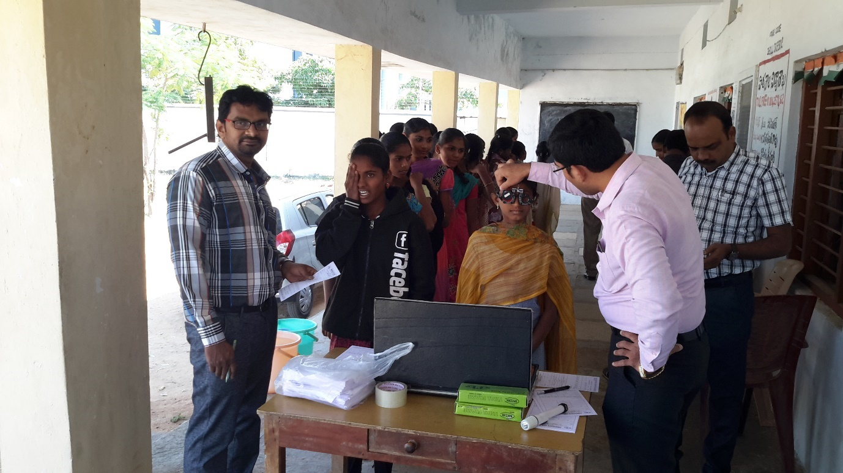

**Free School Camps & Free Glasses & Medicine 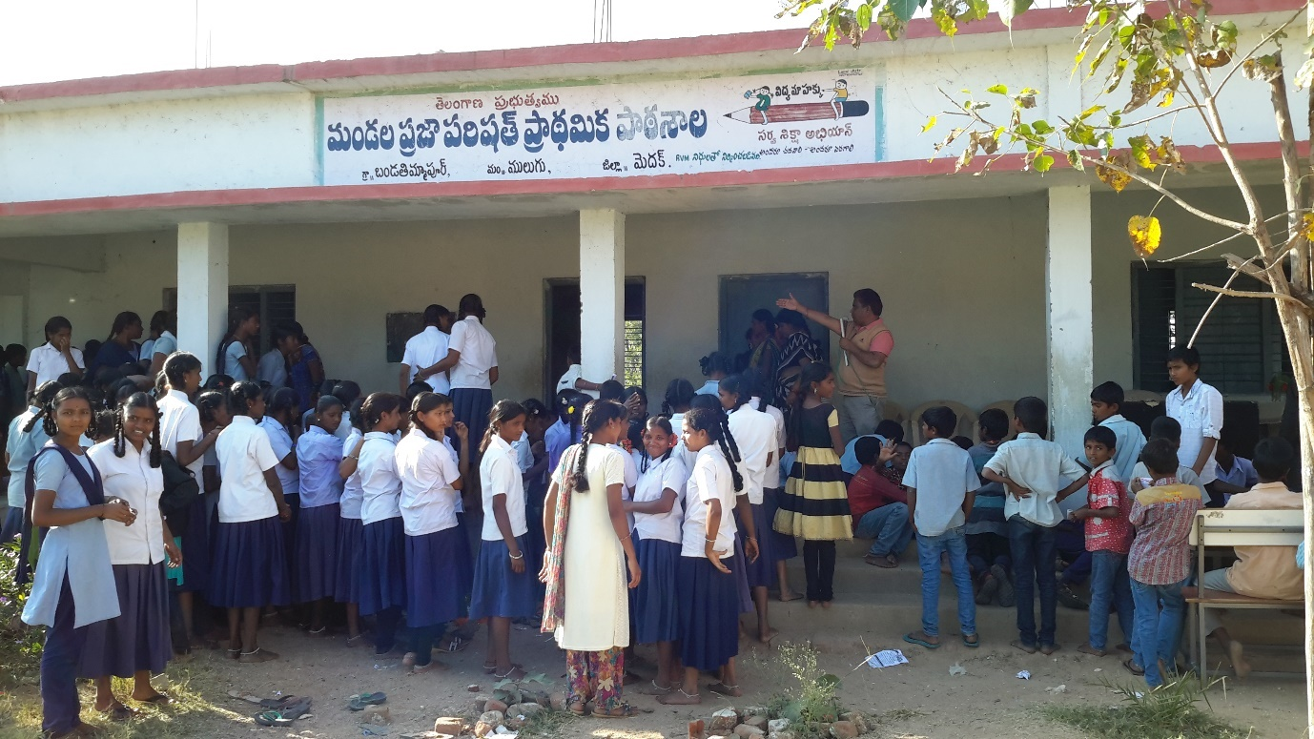 Free School Camps & Free Glasses & Medicine** 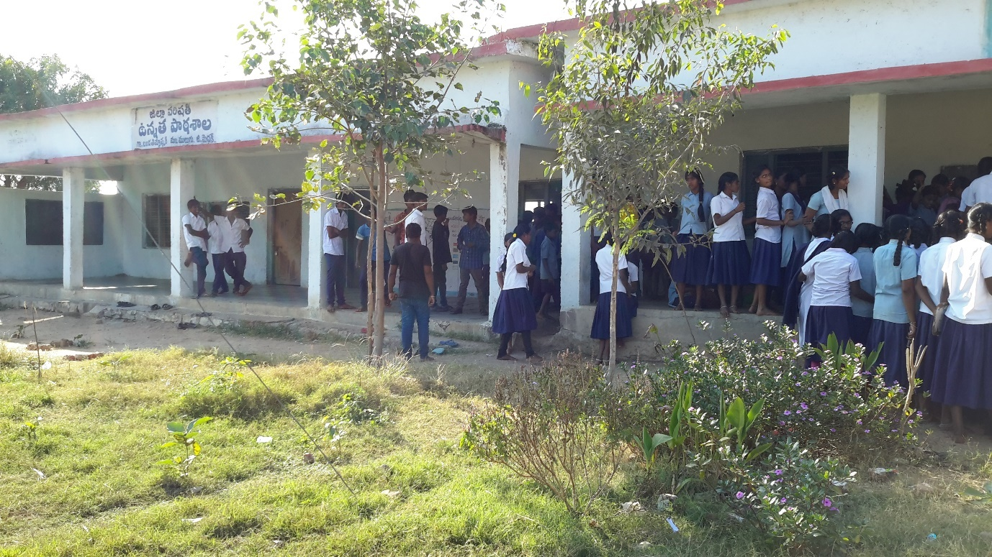

**Free School Camps & Free Glasses & Medicine** 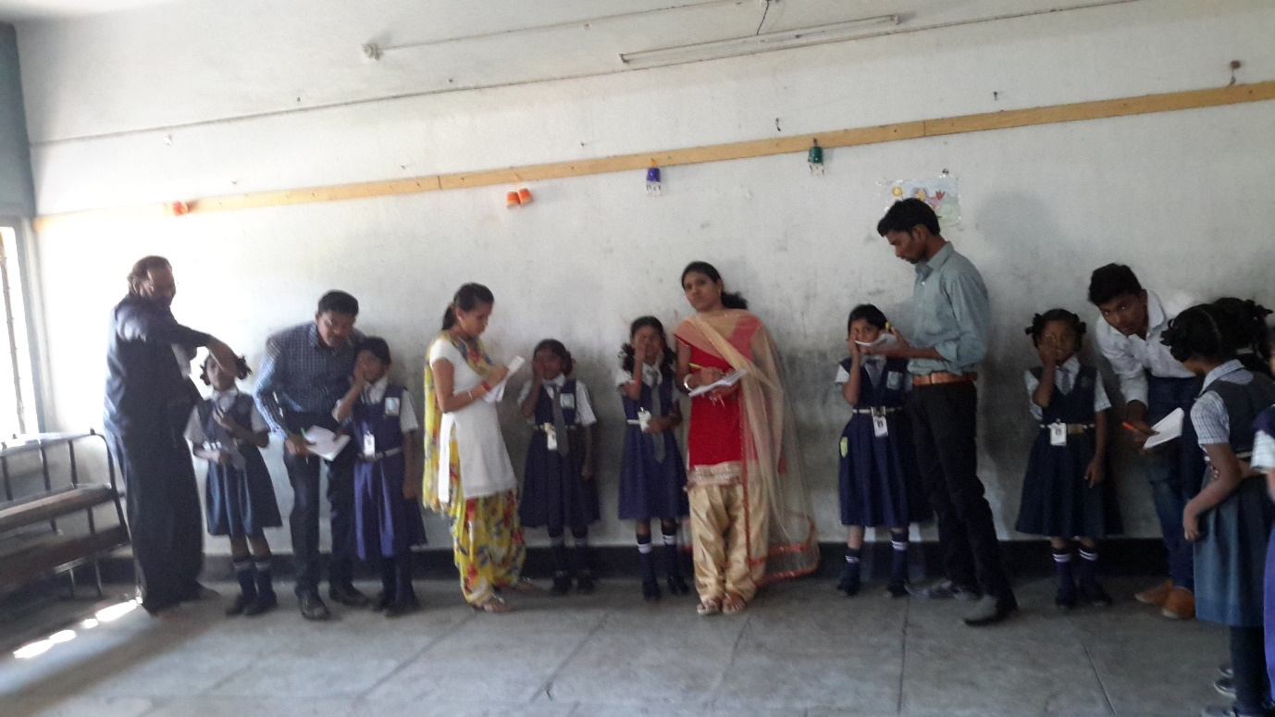

**Free School Camps & Free Glasses & Medicine** 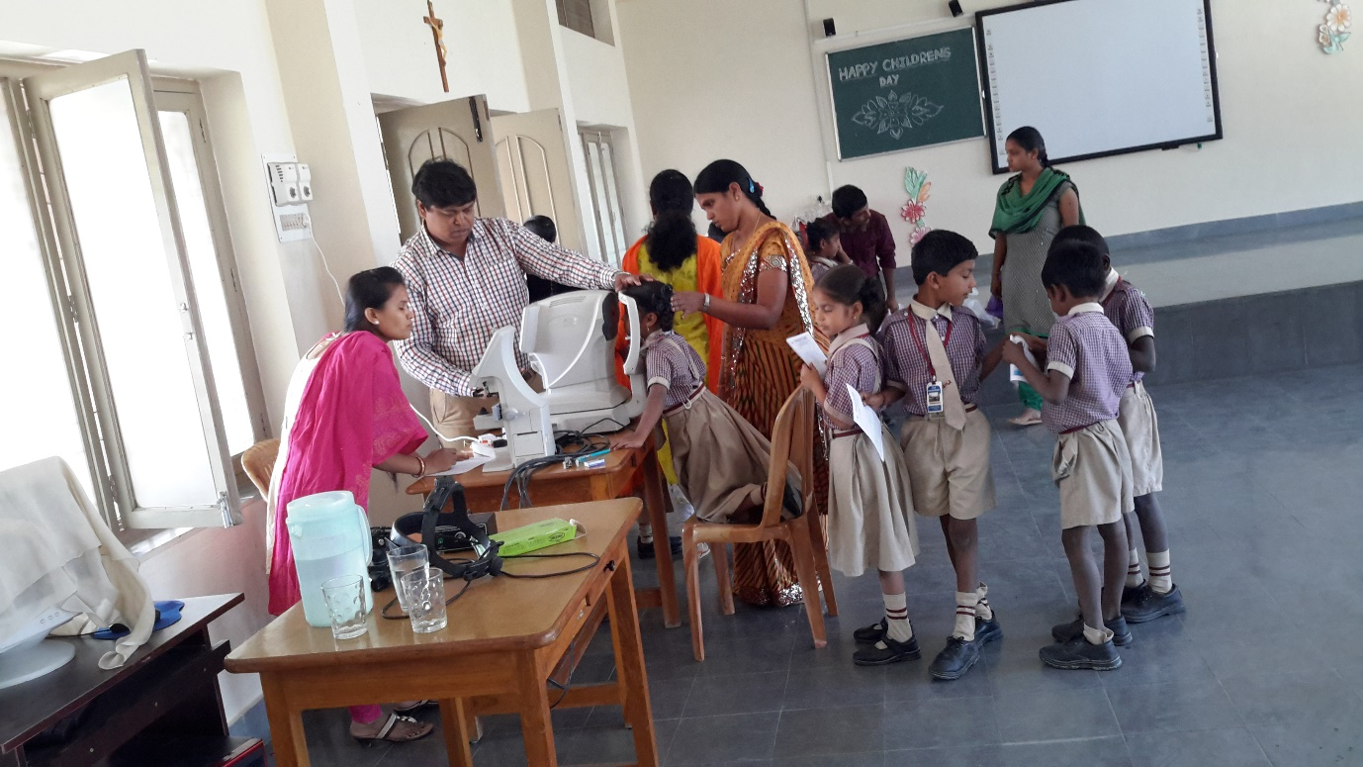

**Free School Camps & Free Glasses & Medicine**

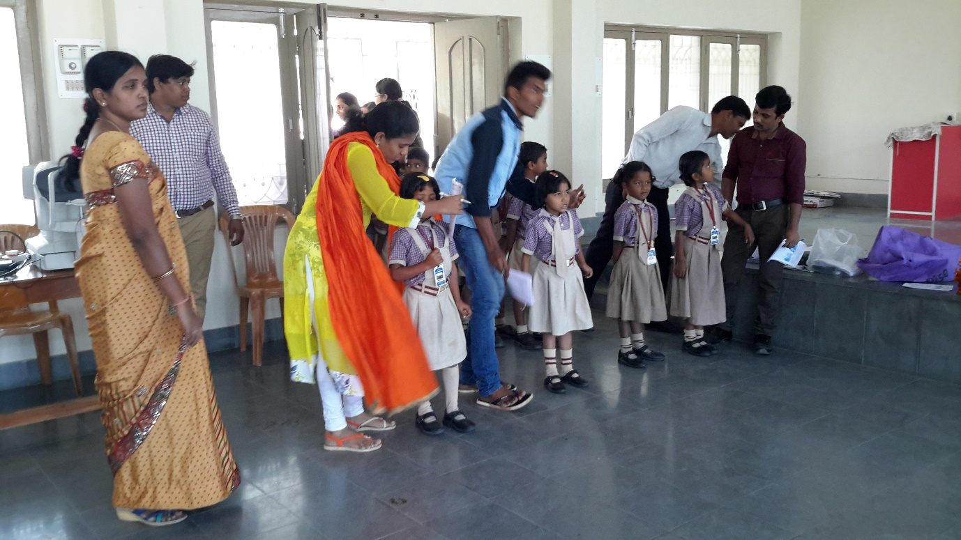

**Free School Camps & Free Glasses & Medicine** 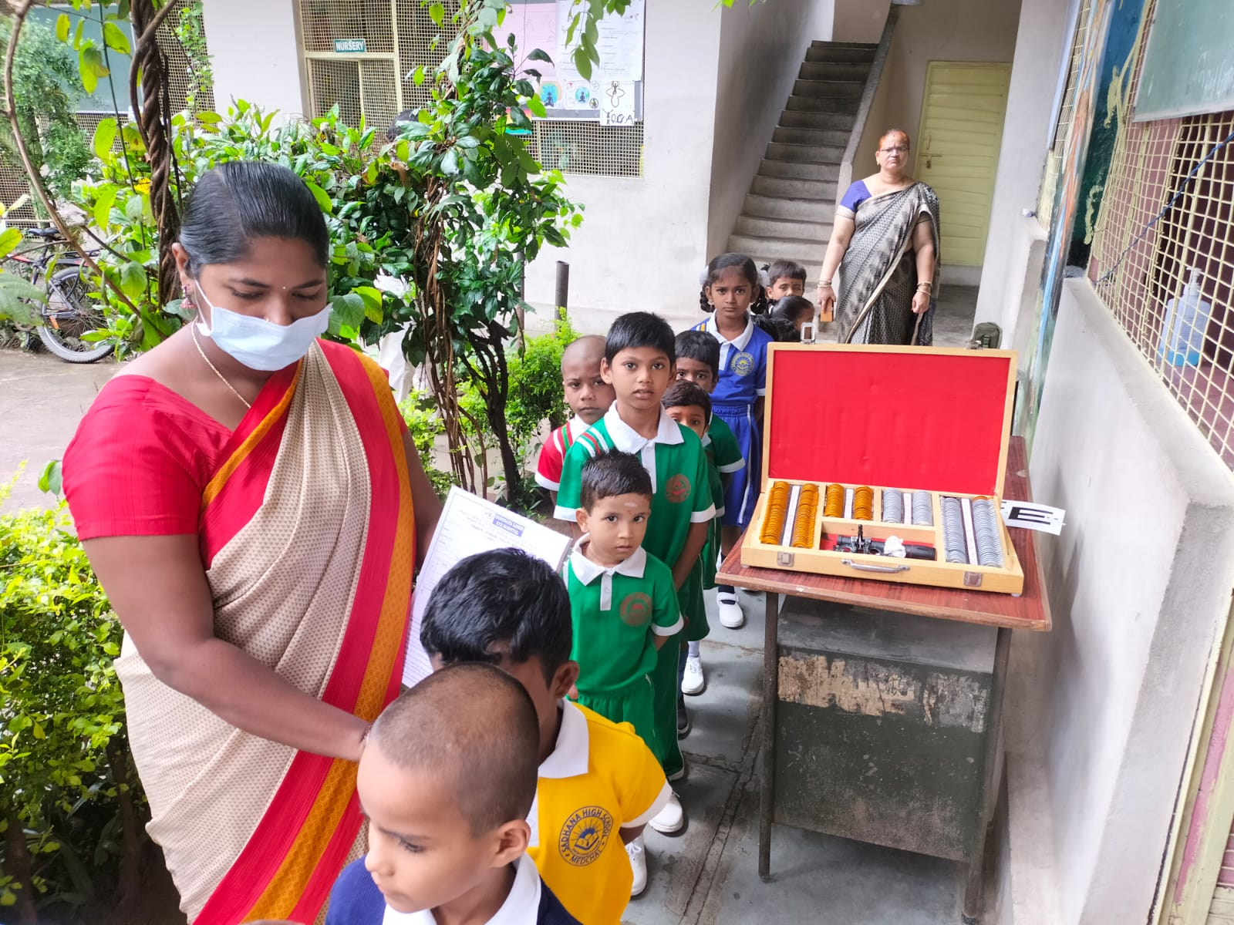

**Free School Camps & Free Glasses & Medicine**

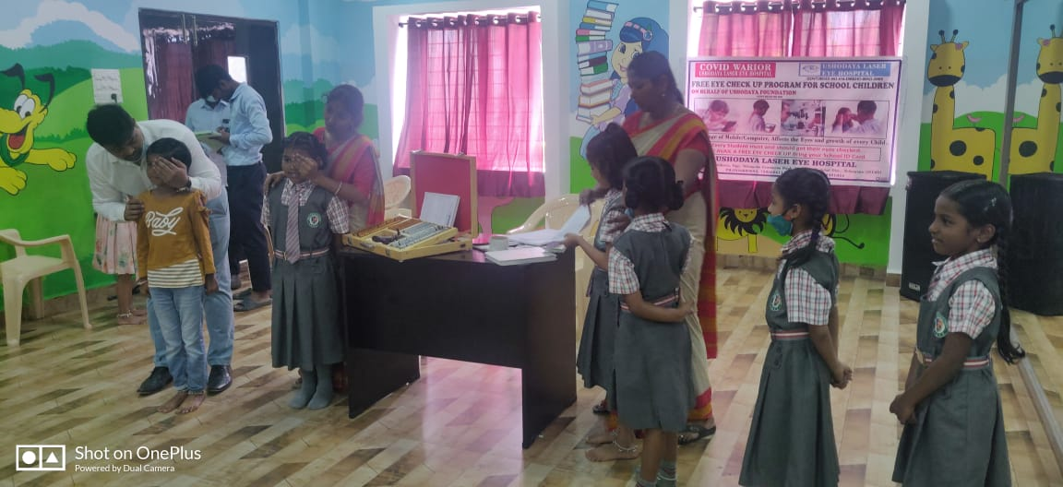

**Free School Camps & Free Glasses & Medicine** 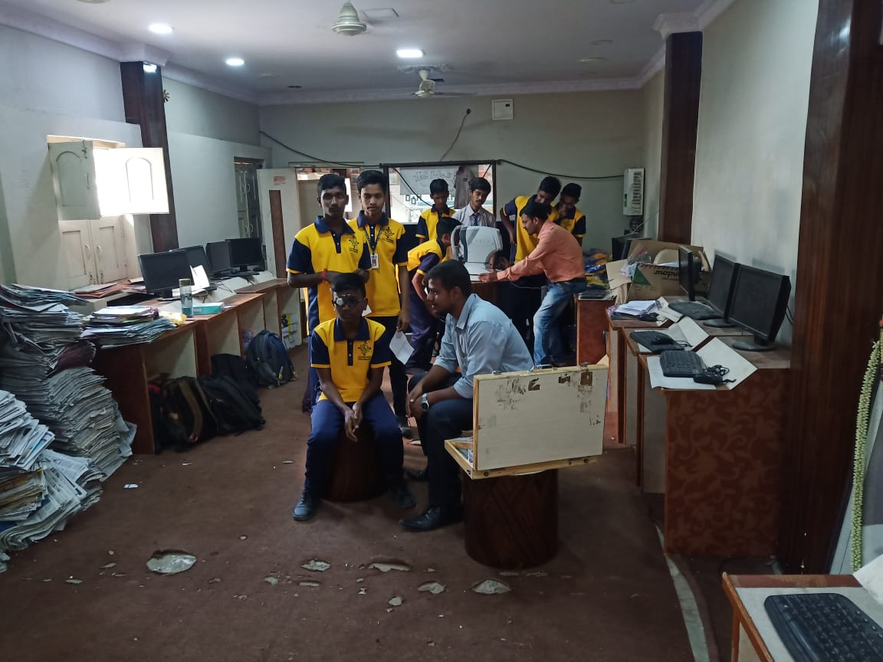

**Free School Camps & Free Glasses & Medicine 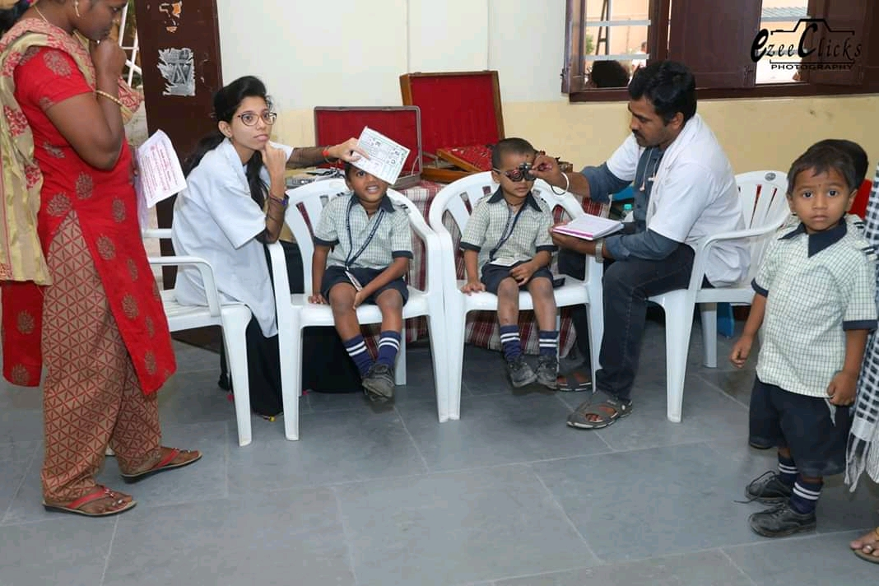 Free School Camps & Free Glasses & Medicine** 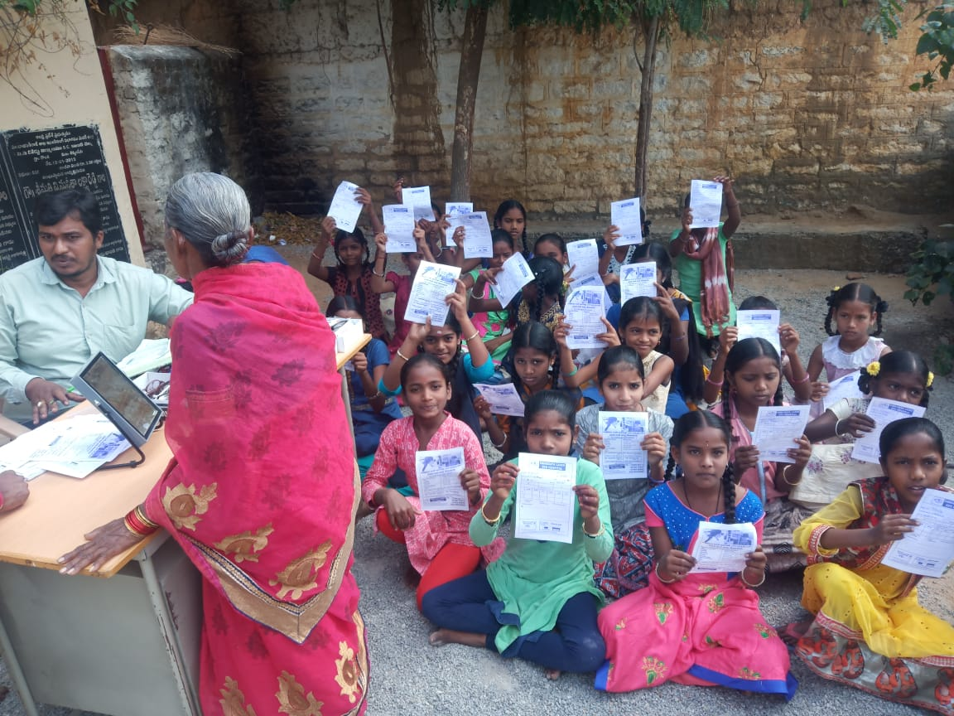

**Free School Camps & Free Glasses & Medicine 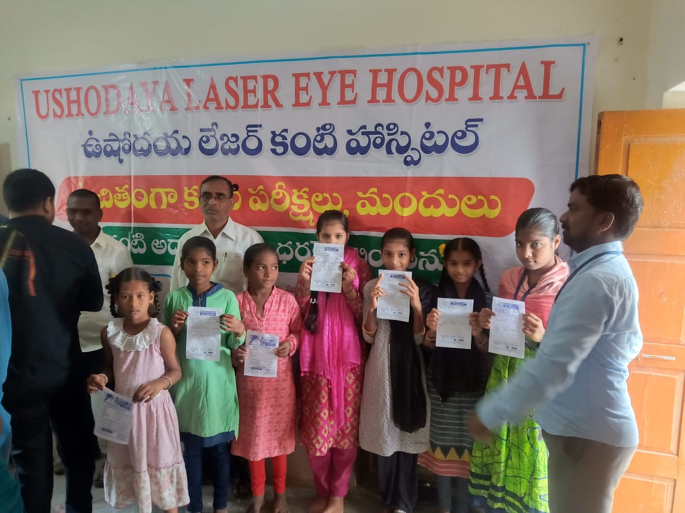 Free School Camps & Free Glasses & Medicine** 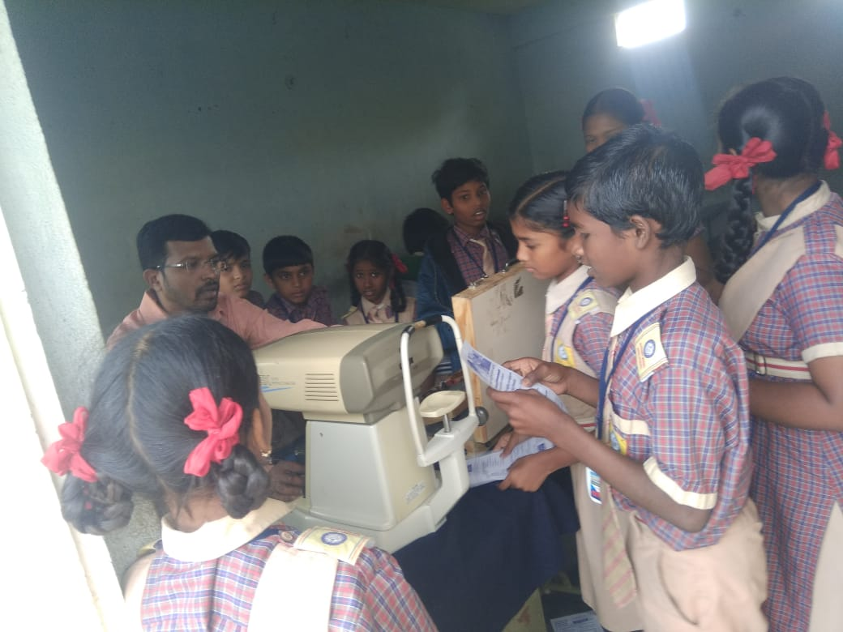

**Free School Camps & Free Glasses & Medicine**

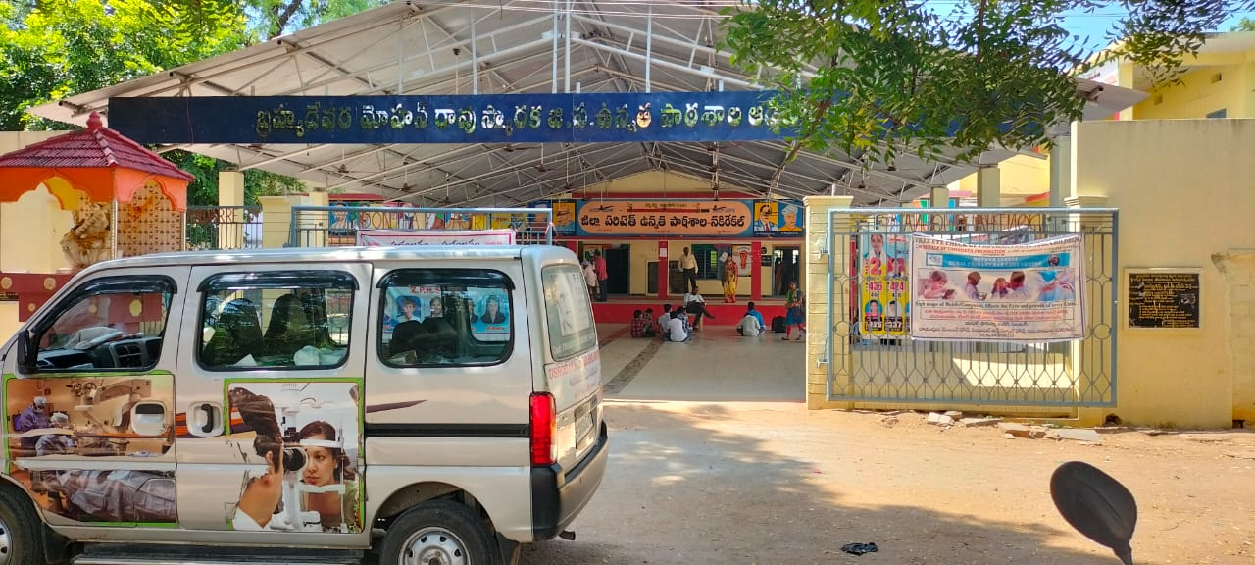 **Free School Camps & Free Glasses & Medicine** 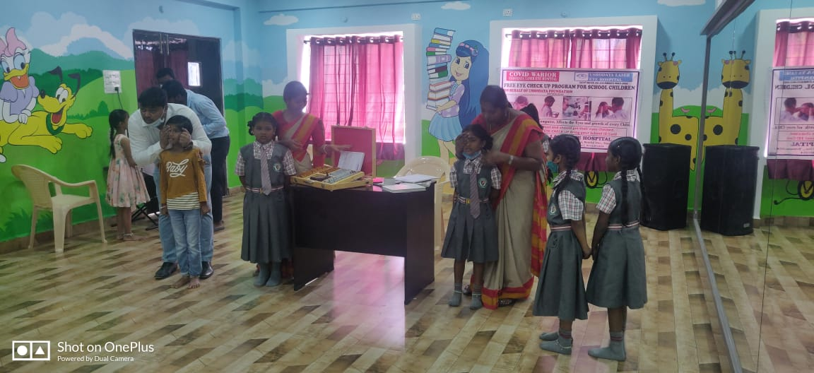

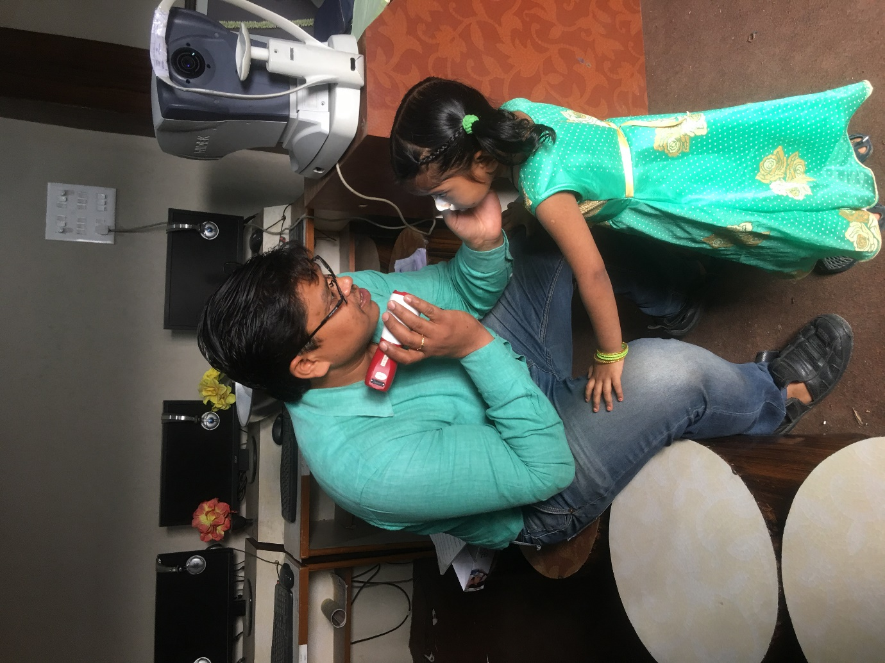

**Free Village Camps & Free Glasses & Medicine**

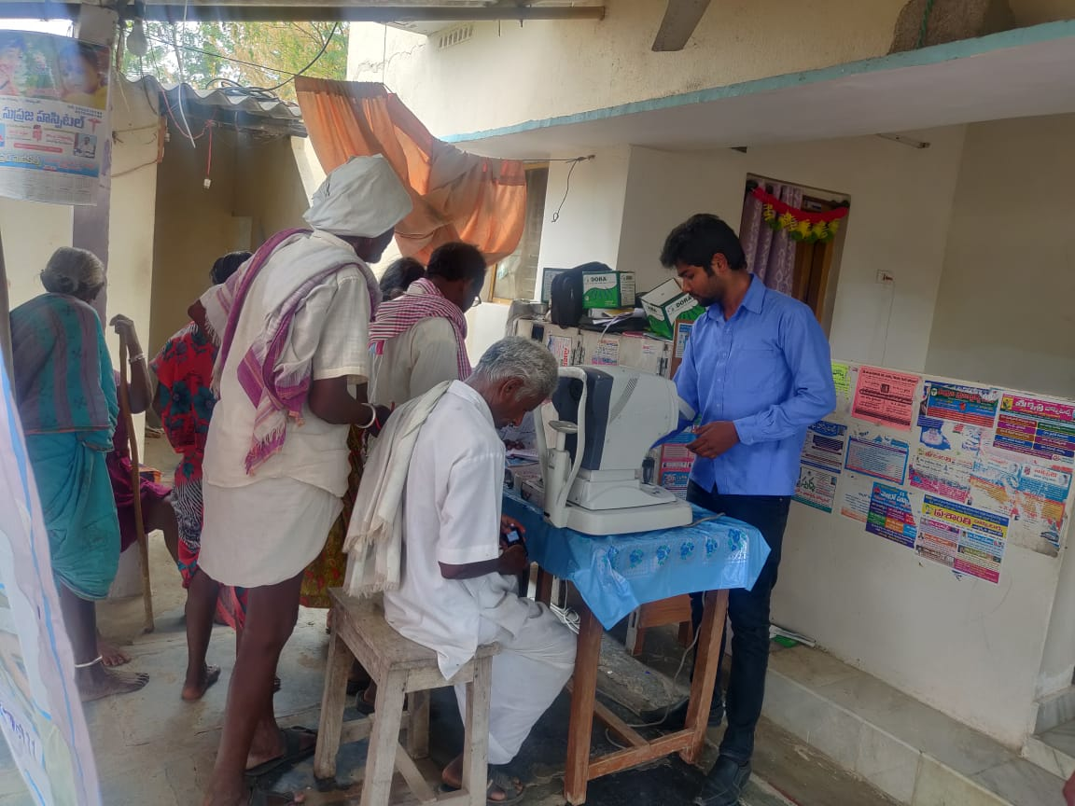 **Free Village Camps & Free Glasses & Medicine**

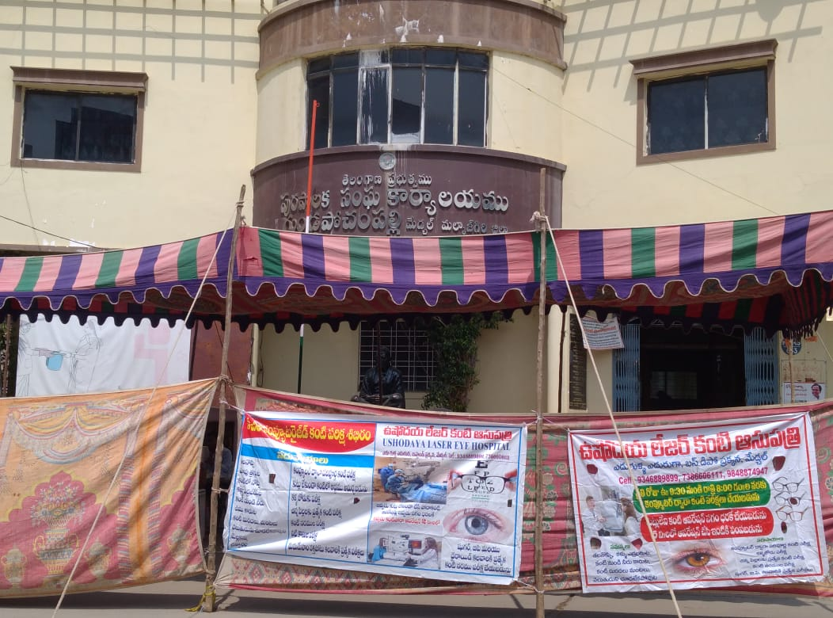

**Free Village Camps & Free Glasses & Medicine**

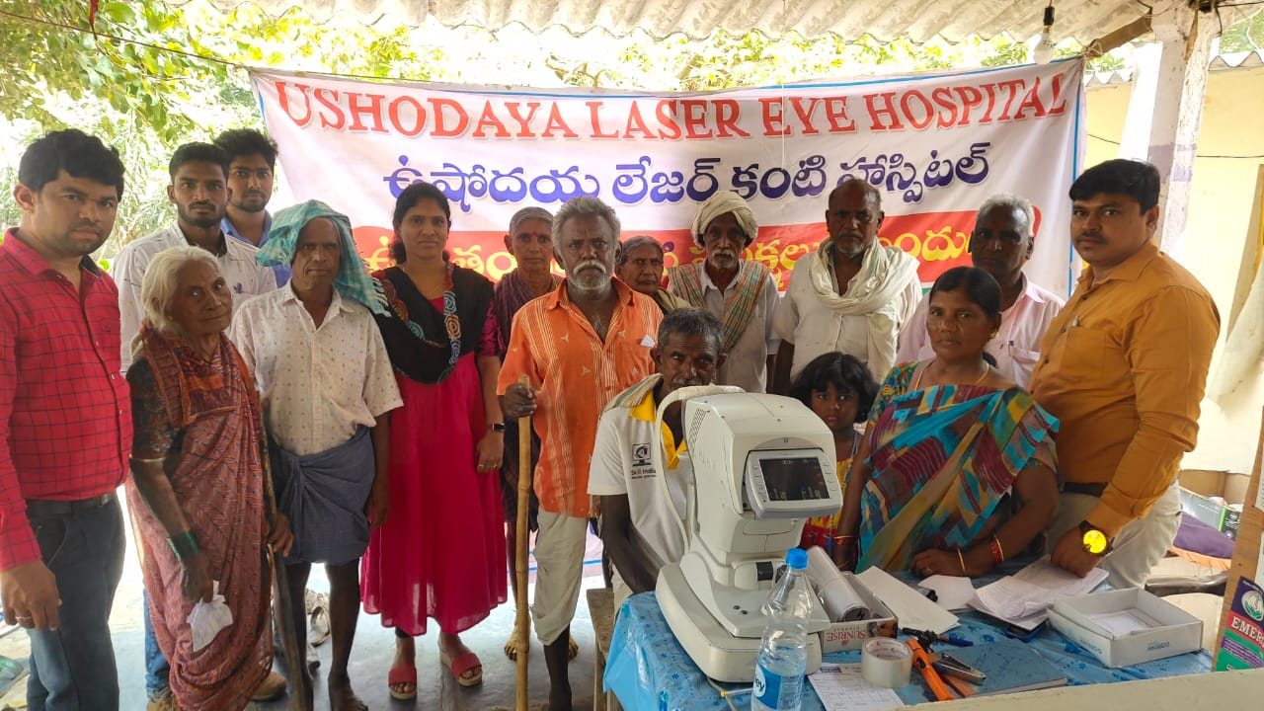 **Free Village Camps & Free Glasses & Medicine**  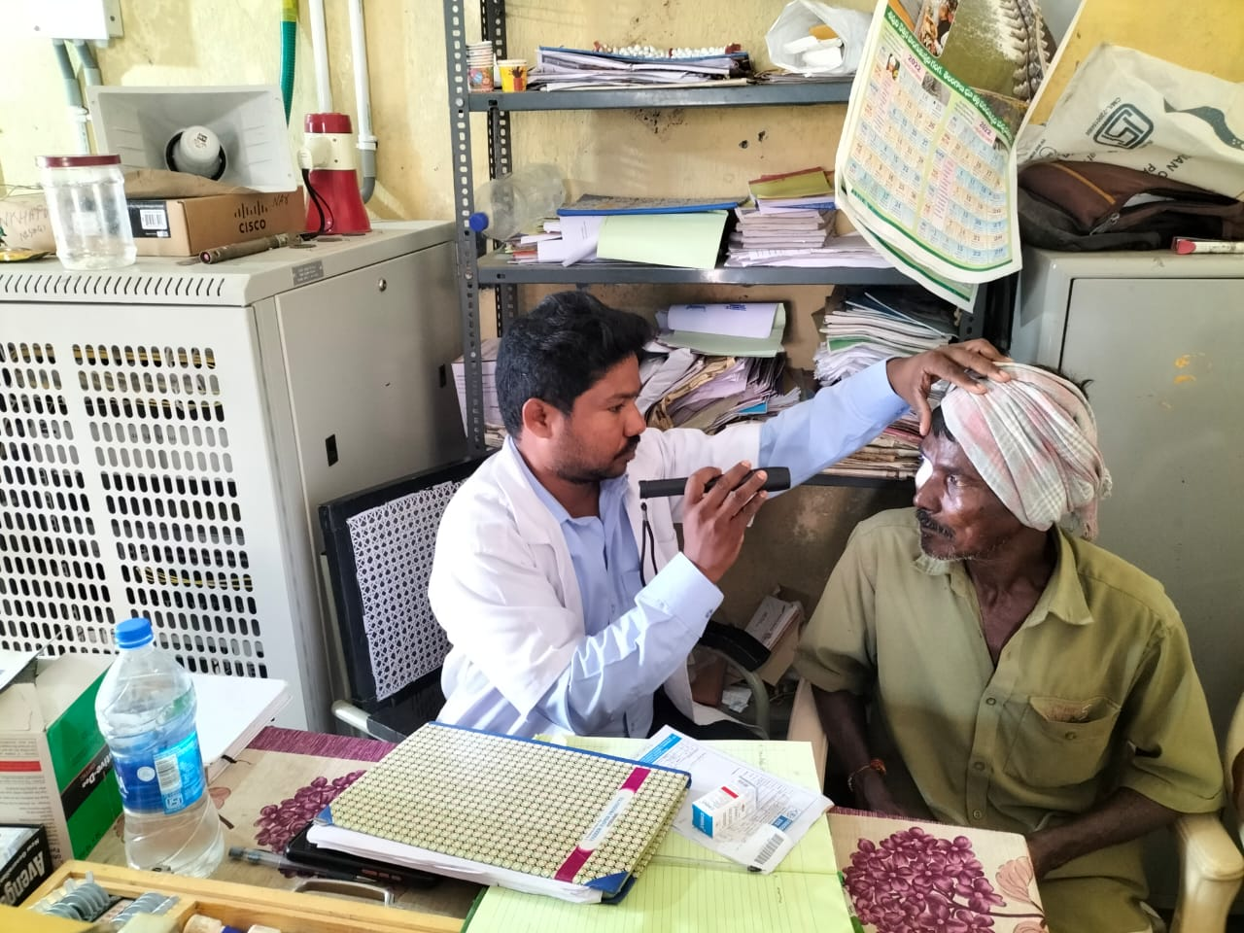

**Free Village Camps & Free Glasses & Medicine**

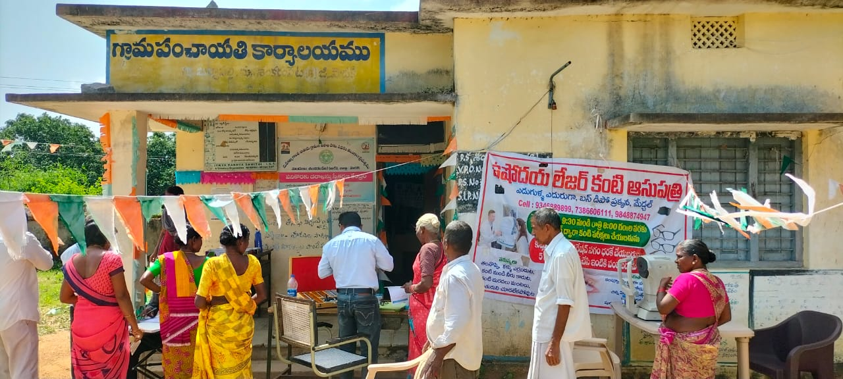 **Free Village Camps & Free Glasses & Medicine**  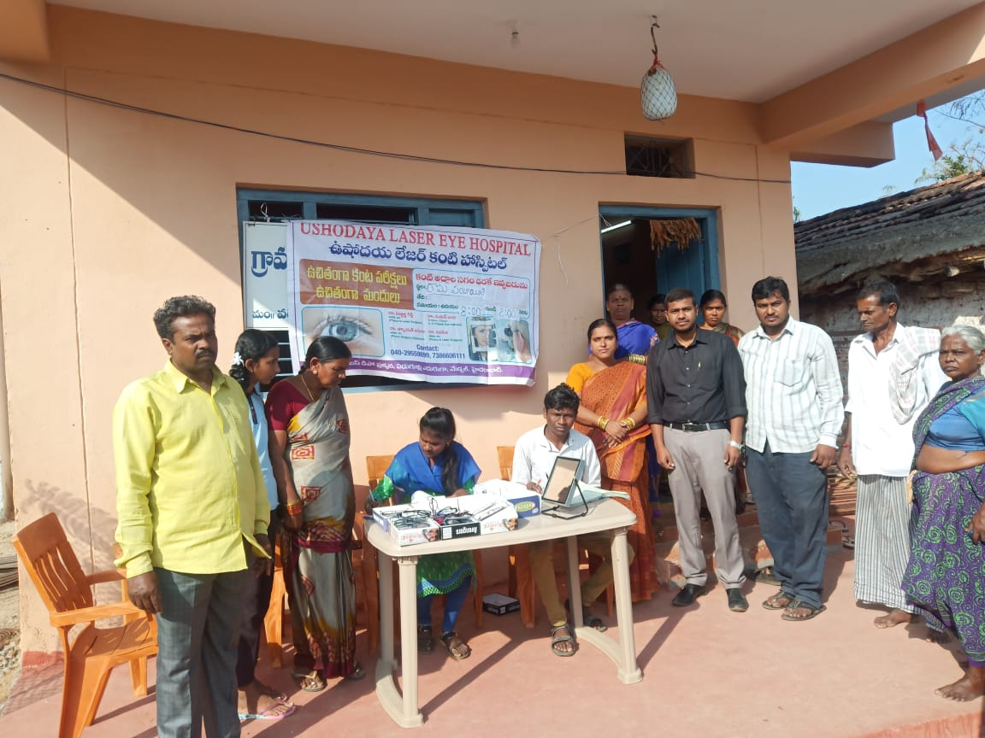

**Free Village Camps & Free Glasses & Medicine  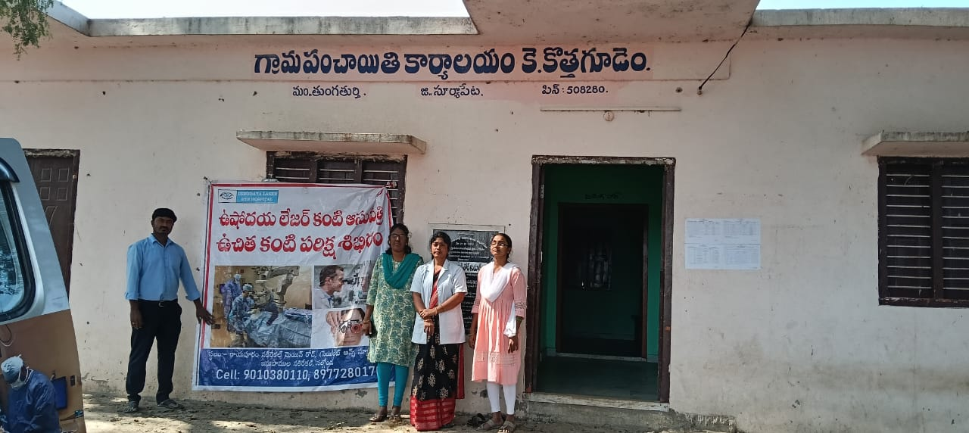 Free Village Camps & Free Glasses & Medicine**  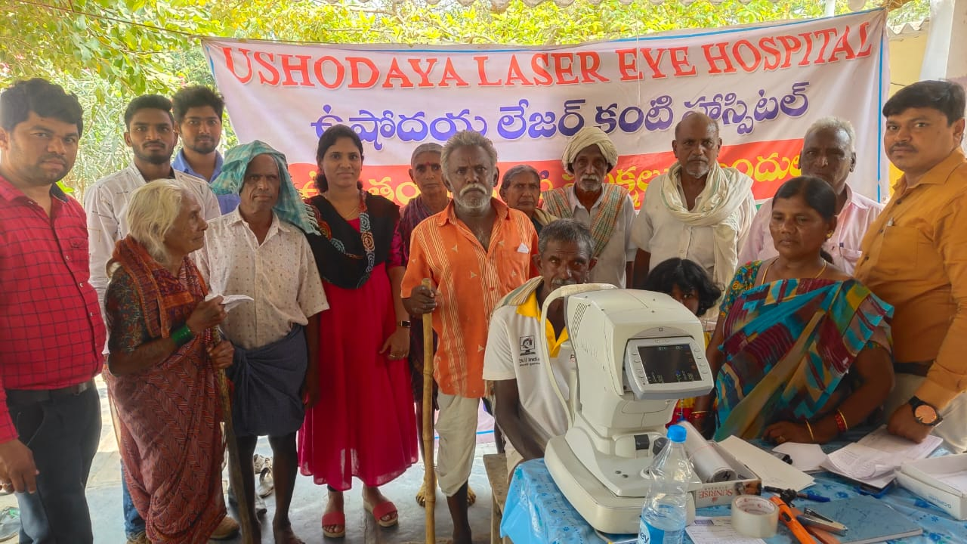

**Free Village Camps & Free Glasses & Medicine**  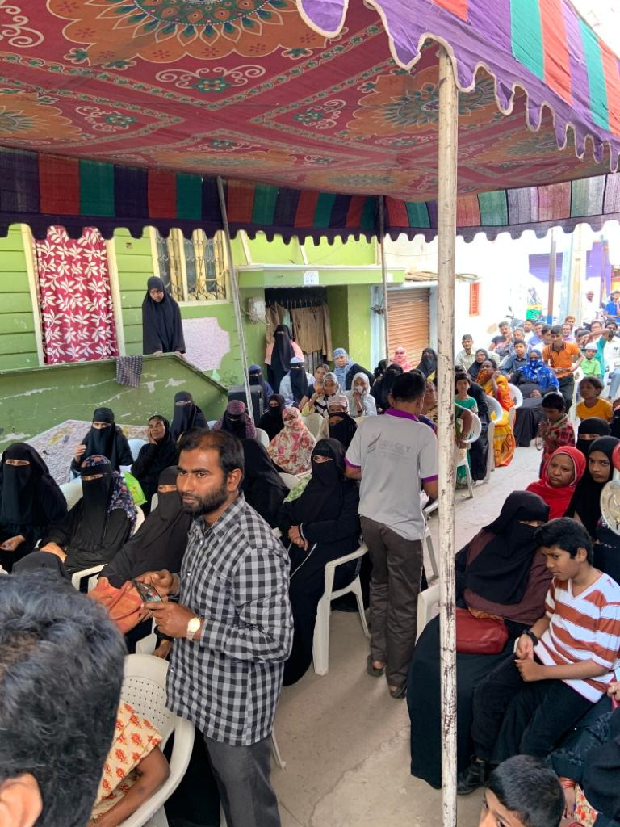

**Free Village Camps & Free Glasses & Medicine  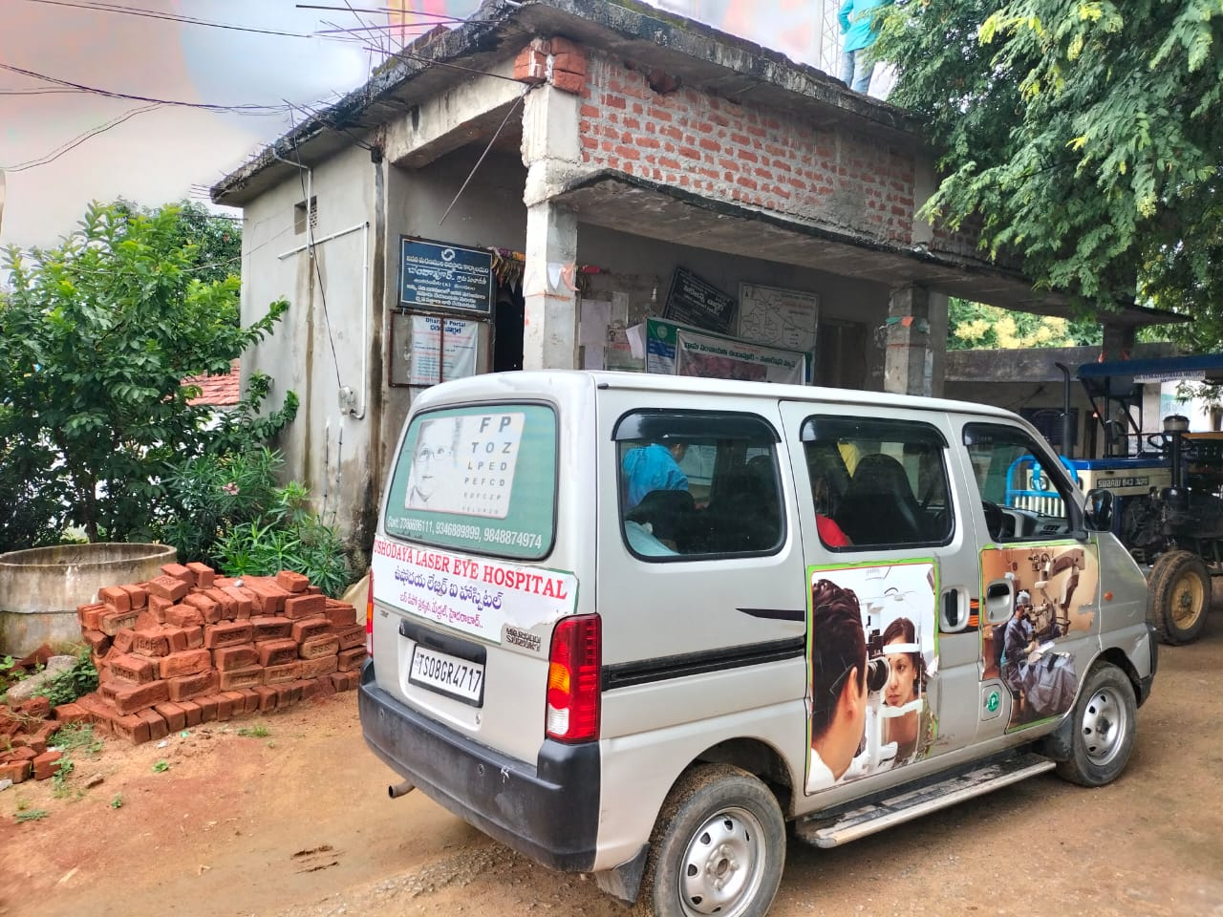 Free Village Camps & Free Glasses & Medicine**  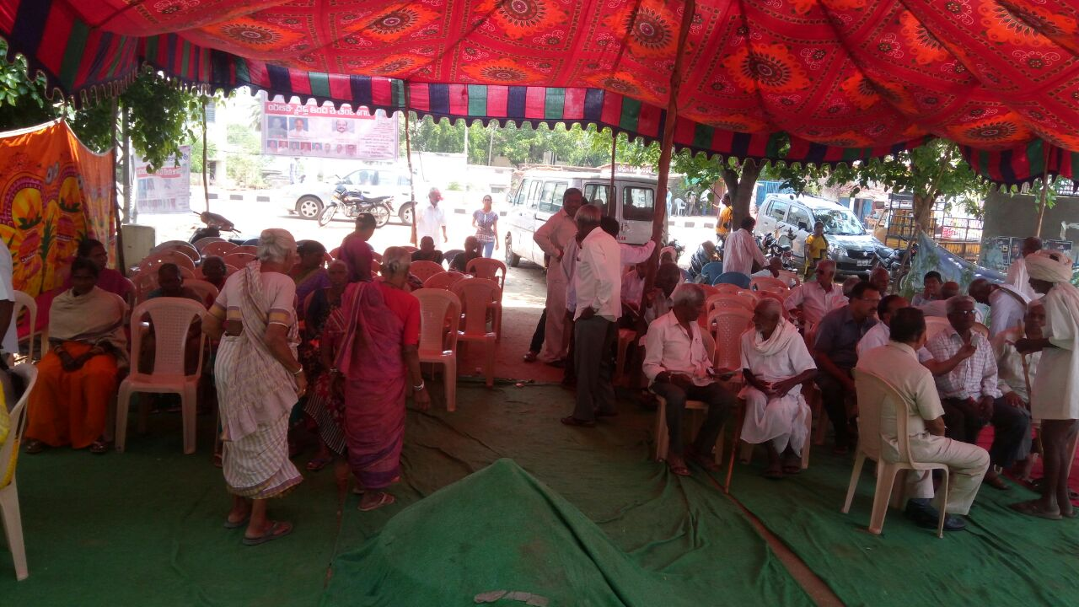

**Free Village Camps & Free Glasses & Medicine  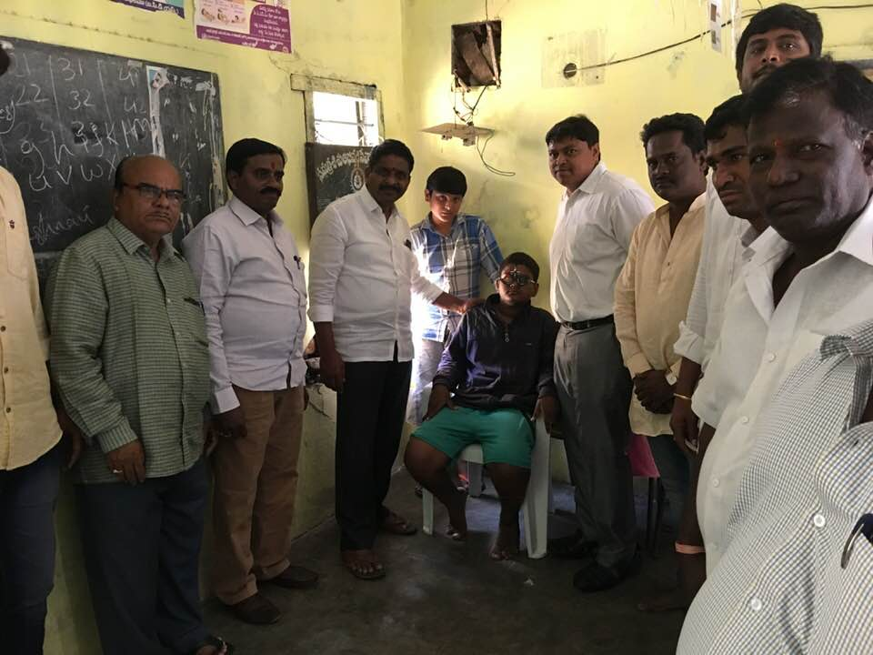 Free Village Camps & Free Glasses & Medicine**  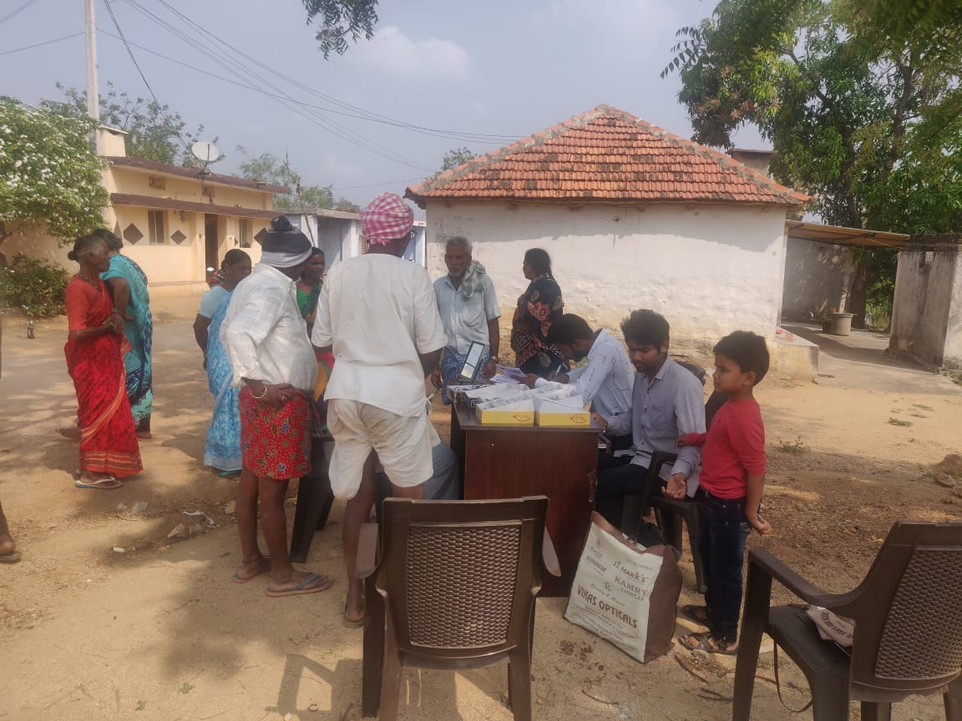

**Free Village Camps & Free Glasses & Medicine  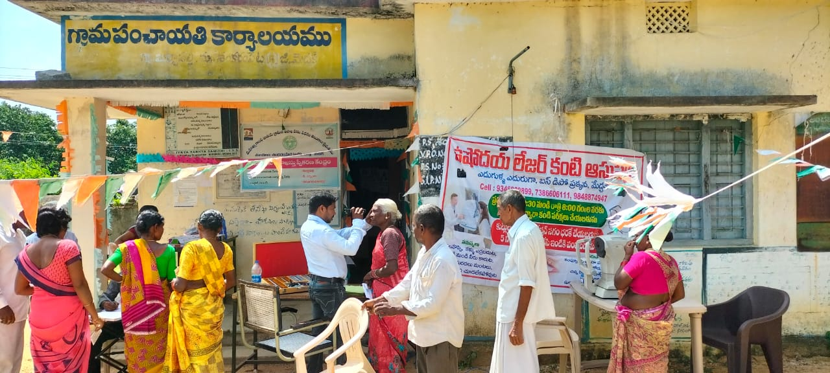 Free Village Camps & Free Glasses & Medicine**  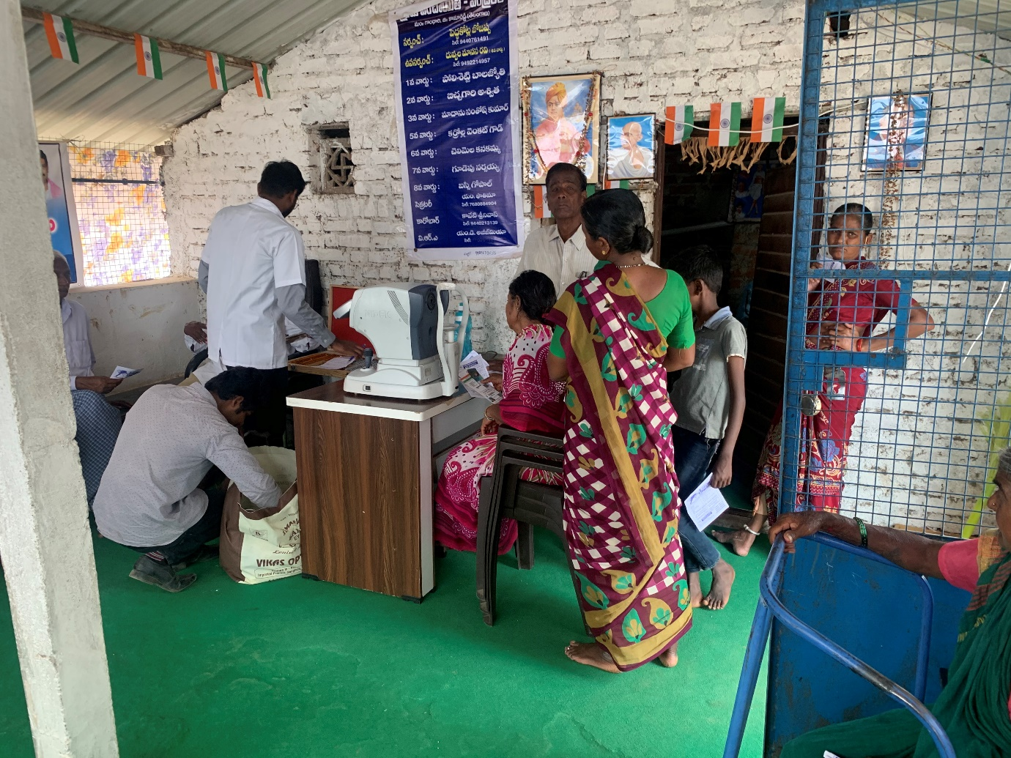

**Free Village Camps & Free Glasses & Medicine  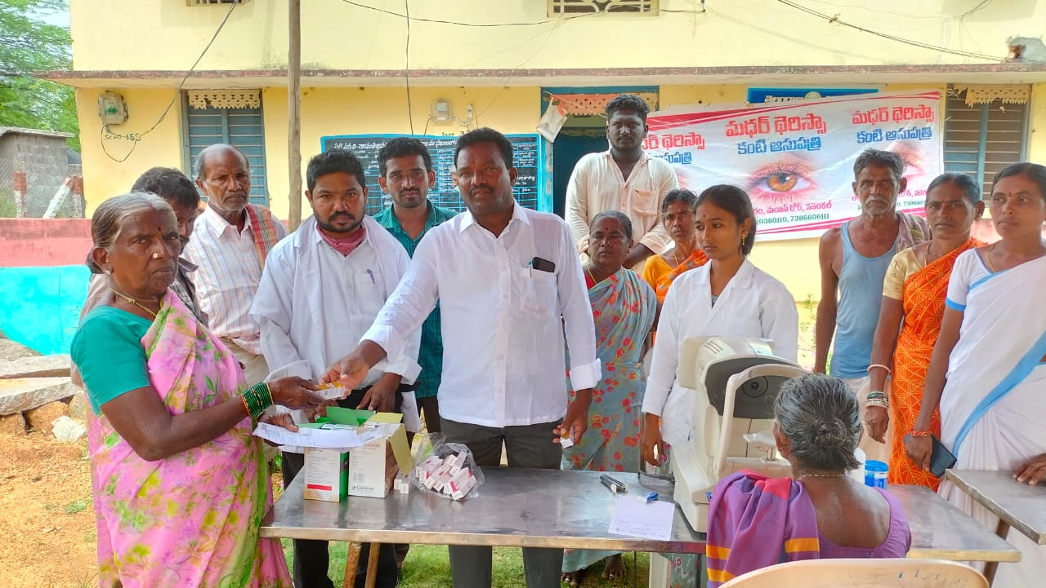 Free Village Camps & Free Glasses & Medicine  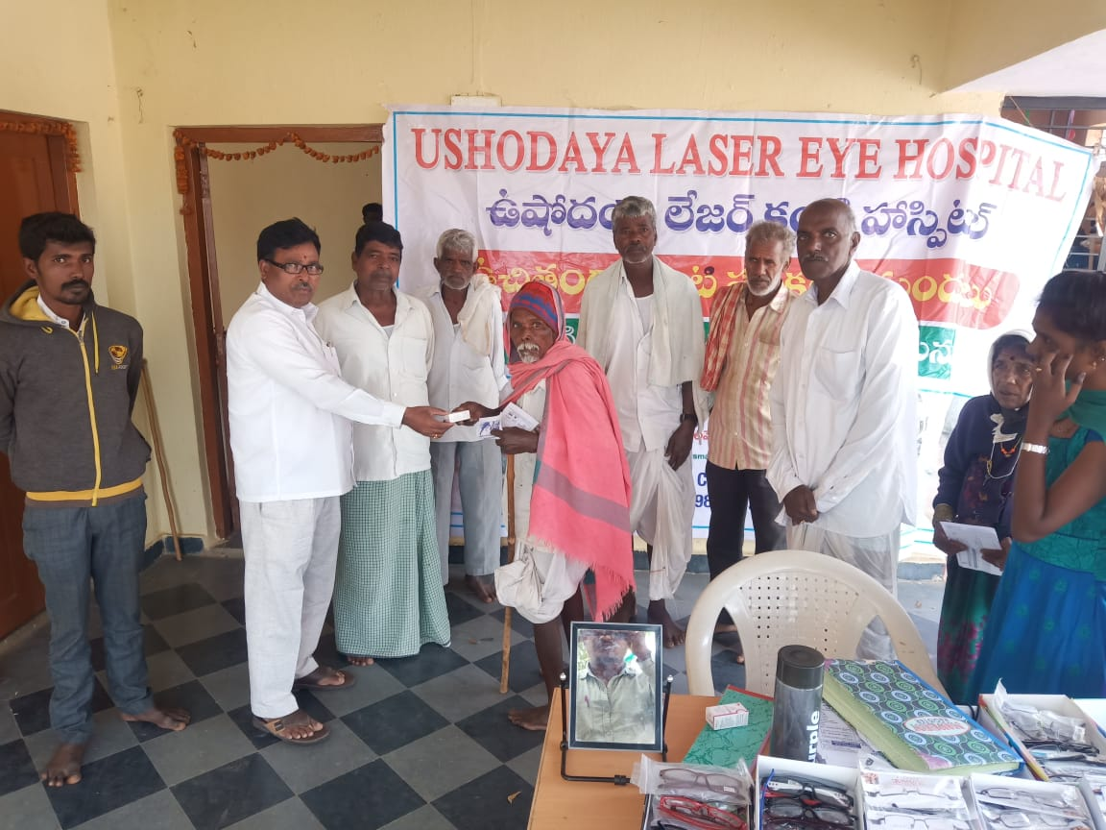 Free Village Camps & Free Glasses & Medicine  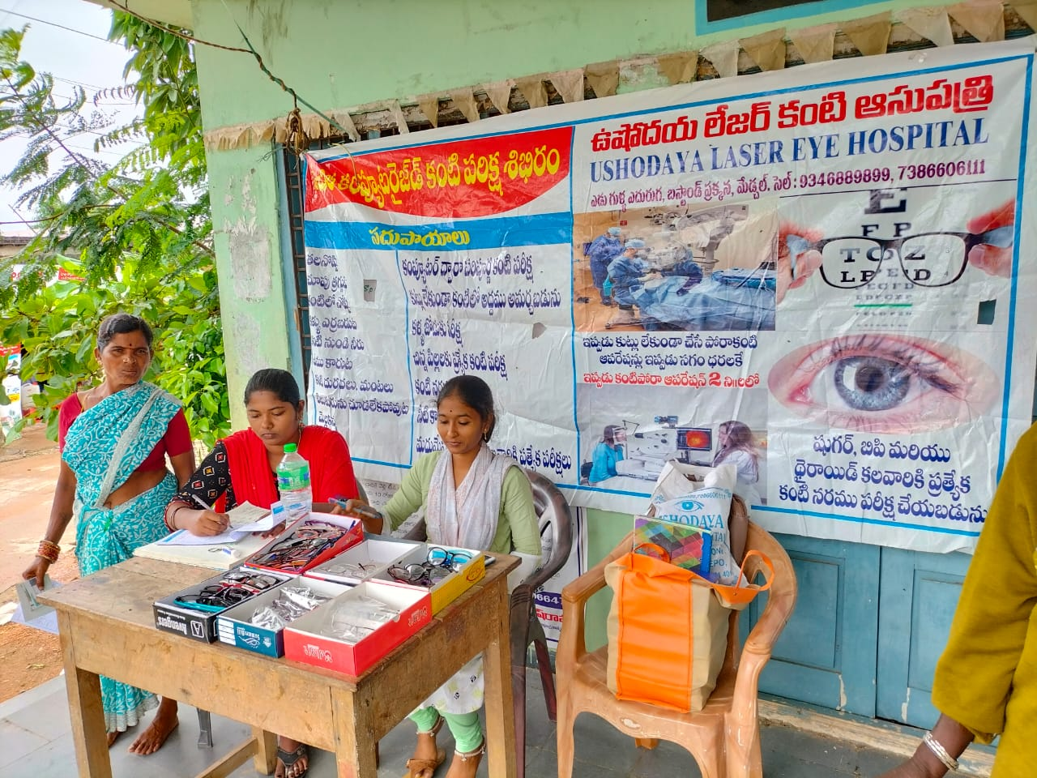 Free Village Camps & Free Glasses & Medicine**  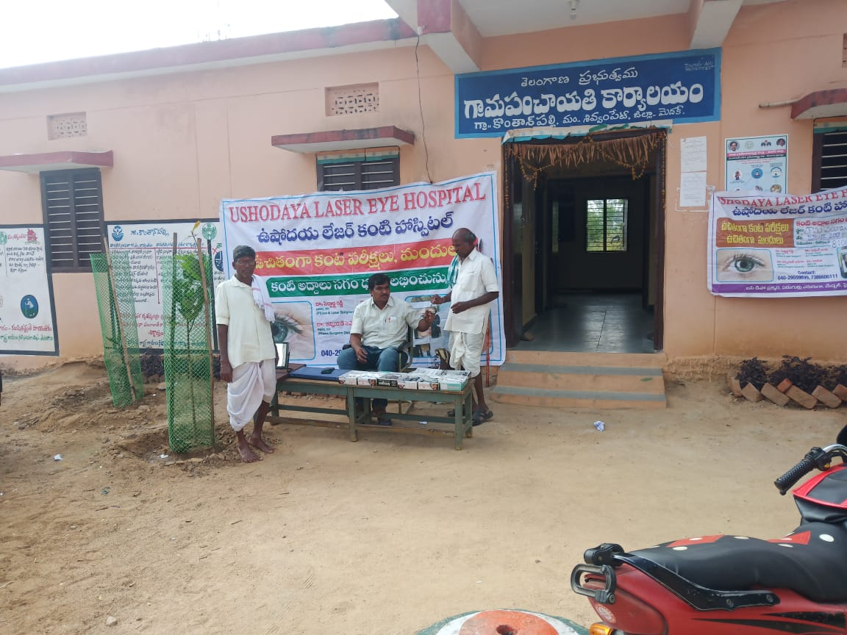

**Old age Homes Camps. Free Glasses & Medicine**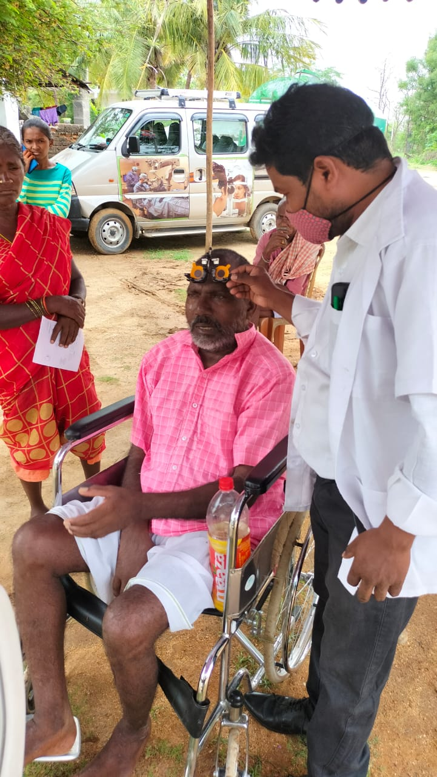

**Old age Homes Camps. Free Glasses & Medicine** 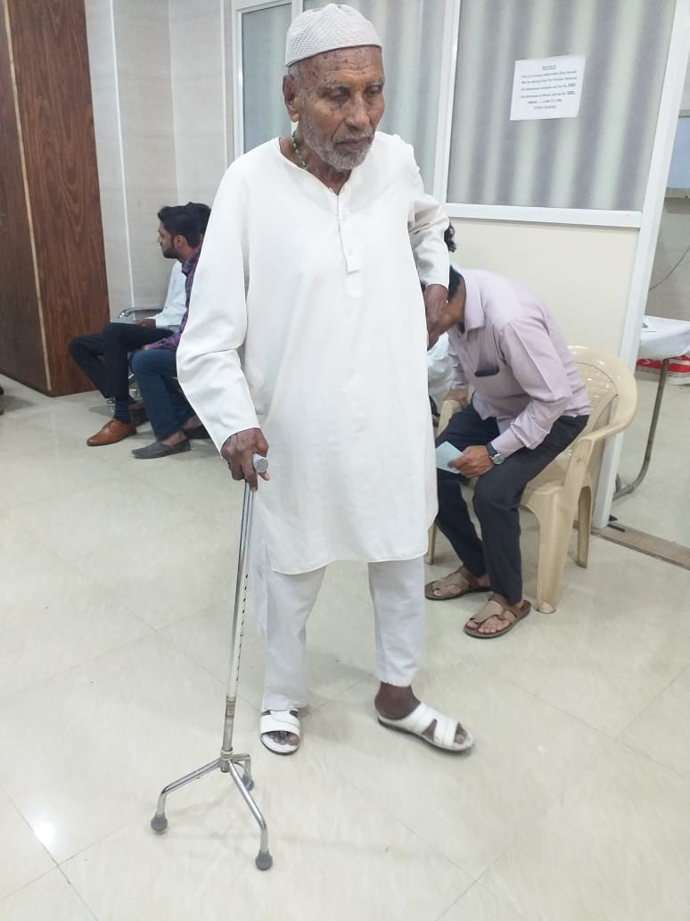

**Old age Homes Camps. Free Glasses & Medicine 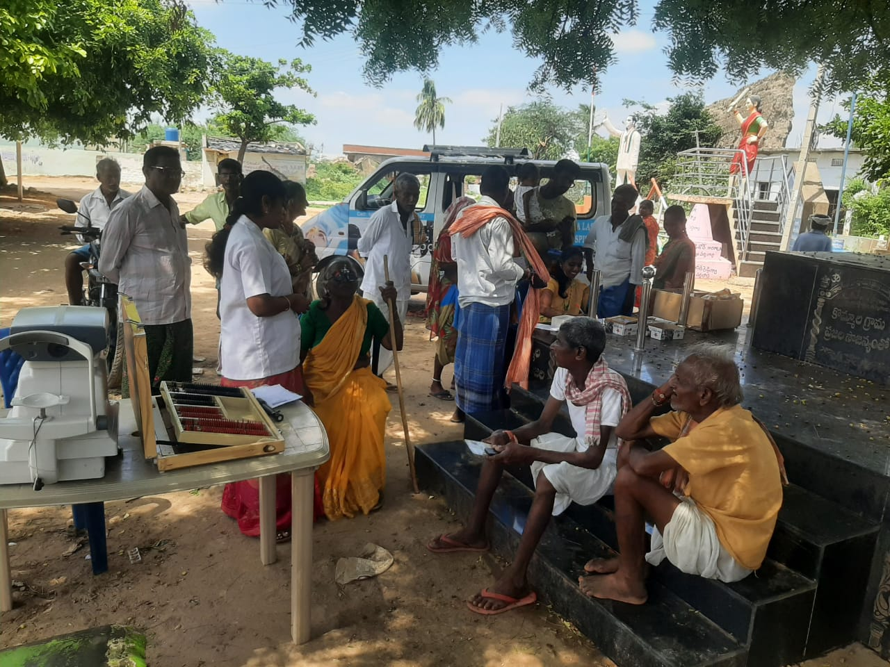 Old age Homes Camps. Free Glasses & Medicine** 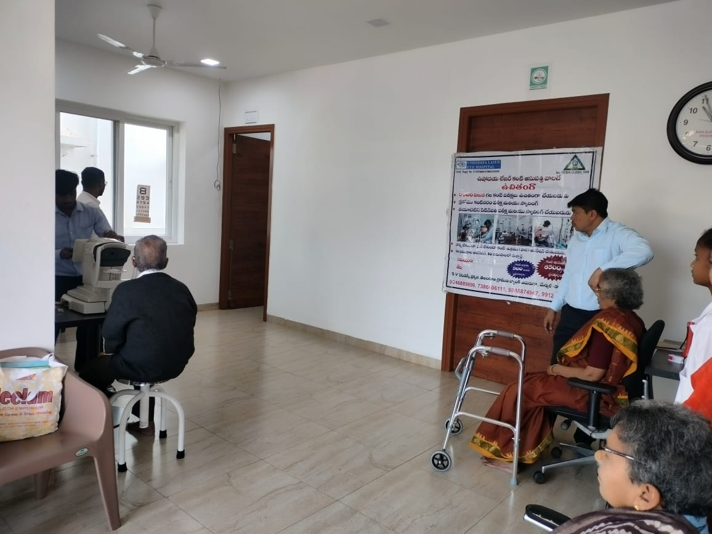

**Received honourable Doctorate from Human Rights Delhi 2021. for the Charity work free Health Care Services**

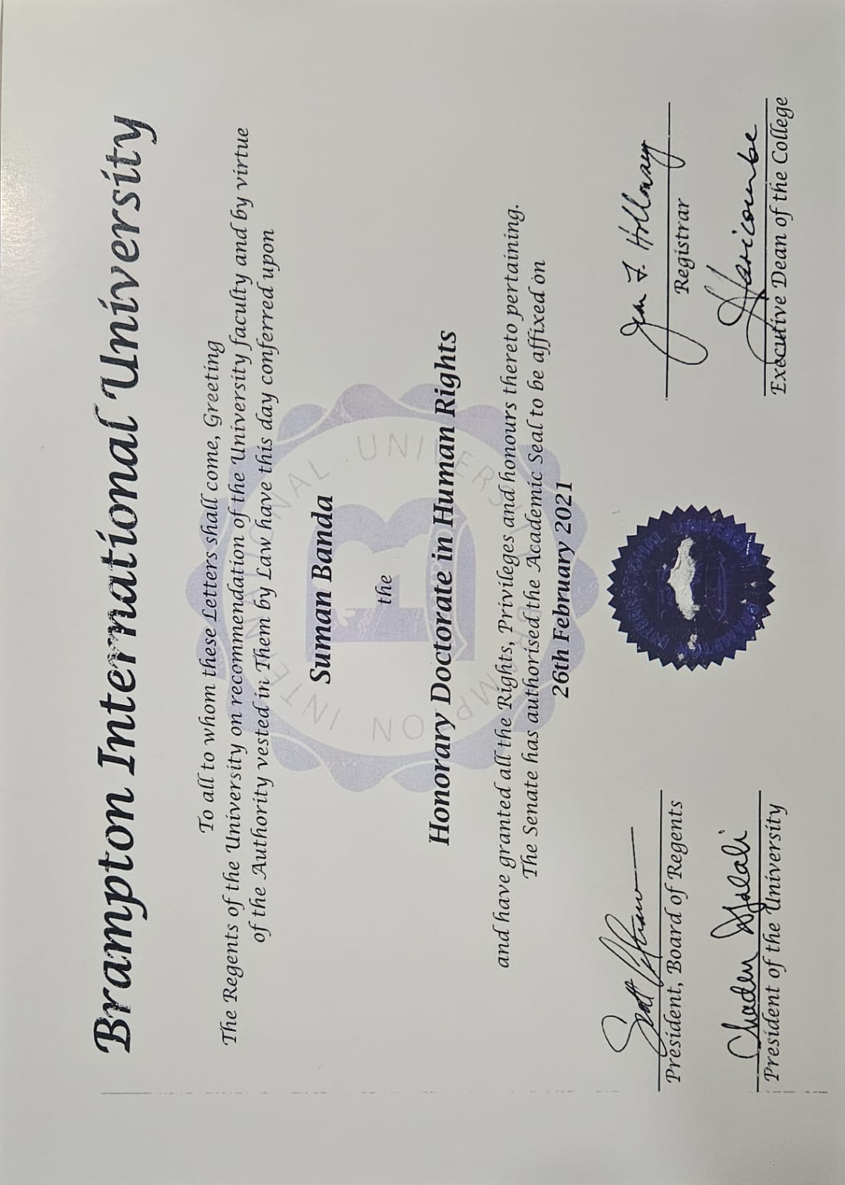

**Received honourable Doctorate from Human Rights Delhi 2021. for the Charity work free Health Care Services**

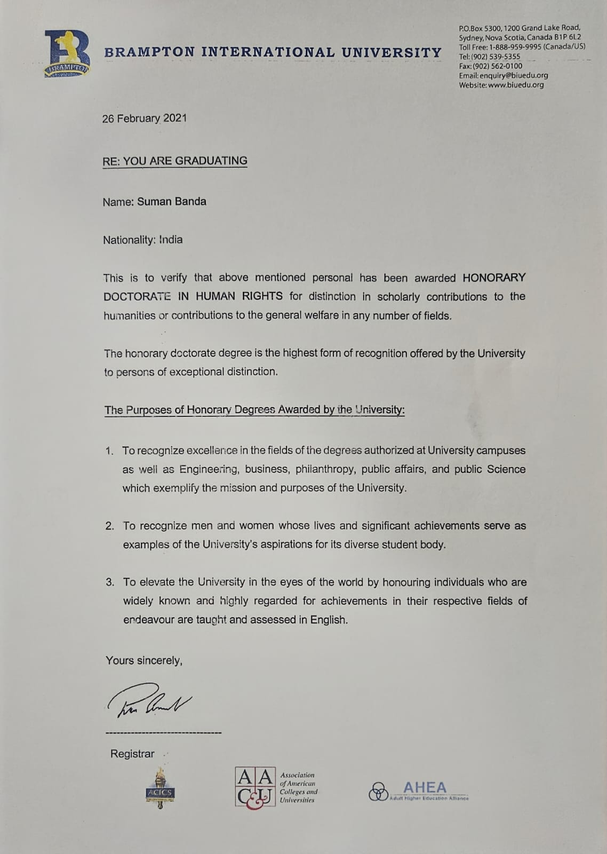

**Received honourable Doctorate from Human Rights Delhi 2021. for the Charity work free Health Care Services**

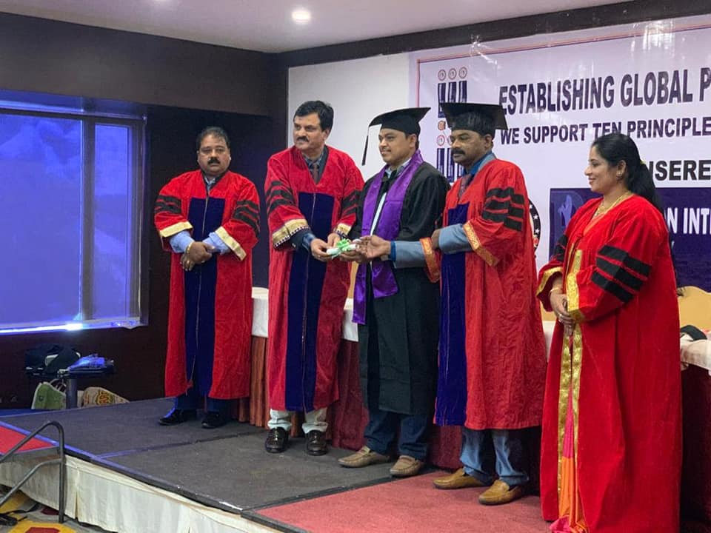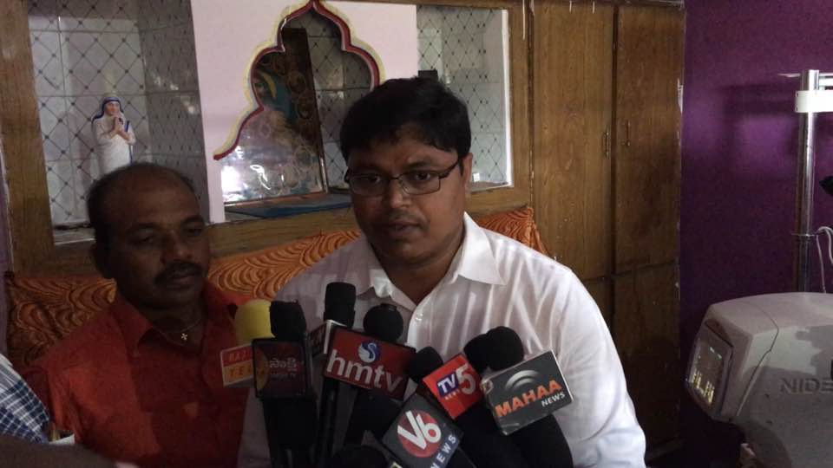

**With Nalgonda Collector Gourav Uppal Sir 2019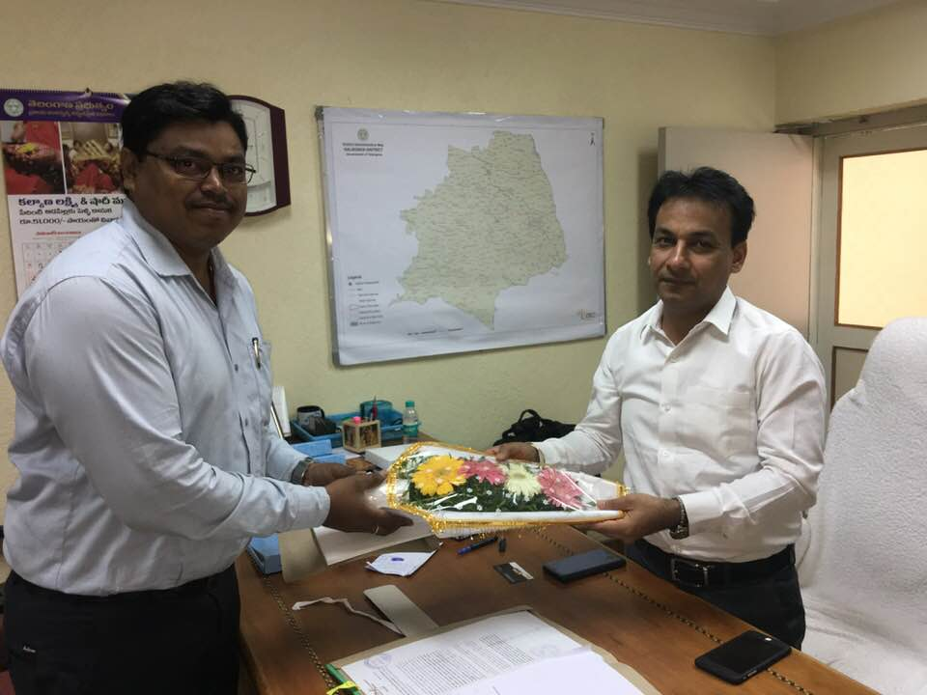 With Nalgonda SP Srinivas Sir 2019**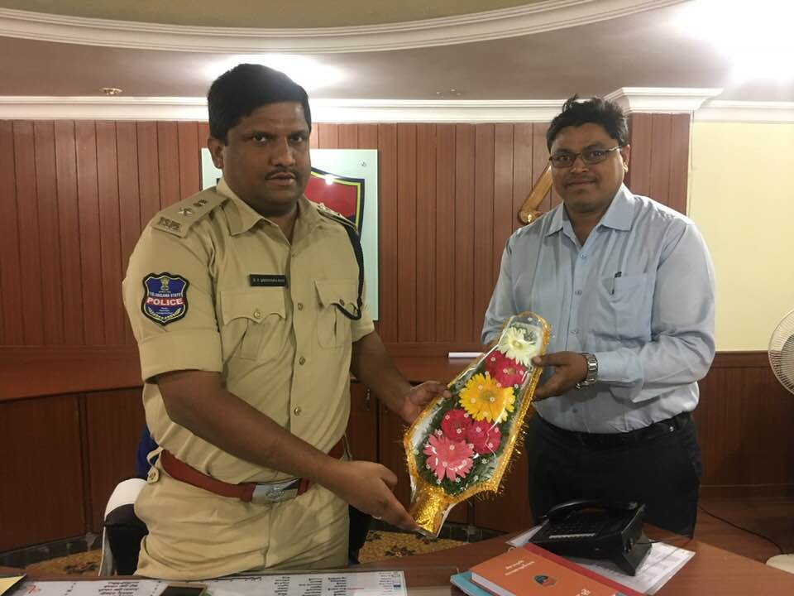

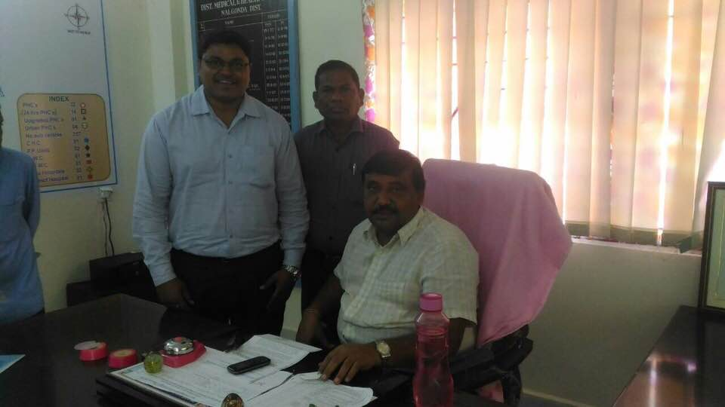

**With Nalgonda DM&HO Sir 2019**